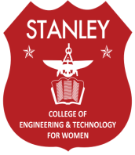
STANLEY COLLEGE OF ENGINEERING AND TECHNOLOGY FOR WOMEN (AUTONOMOUS)
(Affiliated to Osmania University& Approved by AICTE)
(All eligible UG Courses are accredited by NBA & Accredited by NAAC with ‘A’ Grade)
DEPARTMENT OF ELECTRICAL AND ELECTRONICS ENGINEERING

EVENTS :
For every event Registration fees – Rs. 50/- per head
Paper and Poster Presentation topics:
1. Digital GRID (Smart grid, Micro grid)
2. Electrical Vehicles
3. Impact of Electrical Energy in the duration of Covid
4. Renewable energy impact in present situations
5. IOT based Electrical Applications
Project Expo topic:
Modern trends in Electrical technology like Electrical vehicle related projects, IOT Application in Electrical Energy, and related to renewable energy sources
Technical quiz Topics:
1.Powersystems
2. Electrical Machines
3. Measurements
4.Contro systems
5. Basics in Electricals
Short film contest topics:
Life at Stanley college
Important of Parents role in Children life
Women Empowerment
Kindly cooperate to make the event a grant success.

