Stanley College of Engineering and Technology for Women

Chapel Road, Abids, Hyderabad – 500 001

Department of Computer Science and Engineering

Summary of Infrastructure

SNo | LAB NAME | LAB DESCRIPTION
1 | Lab 1 &Lab 2 | H/W :Acer verition-50,Acer Power Service-5,Lenovo-5.  Acer veriton :  Processor : intel(R) Pentium (R),CPU G3250@3.20GHZ  RAM : 4:00GB, 32-bit OS , x64-Based Processor.  Acer Power Service : Intel(R)Pentium(R) Dual CPU E22002.20GHZ,20.GHZ,  RAM : 2:00GB  Lenovo:  Processor : Intel(R) Pentium (R),dual CPU E2140@1.60GHZ 800MHZ  RAM : 1:00GB,32-bit OS  S/W:turbooc+,Star UML,Java,Jubins simulator.
2 | Lab 3 &Lab 4 | H/W :Acer verition-32,  Ram -4GB  Processor-Intel Pentium DualCore  cpu@e4500@3.00ghz,Opticalmouse,  crt color moniter  S/W:java,mysql,appachitomcat,wp,staruml,putty,turbo++,python  O/S : Windows 10  HP-16  Ram -4GB  Processor-Intel Pentium DualCore  cpu@ie-2100@3.00ghz,Opticalmouse,  crtcolor monitor15inches  S/W:turbooc++,gcc,g++  O/S :ubuntoo,Windows 10  Acer-12  intel(r)pentium(r)processor cpug2020@2.90ghz,2.90ghz,4.00gb ram,32-bit os,x-64-based processor
3 | Lab 5 | H/W :Acerverition-32,  Ram -4GB  Processor-Intel Pentium DualCore  cpu@e4500@3.00ghz,Opticalmouse,  crtcolormoniter  S/W:java,appachi tomcat,turbooc++  O/S : Windows 10
4 | Lab 6 &Lab 7 | H/W :Acerveriton-42,  Acerveriton core i3-18,  Ram -4GB  Processor-Intel Pentium DualCore  cpu@e7400@3.00ghz,Opticalmouse,  crtcolormoniter  S/W:java,mysql,dosbox,masam,appachi tomcat,wp,python,weka  O/S : Windows 10
5 | Lab 8 | H/W :  Acer -11  Ram-8GB  Processor-Intel ®core™ i5-9400 cpu@2.90Ghz  64 bit,OS  crtcolor monitor17inches  Windows 10  HP-18  Ram -4GB  Processor-Intel Pentium DualCore  cpu@ie-2100@3.00ghz,Opticalmouse,  crtcolor monitor15inches  S/W:turbooc++,gcc,g++  O/S :ubuntoo,Windows 10

The Institution has adequate infrastructure and physical facilities for teaching- learning viz., classrooms, laboratories, computing equipment, etc. as library, laboratories, computer centre, class room teaching, events, meetings and conferences; in addition to central library, all the departments in the college run their own departmental libraries. Support facilities include hostels, Wi-Fi, canteens, seminar halls, committee rooms; Utilities include safe drinking water, restrooms and power generators. All the class rooms and laboratories are equipped with mounted projectors. Smart Class room is available, Tutorial room and digital library facility is available in the campus. The available physical infrastructure is utilized, to also conduct certificate courses, co-curricular activities/extra – curricular activities, Campus Recruitment Training classes, campus recruitments, meetings, seminars, conferences etc. The college has allotted a Lab for Research & Development (R&D) work with higher end systems, updated s/w’s and plagiarism software which can be used by faculty and students. BBB (Big Blue Button) is a tool of ICT (Information and Communication Technology) which is used as an Online Teaching Learning Process. Examination Branch is using Smart Brainy Solutions software which helps in result analysis, for maintaining the student’s database and taking care of results, Online marks entry and printing Memos.

Stanley College of Engineering and Technology for Women

Chapel Road, Abids, Hyderabad – 500 001

Department of Electrical and Electronics Engineering

Summary of Infrastructure

S no | LAB NAME | LAB DESCRIPTION
1 | SIMULATION(ES) LAB | ACER  Intel (R) Dual CPU E2200@2.20GHZ,2193MHZ, 2(cores),4 logical pro  Processor:  Intel (R)core (Tm)i3-7100 CPU@3.90GHZ,3900MHZ, (2cores), 4 logical pro  Intel (R) Pentium (R) CPU G4400@3.30GHZ,3300MHZ, 2 Cores,2 logical pro  RAM-8GB

Stanley College of Engineering and Technology for Women

Chapel Road, Abids, Hyderabad – 500 001

Department of Electrical and Electronics Engineering

4.1.1 Summary of Infrastructure
4.3.2. No. Of Computers

S no | LAB NAME | LAB DESCRIPTION
1 | SIMULATION(ES) LAB | ACER  Intel (R) Dual CPU E2200@2.20GHZ,2193MHZ, 2 (cores),4 logical pro  Processor:  Intel (R) core (Tm)i3-7100 CPU@3.90GHZ,3900MHZ, (2cores), 4 logical pro  Intel (R) Pentium (R) CPU G4400@3.30GHZ,3300MHZ, 2 Cores,2 logical pro  RAM-8GB

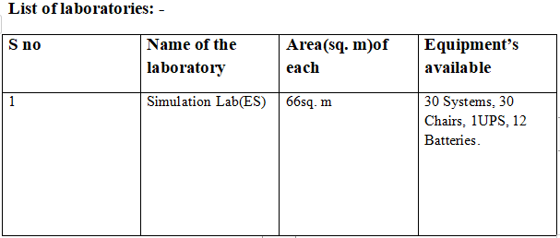

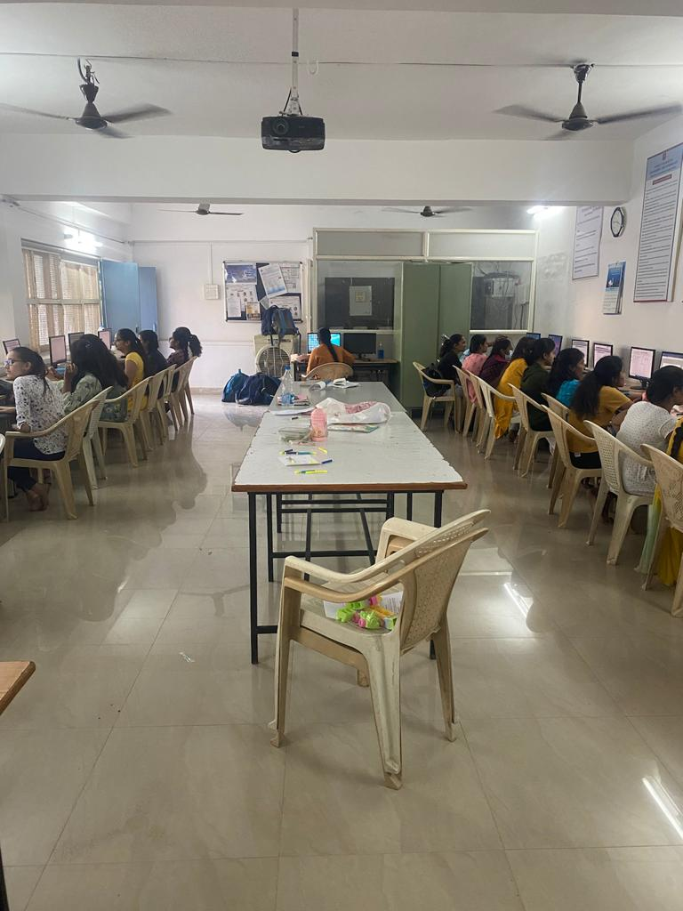 | 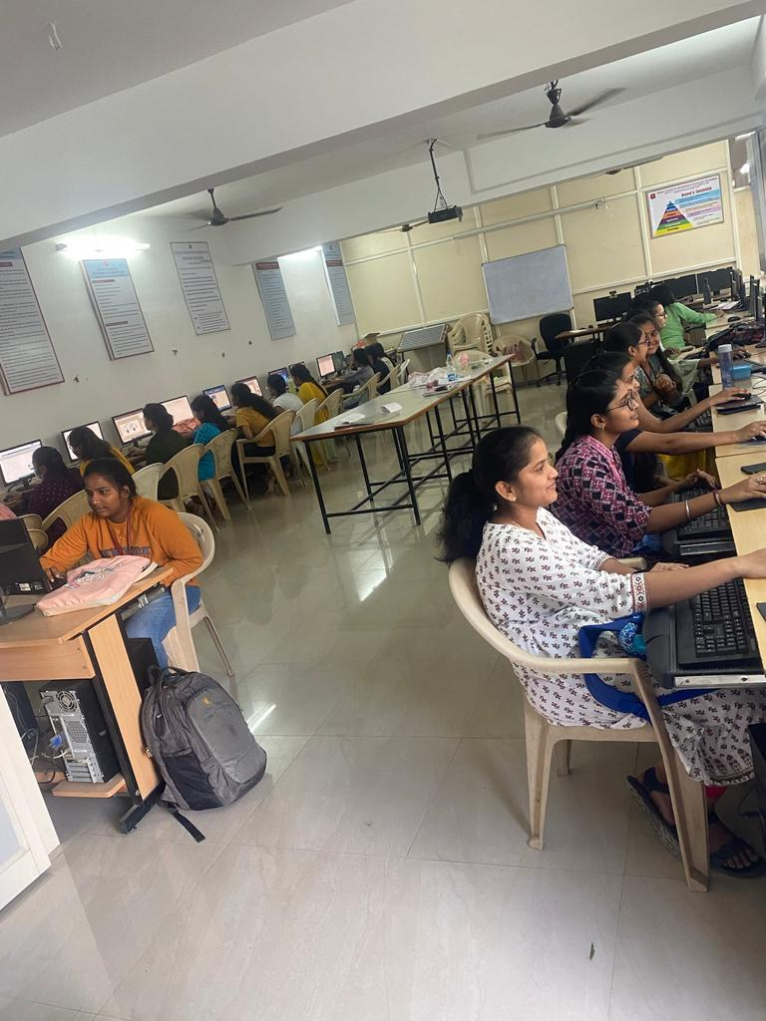

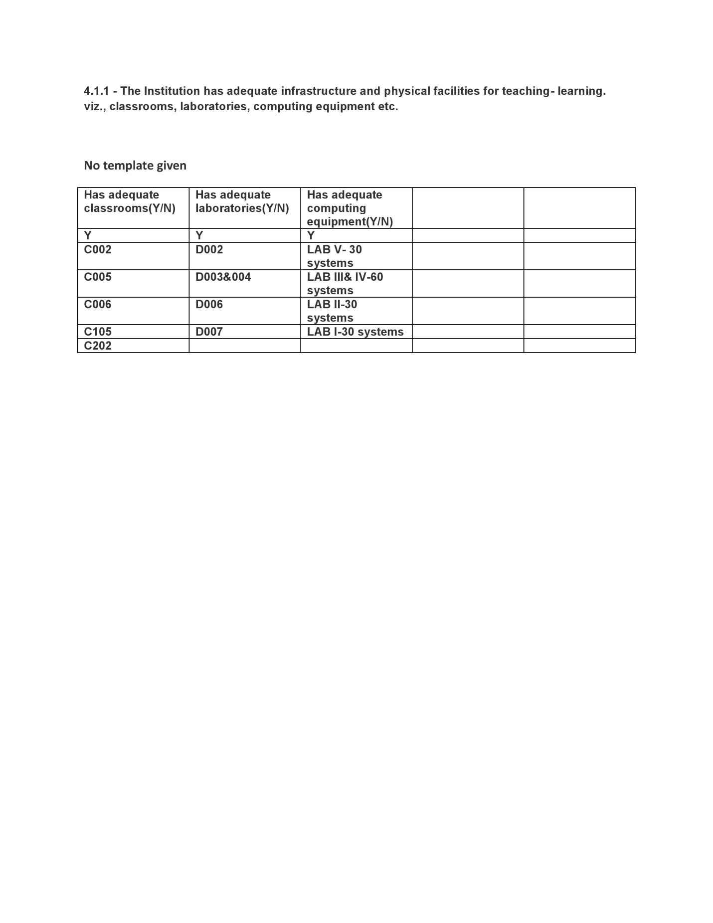

Criteria 4.1.1 - The Institution has adequate infrastructure and physical facilities for teaching- learning. viz., classrooms, laboratories, computing equipment etc.

Chemistry Laboratory
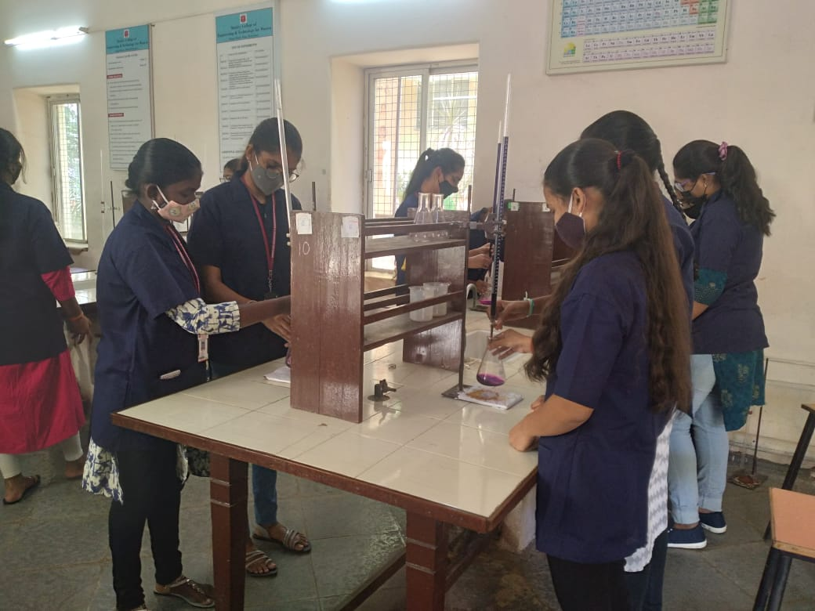
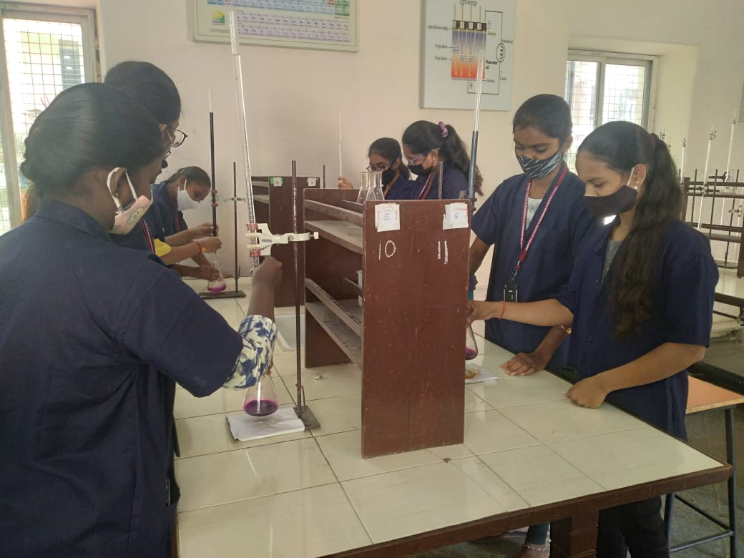

AutoCADD LAB

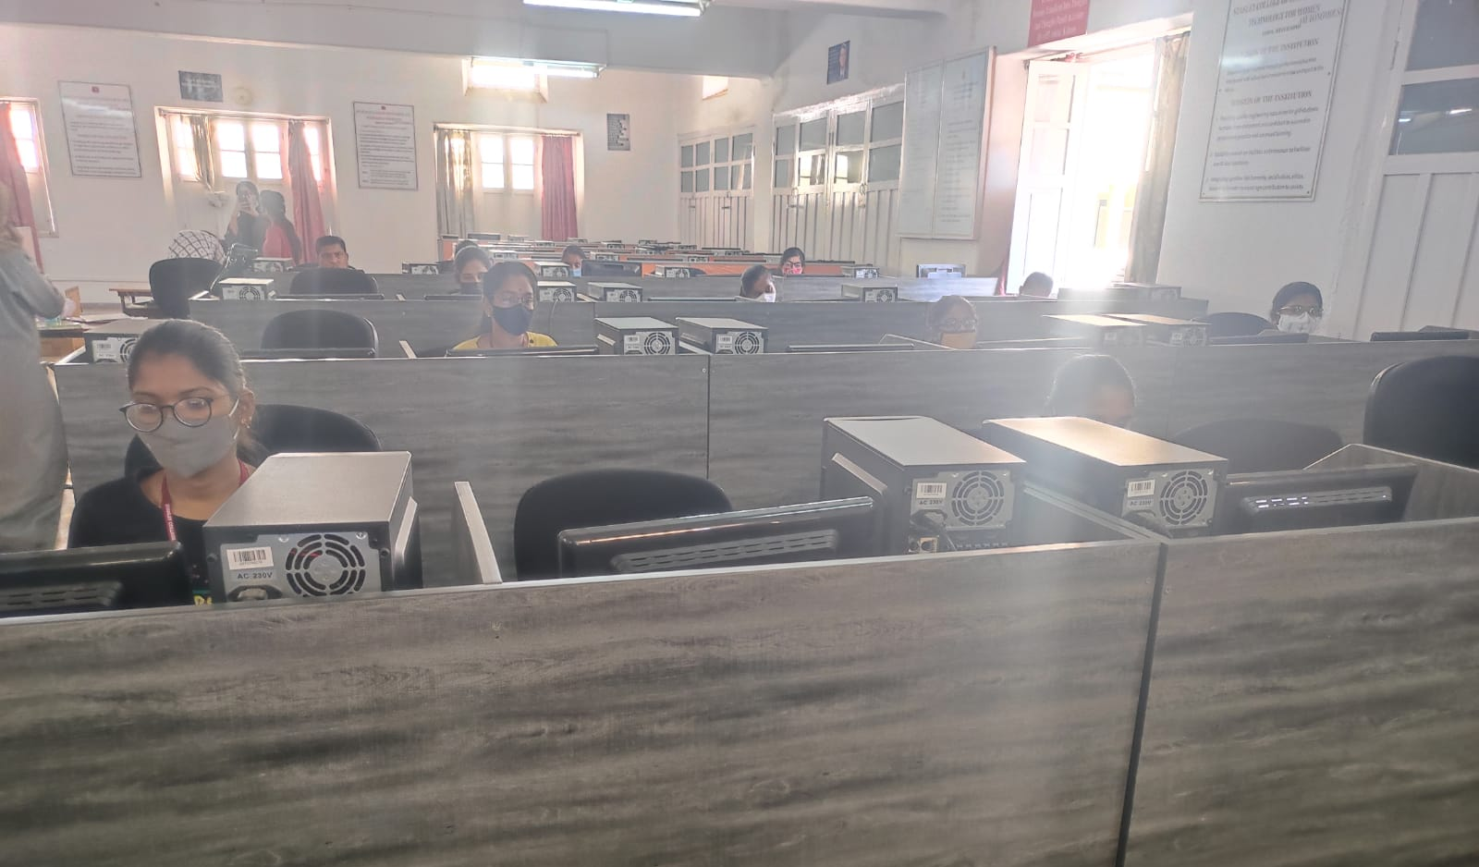
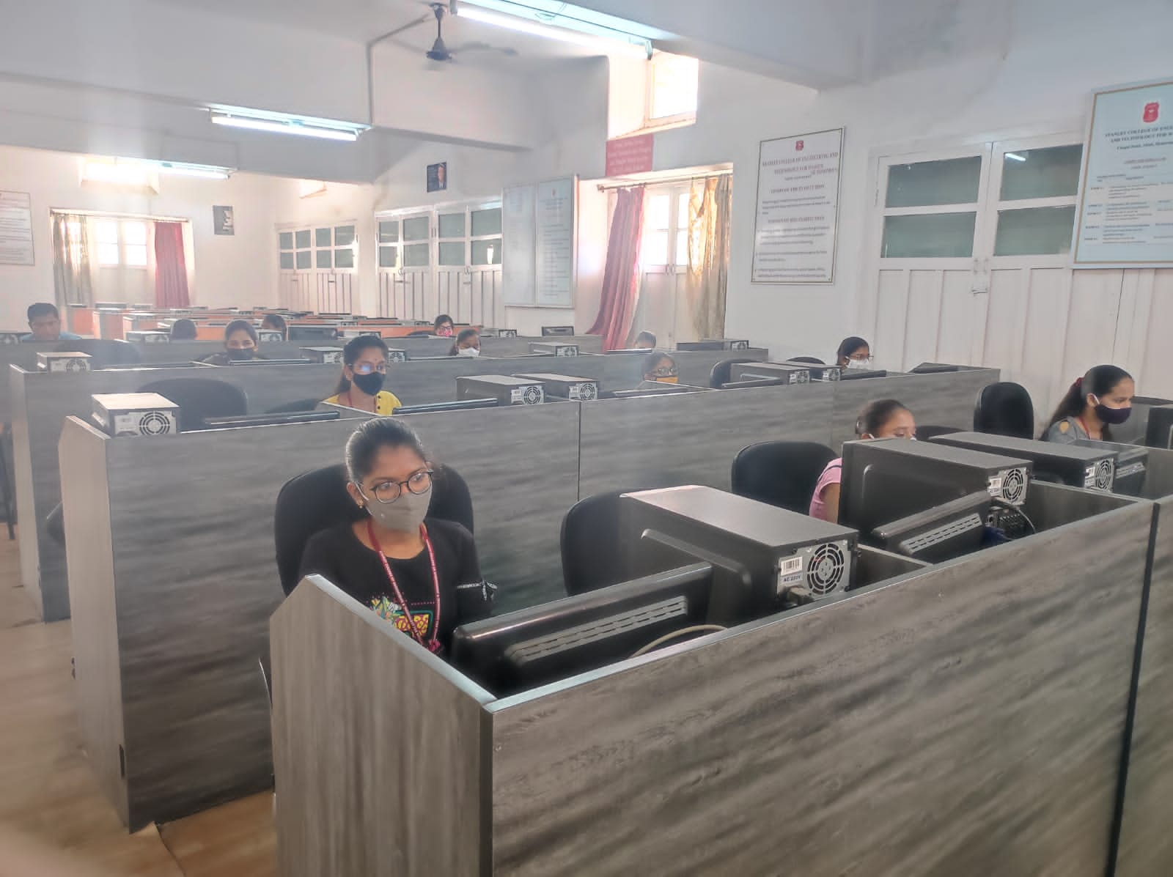

Communication Lab

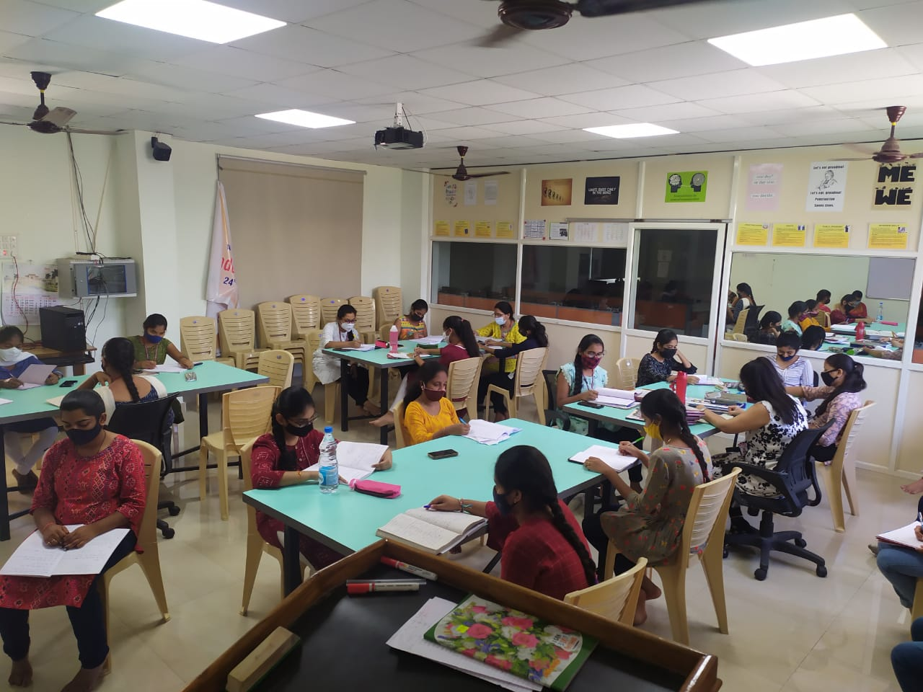

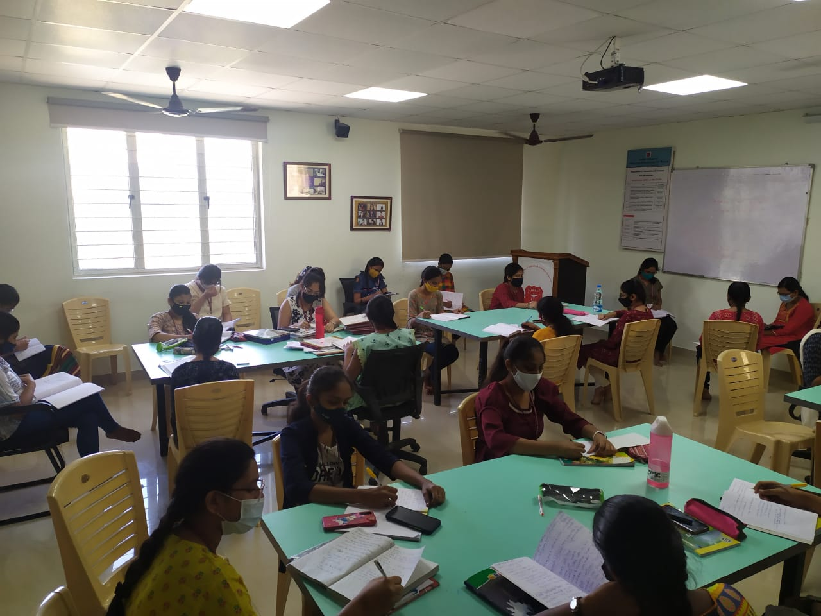

Big Blue Button
Big blue button is the online classroom platform that Stanley College has adapted from the time of pandemic. It’s a tool that allows an unlimited number of students to attend the classes.

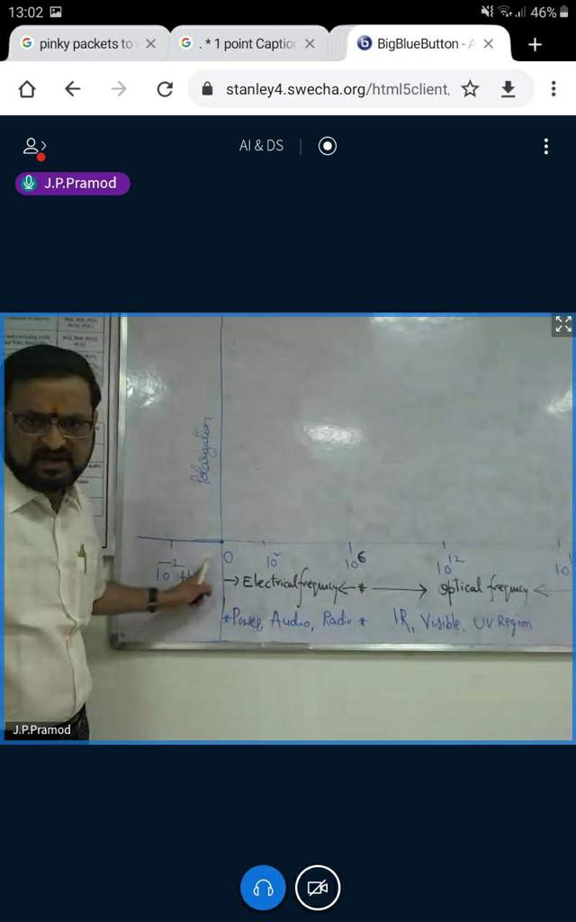

4.1.1 The Institution has adequate infrastructure and physical facilities for teaching- learning. viz., classrooms, laboratories, computing equipment etc.

