4.4.2 - There are established systems and procedures for maintaining and utilizing physical, academic and support facilities - laboratory, library, sports complex, computers, classrooms etc.
S. No. | Venue (Lab) | Room No | Area  (sq. cm) | No. of Systems
 | DSP LAB | D206 | 79 | 36
 | ES LAB/MPMC LAB | D207 | 41 | 41
 | PROJECT LAB | C206 | 71 | 34

SNo. | Facility | Description
1 | Systems | 111
2 | Internet | Wi-Fi to 100mbs VOIS COMMUNICATION LEASED LINE and 20mbs PIONEER LEASED LINE
3 | Server | 2 Centralized Servers
4 | Softwares | Open Source- Scilab, NG Spice, Octave,QUCS, Xilinx, Mentor Software, Matlab 9.2,MATLAB 8.3,Xilinx Vivado systems design suites software

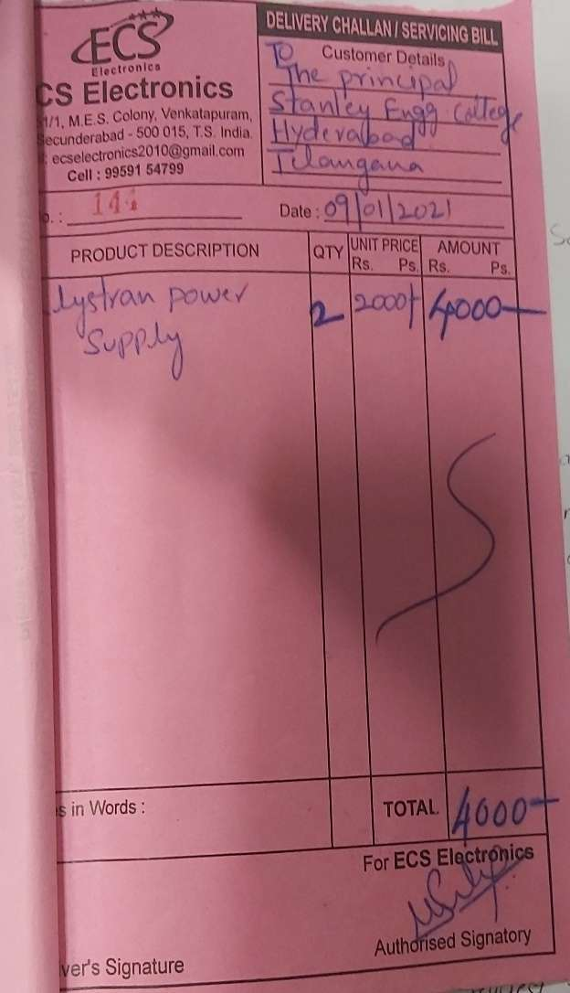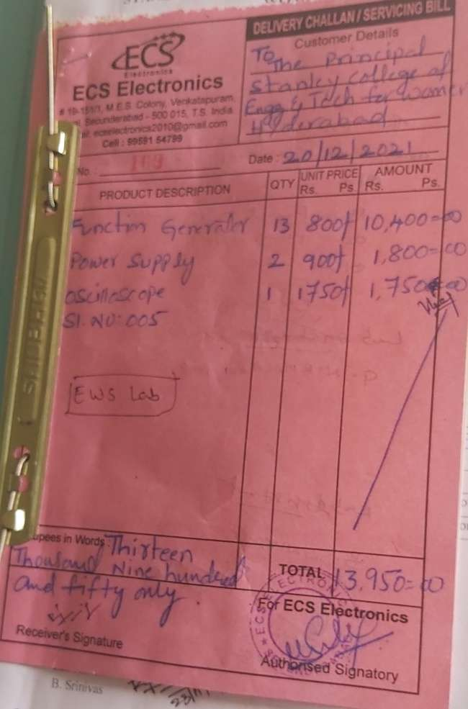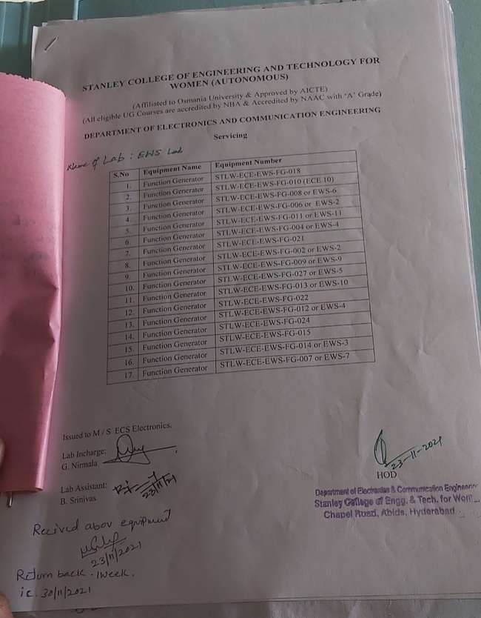

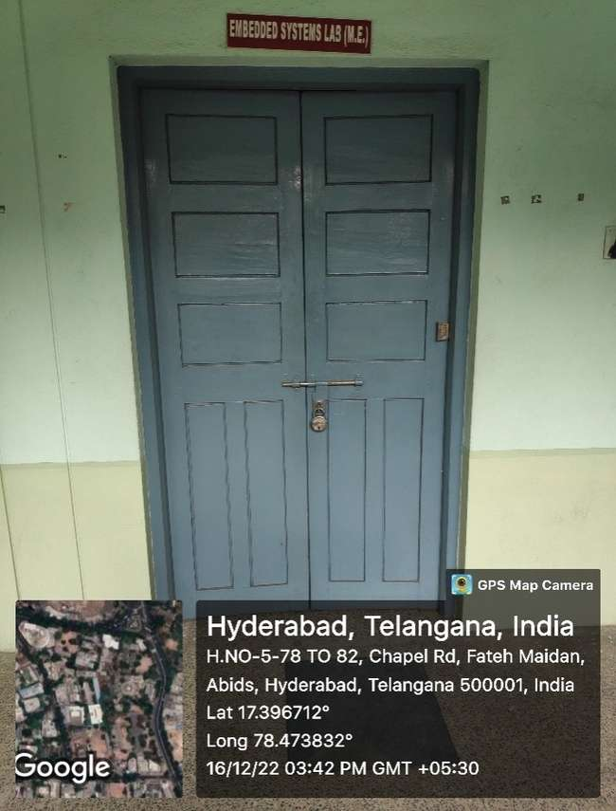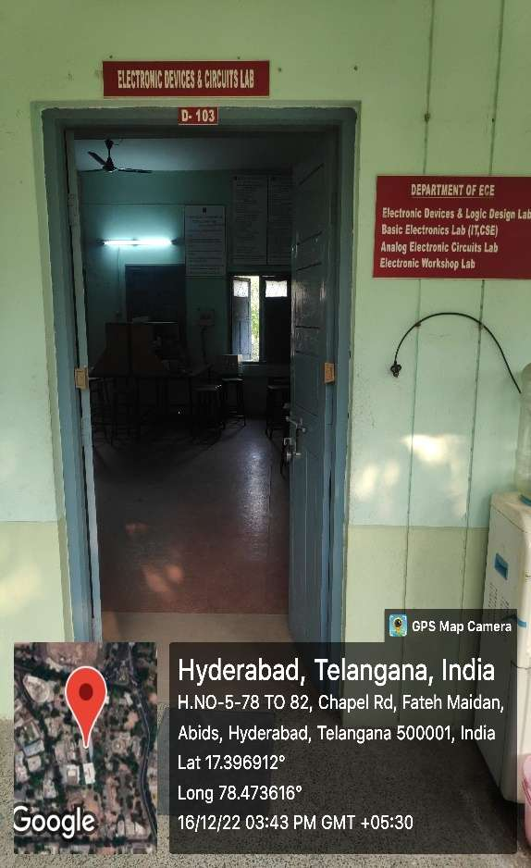
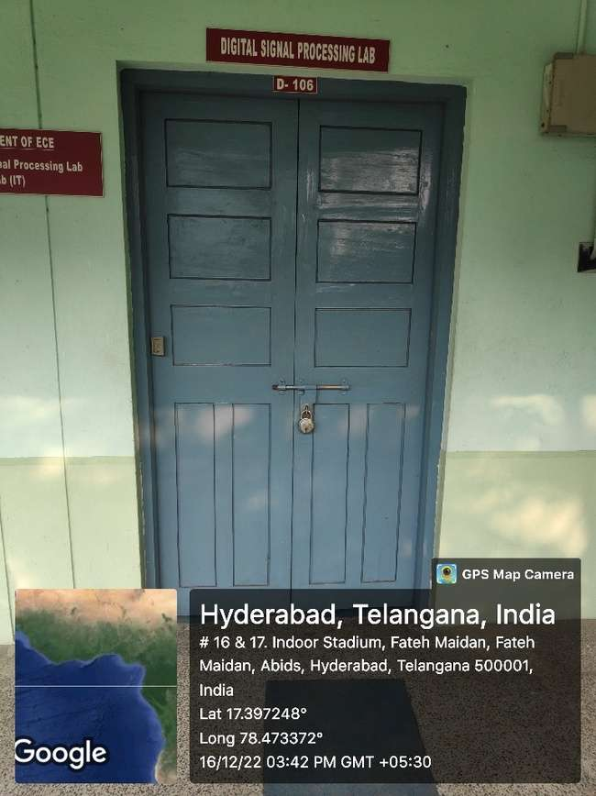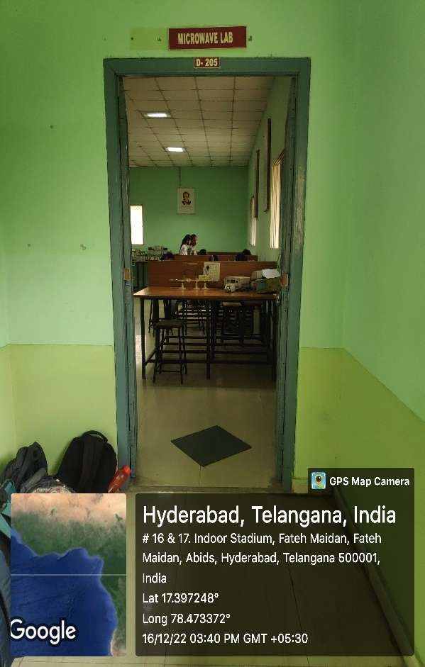

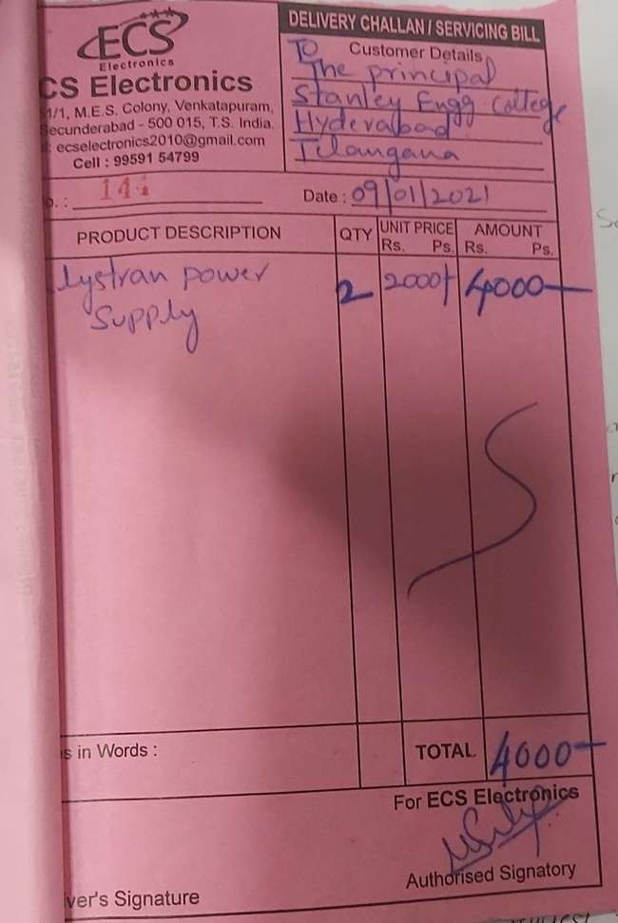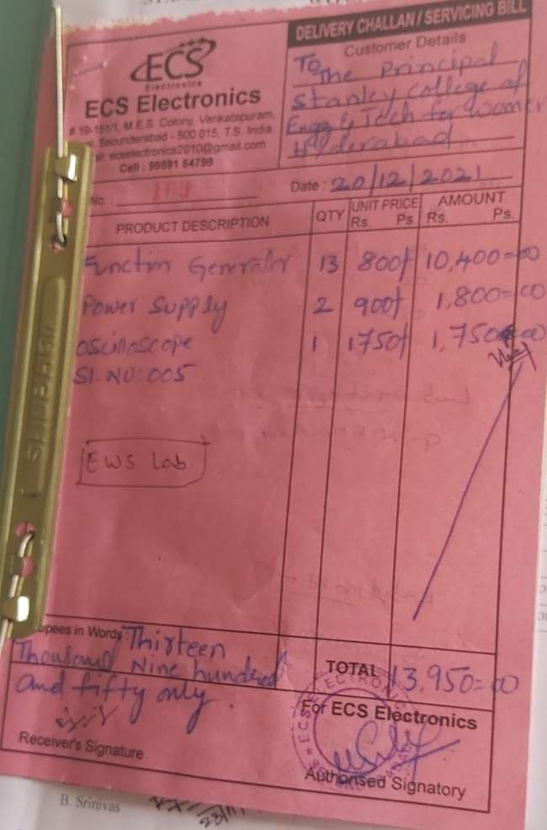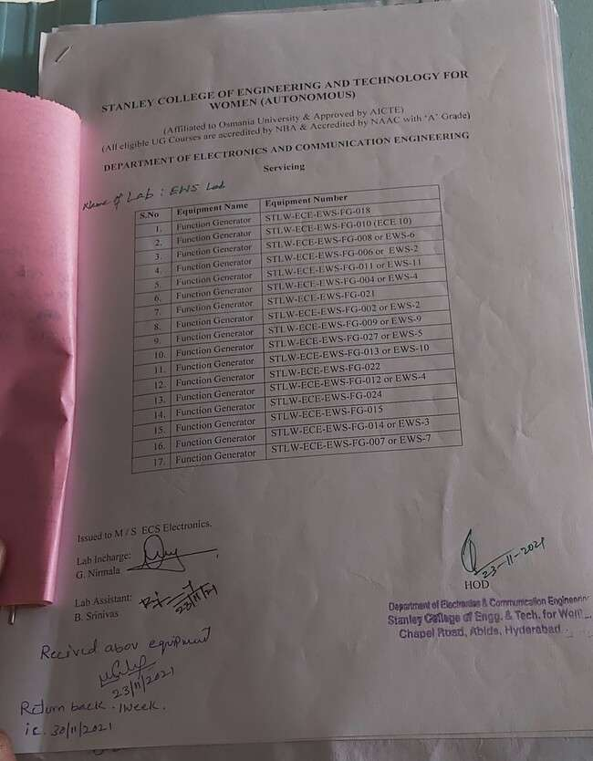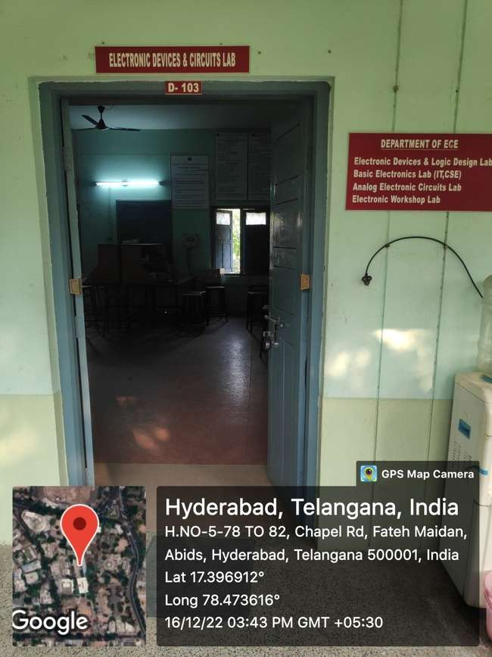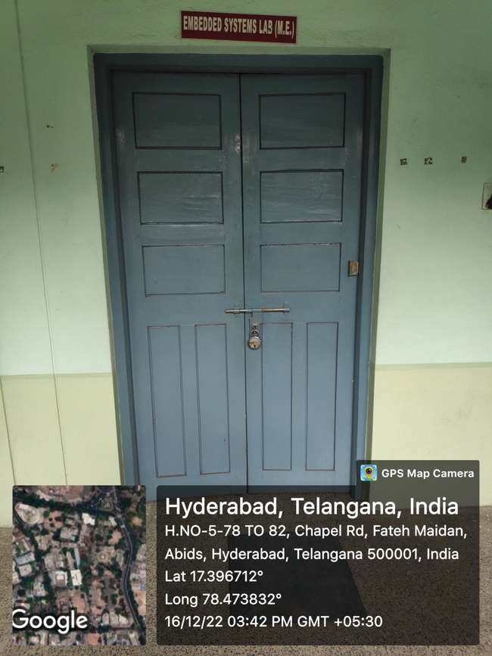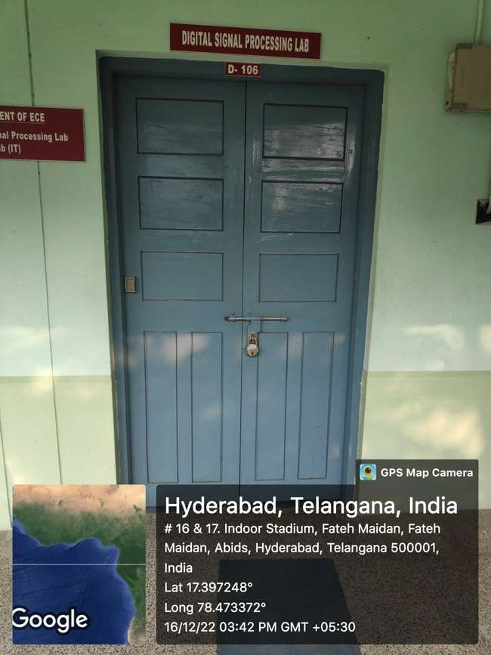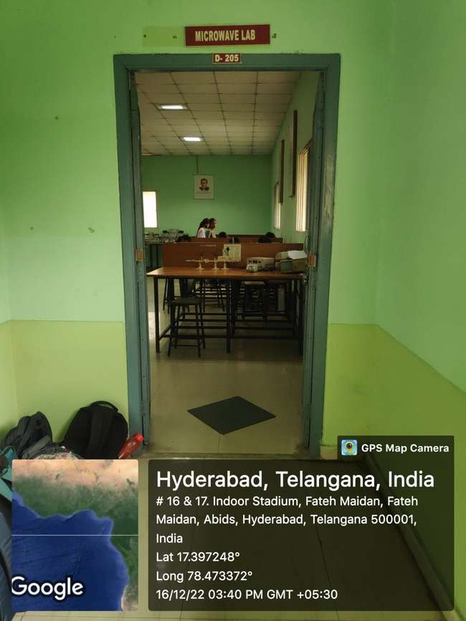

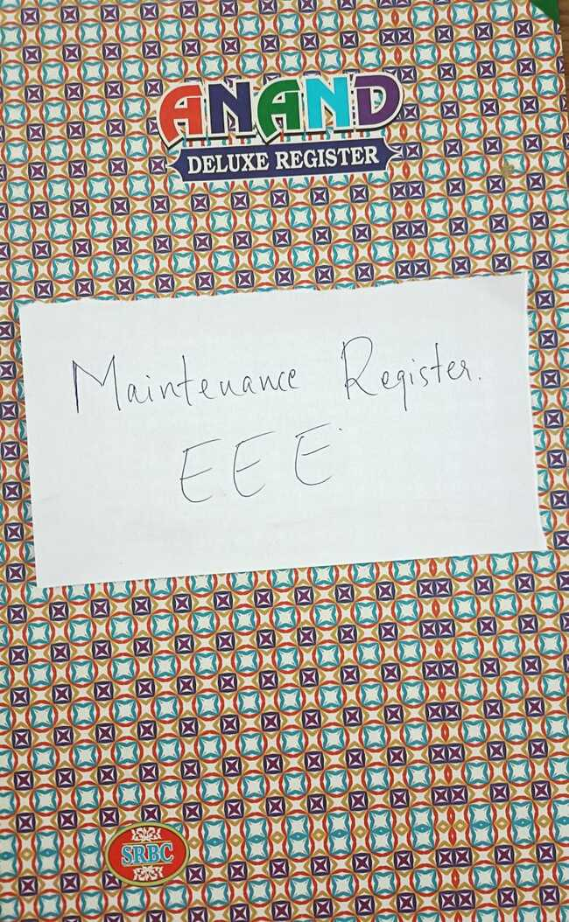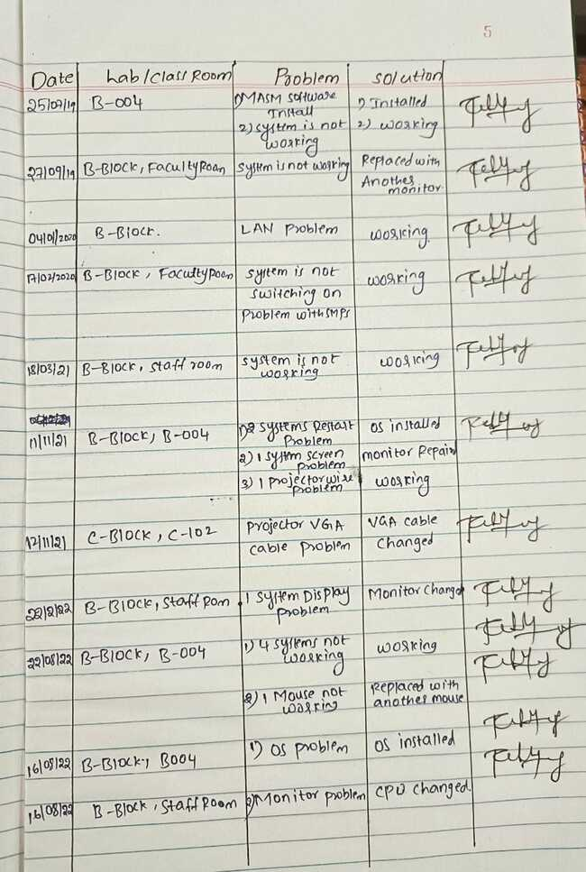

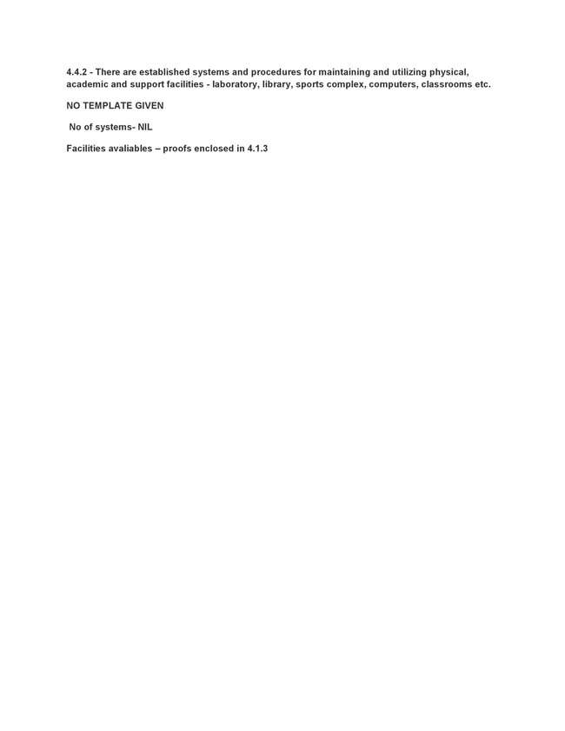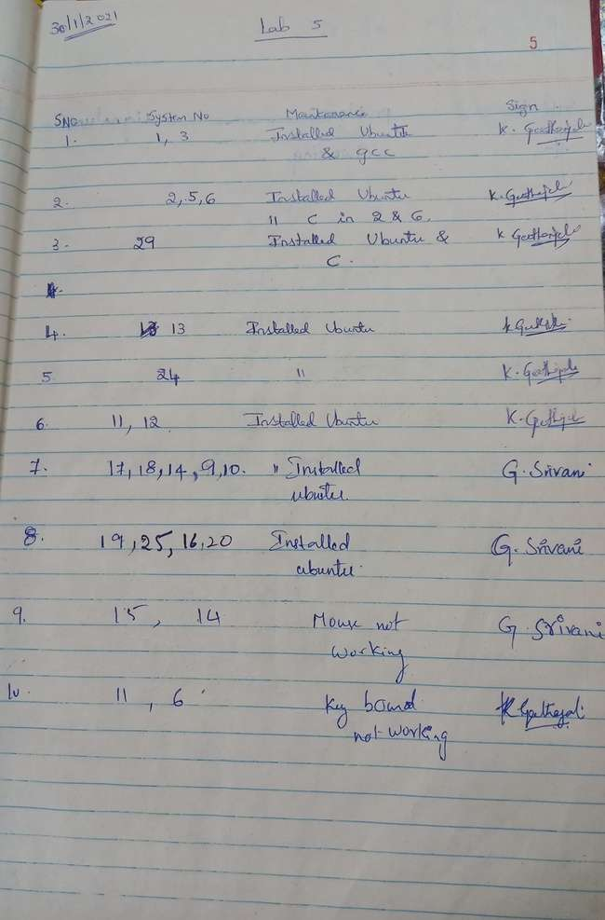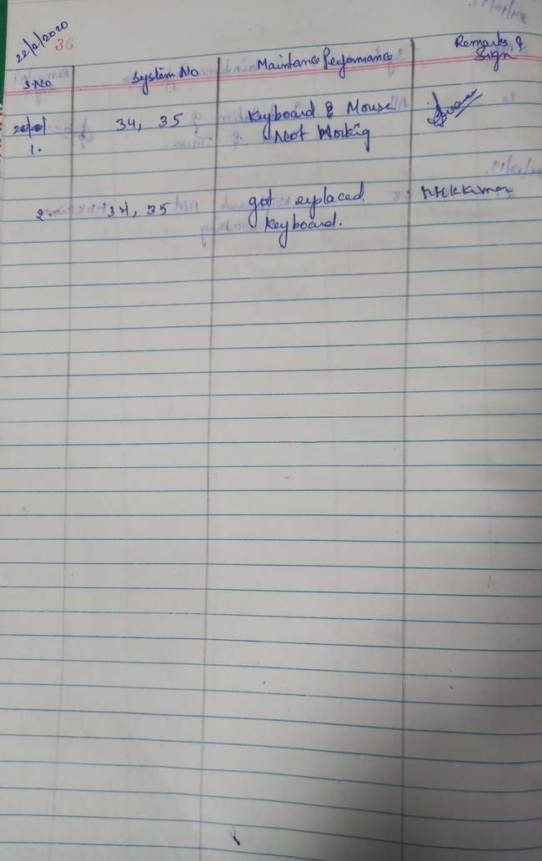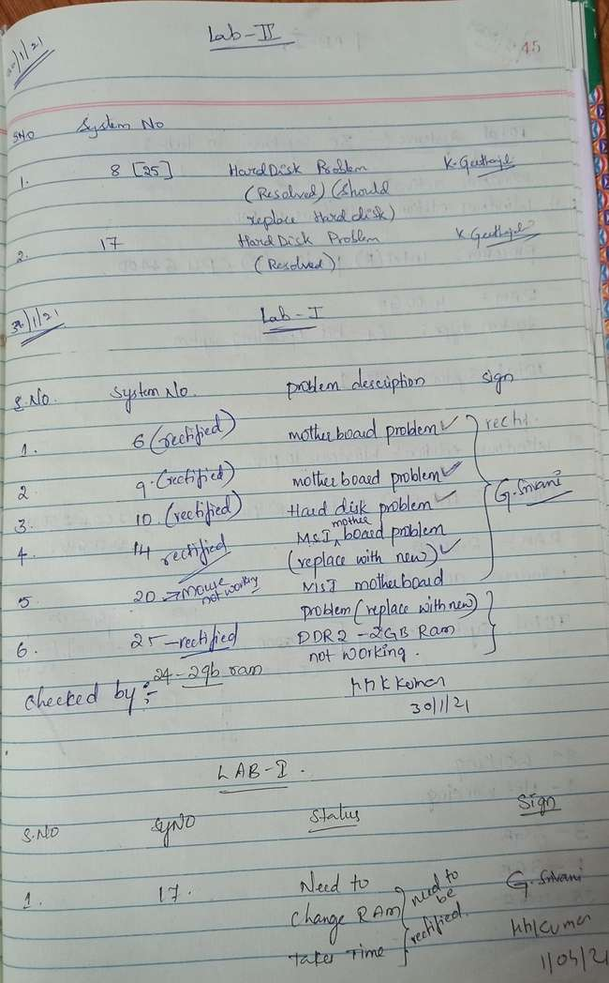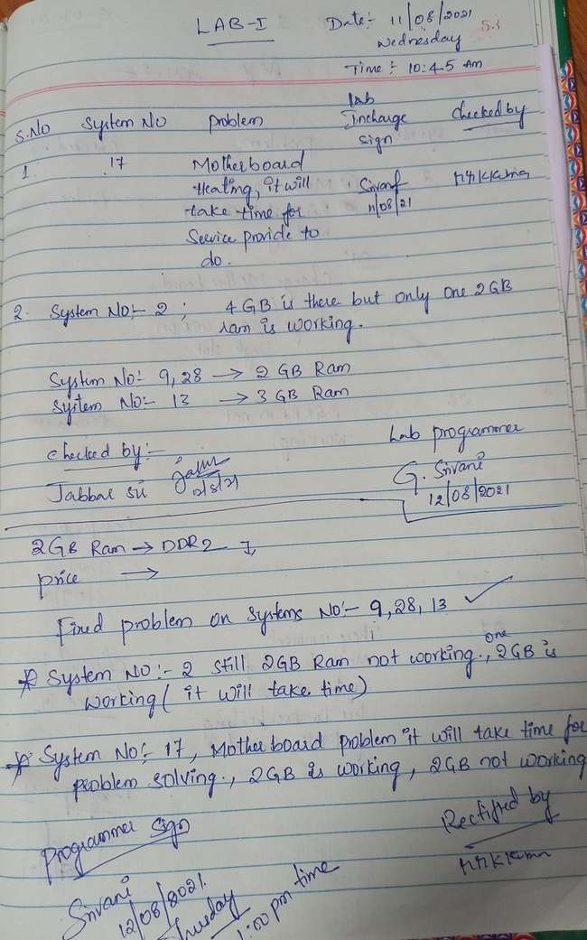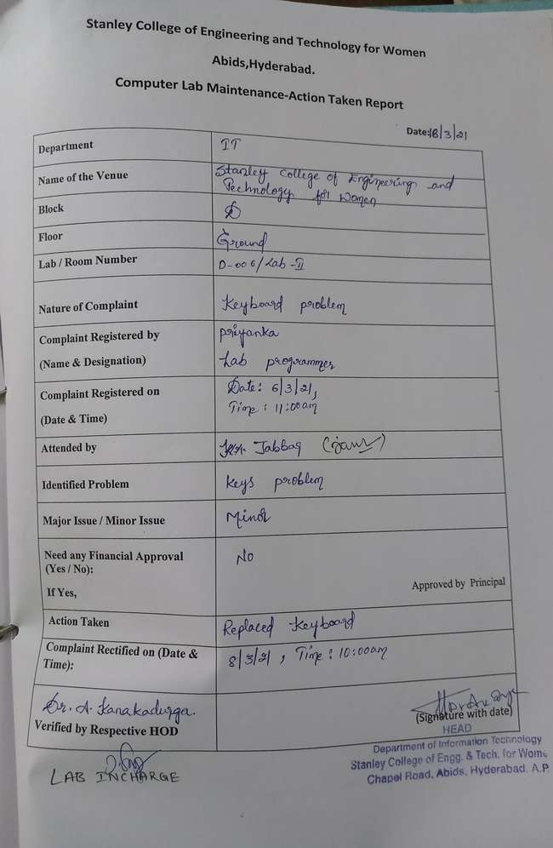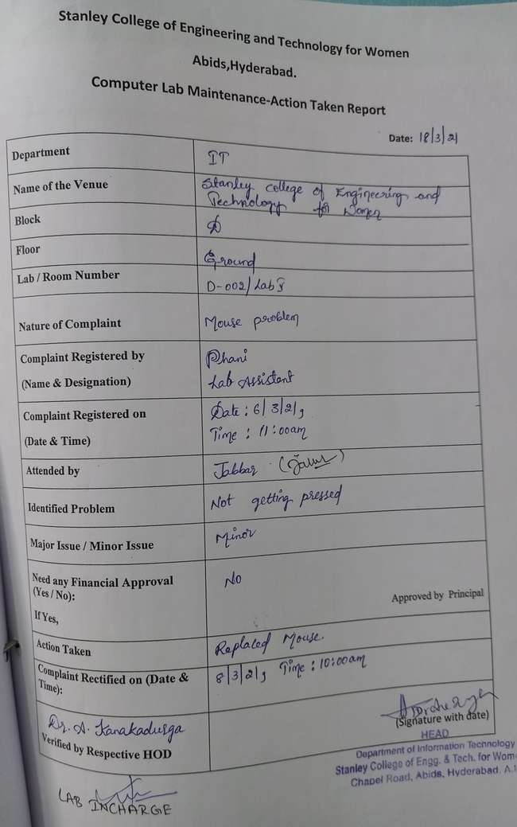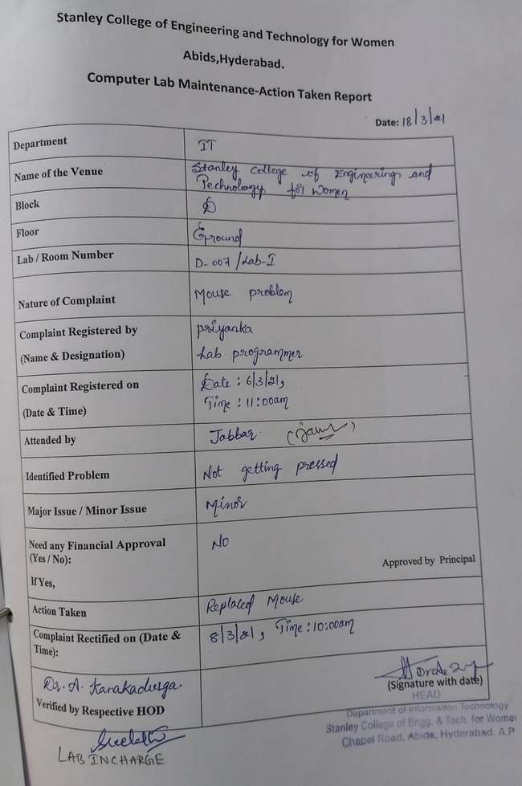
4.4.2 - There are established systems and procedures for maintaining and utilizing physical, academic and support facilities - laboratory, library, sports complex, computers, classrooms etc.
S.NO | Name Of The Laboratory | Area(sq.m)of each | Equipments Available
1 | Lab 1& 2  E- BLOCK | 66 sq.m | 60 Systems,60 Chairs, 1 UPS, 3 ACS, 10 Batteries, 2 Switches, 12 fans, 8 Lights,1 Tables,1 Projector Sheet

Lab Maintenance (2021-22)
S.no | Lab Name | System No | Issue | Date of reporting | Date of resolving
1 | 1&2 | 15,19 | 2 Mouses | 20-09-2021 | 20-09-2021
2 | 1&2 | 35 | SMPS | 01-09-2022 | 06-09-2022
3 | 1&2 | 4,7,10,13,18,21,22,27,33 | 9 Mouses | 27-06-2022 | 27-06-2022
4 | 1&2 | 61 Systems | RAM (DDR 8GB) | 04-11-2022 | 14-11-2022
5 | 1&2 | 18 Systems | Systems Shifted to lab 1&2 from Lab 6&7 | 20-09-2022 | 29-09-2022
6 | 1&2 | 4 Systems | New Systems(Acer Veriton) | 15-06-2022 | 13-09-2022

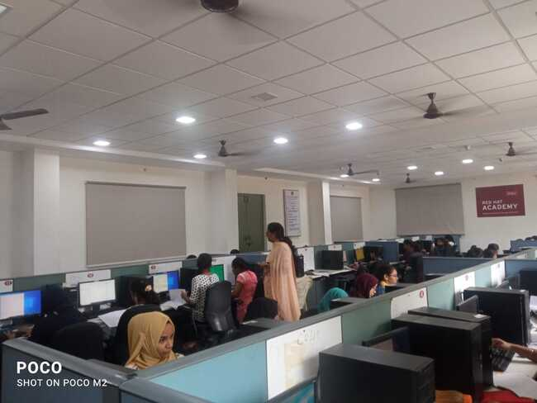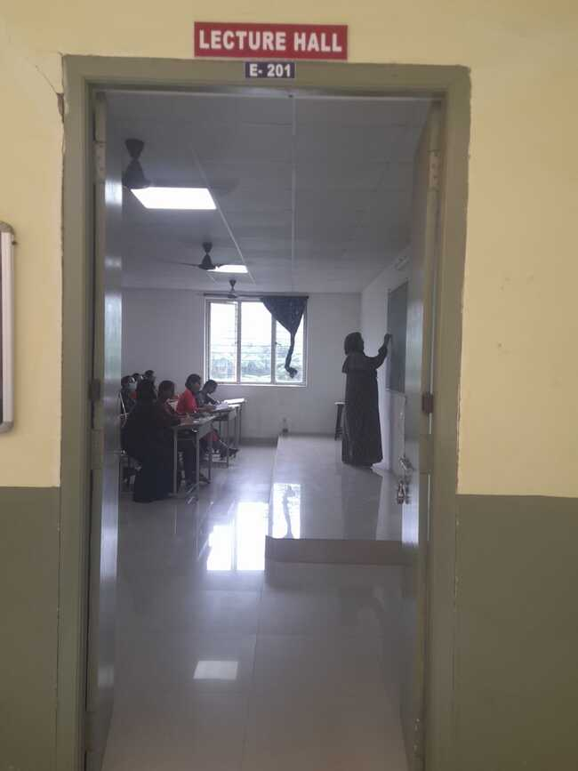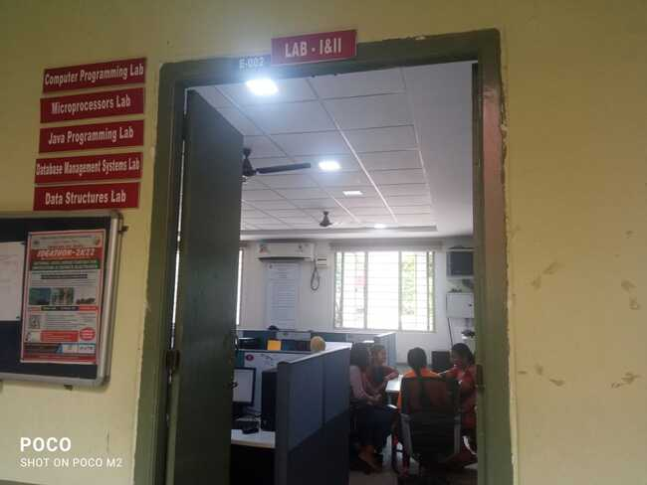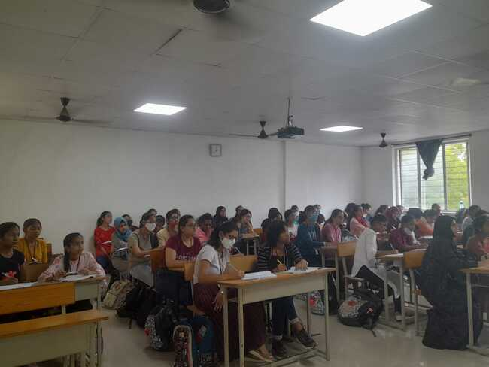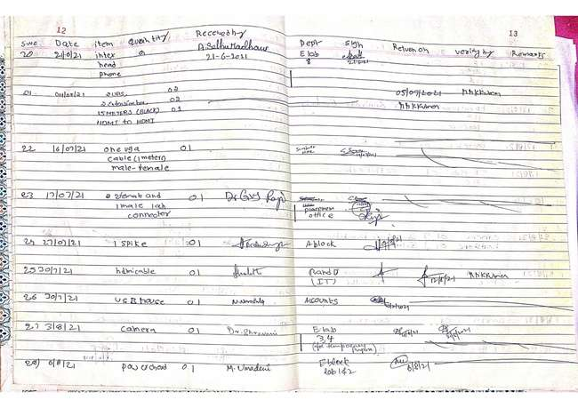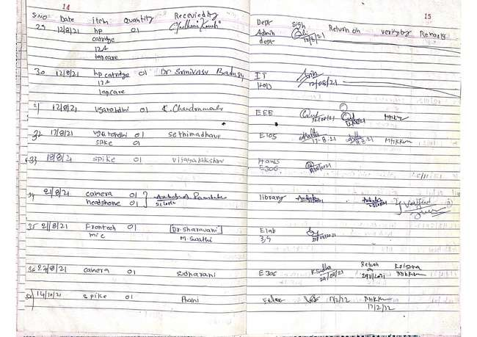

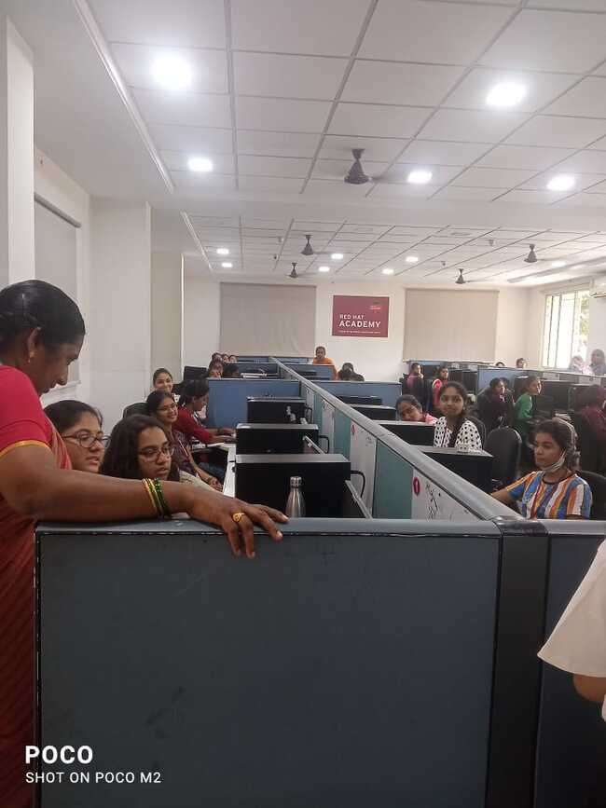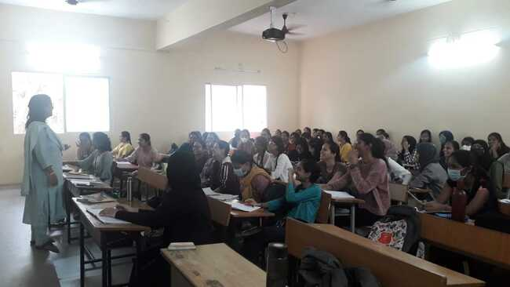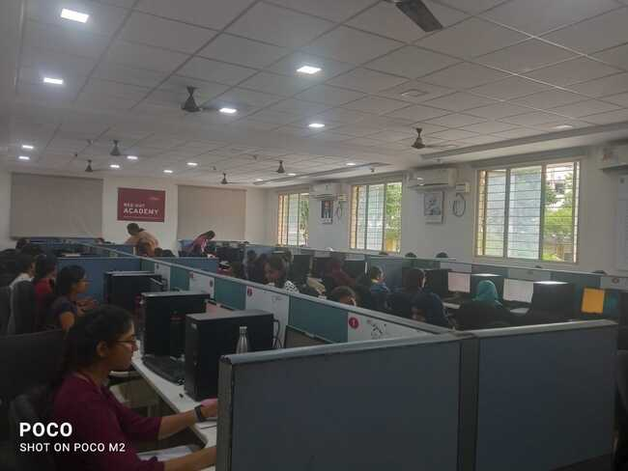

Criteria 4.4.2 - There are established systems and procedures for maintaining and utilizing
physical, academic and support facilities - laboratory, library, sports complex, computers,
classrooms etc.

The institution has an in-house team for the maintenance and replacing of computers, projectors and other technical infrastructures. A faculty or head of the department can register the issue on the complaint register and the concerned authority rectifier the same. Dr. Manivannan looks after the communication and electronic aids (network systems, technological analysis, purchase and replacement, passwords etc,) Mr. G. Srinivas looks after the hardware devices requirements such as microphones, extension cables, projectors, speakers, electrical solutions etc. and Mr. Krishna for the technical and technological assistance and maintenance.

Complaint Register for Communications, Computers, internet issues

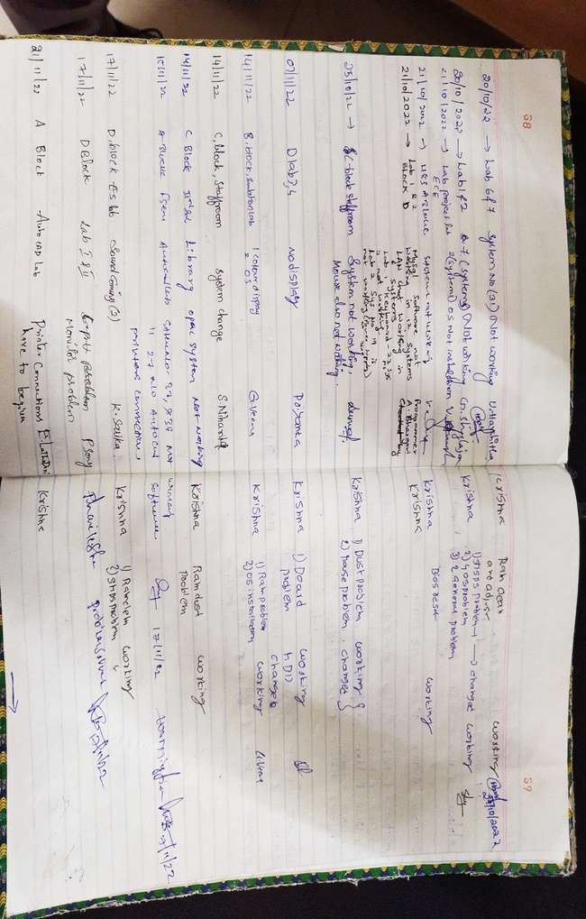

Electricity Maintenance Complaint Register

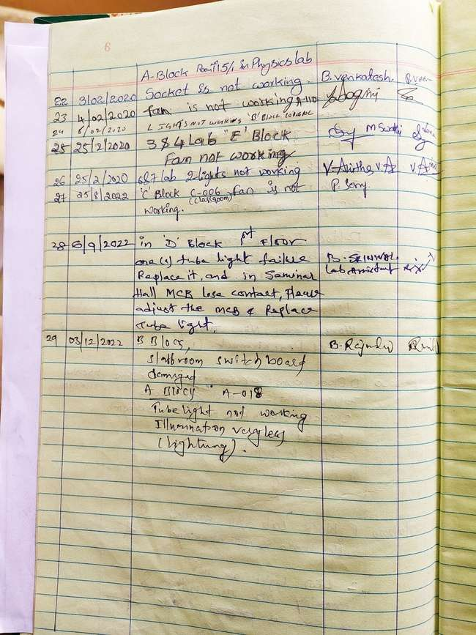
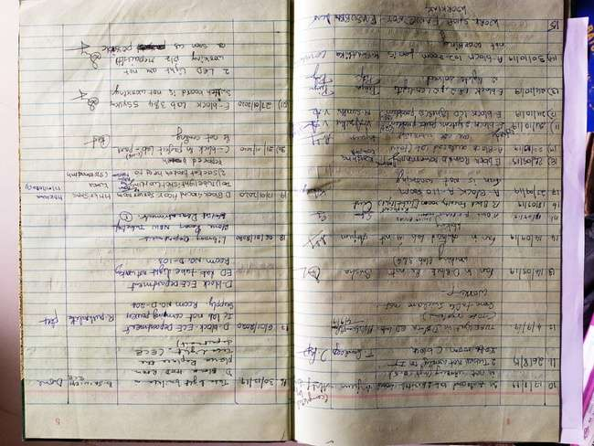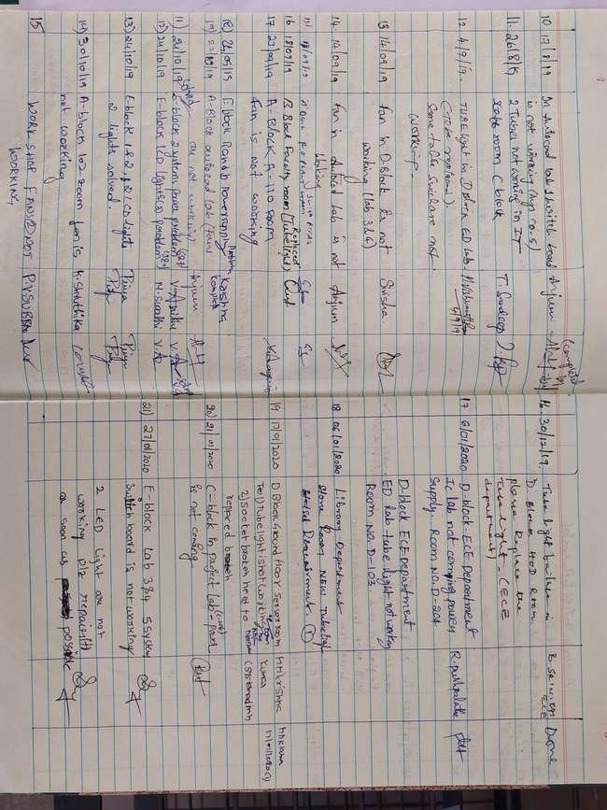

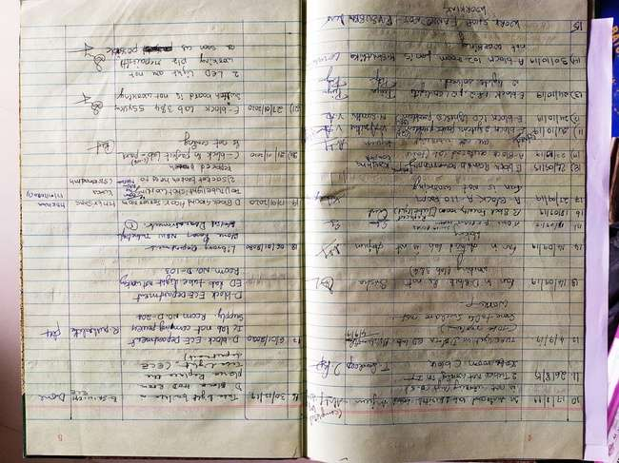

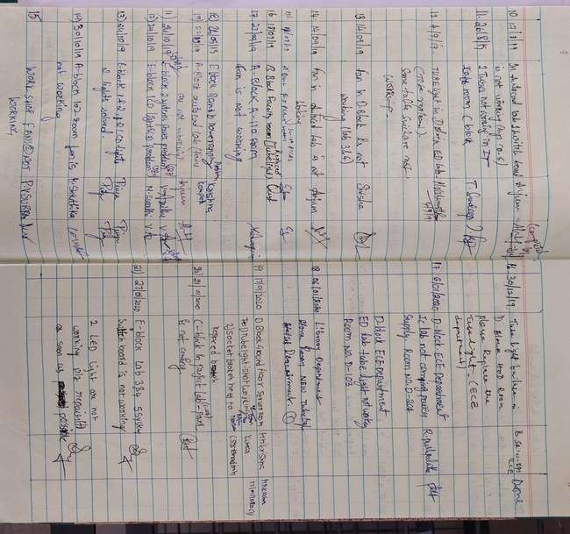

4.4.2 - There are established systems and procedures for maintaining and utilizing physical, academic and support facilities - laboratory, library, sports complex, computers, classrooms etc.
S. No. | Venue (Lab) | Room No | Area  (sq. cm) | No. of Systems
 | Auto CAD Lab | A117 | 120 | 70

SNo. | Facility | Description
1 | Systems | 70
2 | Internet | Wi-Fi to 100mbs VOIS COMMUNICATION LEASED LINE and 20mbs PIONEER LEASED LINE
3 | Server | 2 Centralized Servers
4 | Softwares | Auto CAD software

