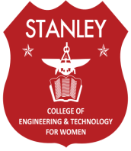
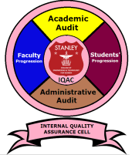
STANLEY COLLEGE OF ENGINEERING AND TECHNOLOGY FOR WOMEN
(Affiliated to Osmania University)
(Accredited by NAAC with “A” Grade, Accredited by NBA)
ABIDS, HYDERABAD- 500 001

INTERNAL QUALITY ASSURANCE CELL (IQAC)

VISION

To promote quality culture as the prime concern of Higher Education Institutions through institutionalizing and internalizing all the quality-enhancing and sustaining initiatives taken with internal and external support.

