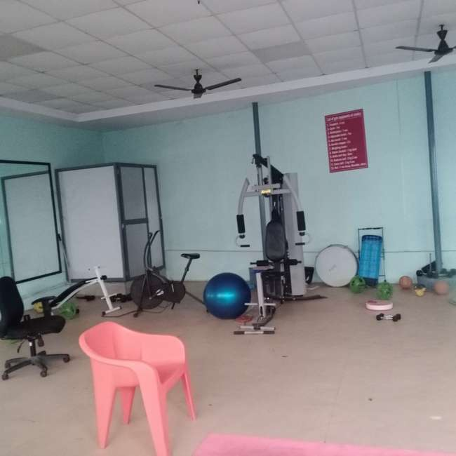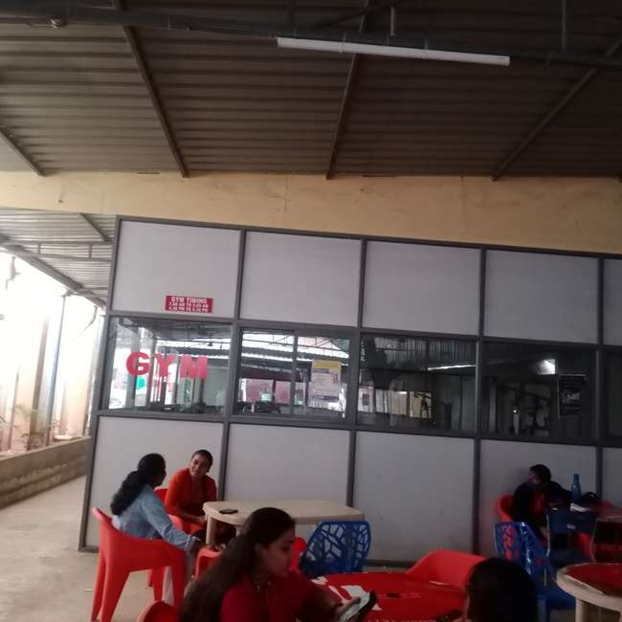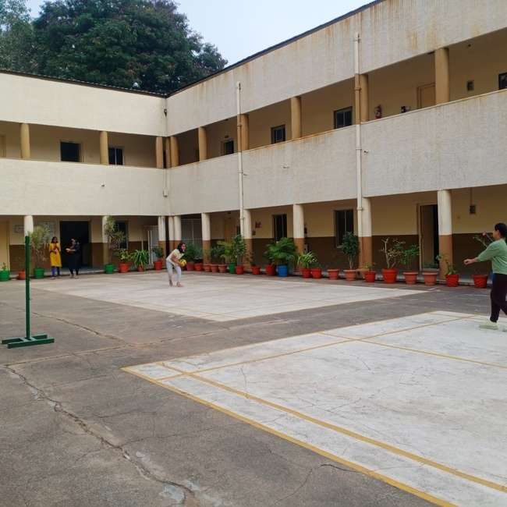

4.1.2 The Institution has adequate facilities for cultural activities, Sports, Games(Indoor, Outdoor),
Gymanasium, Yogacentre etc.

Date of event/activity (DD-MM-YY) | Name of the event/ cultural activity | Branch & Year | Name of the student participated
14/5/2022 | Annual Day –Dancing | ECEIII rd Year | Mokshita, Meghana
14/5/2022 | Annual Day –Sports Meet-Throwball | ECE III rd Year | P. Sai Keerthana
14/5/2022 | Annual Day –Classical Dancing | ECE III rd Year &IInd year | Varshaswi and group
14/5/2022 | Annual Day- Fashion Show | ECE IIIrd Year | Shree Poorna ,Sunidhi, Apoorva

MOKSHITHA AND MEGHANA Varshaswi and Group
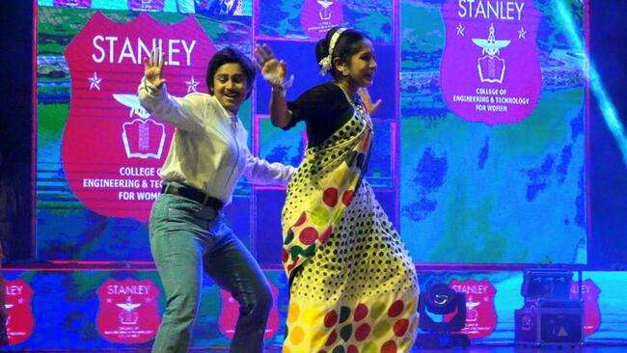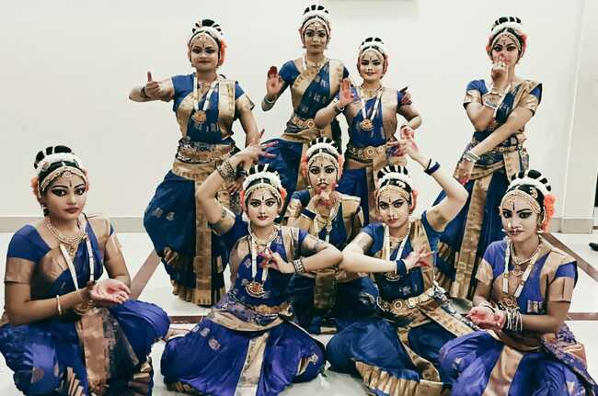

P. Sai Keerthana
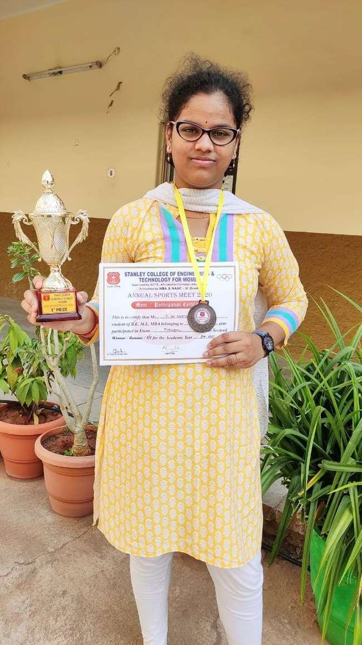
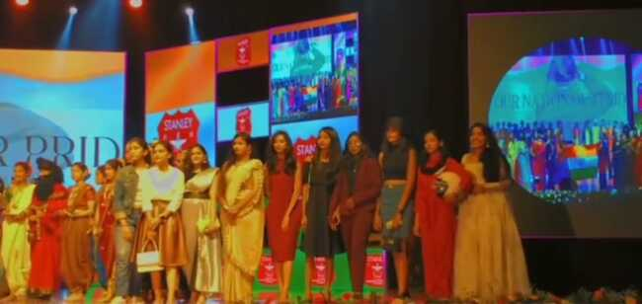

Stanley College of Engineering and Technology for Women

Chapel Road, Abids, Hyderabad – 500 001

Department of Electrical and Electronics Engineering
4.1.2 The Institution has adequate facilities for cultural activities, Sports, Games(Indoor, Outdoor), Gymnasium, Yoga Centre etc.

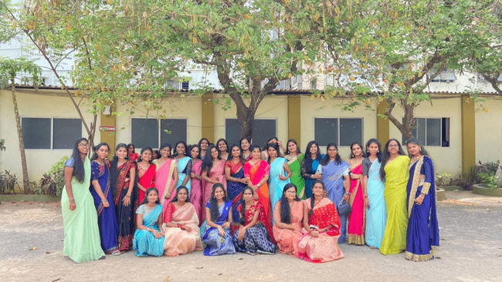

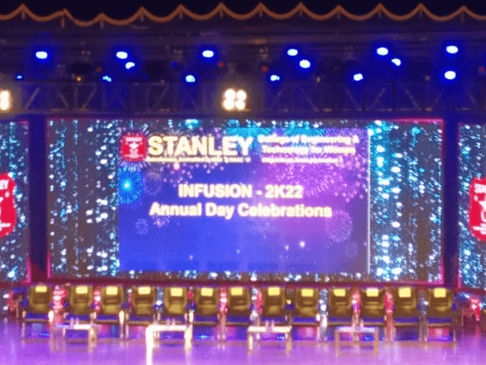
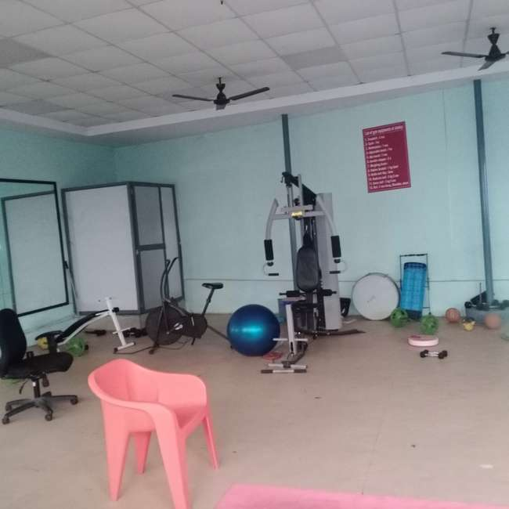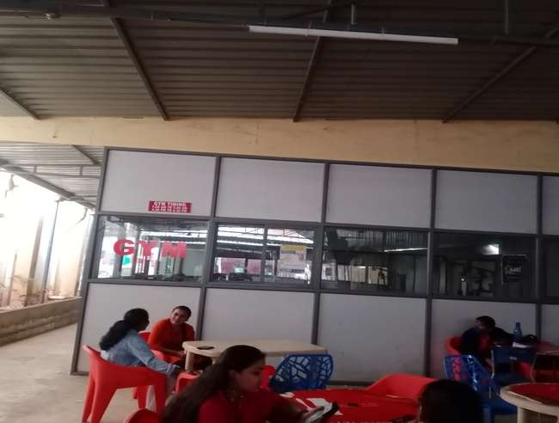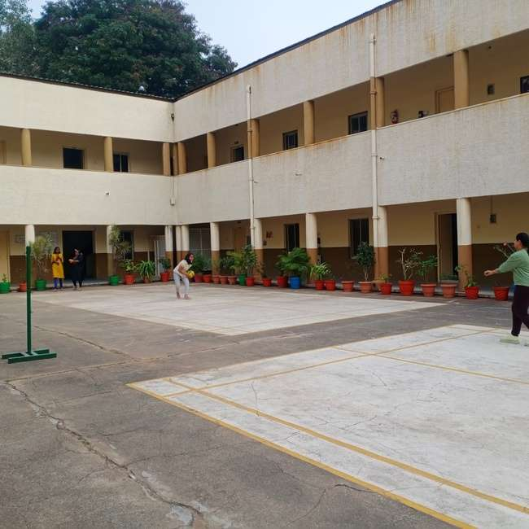

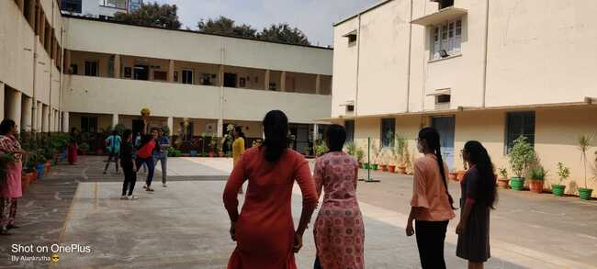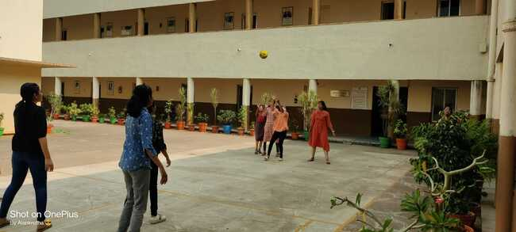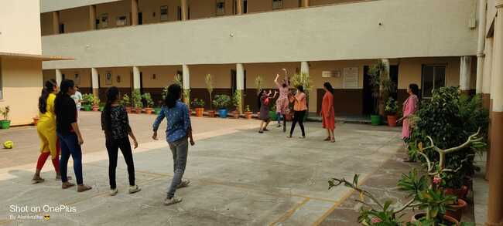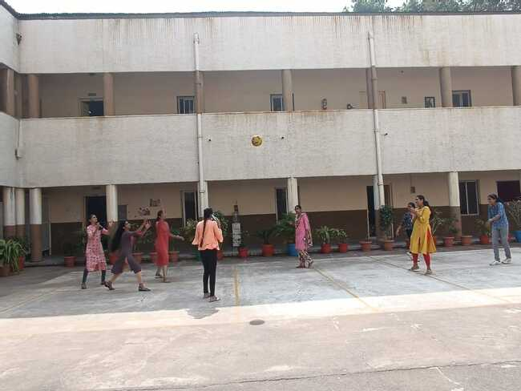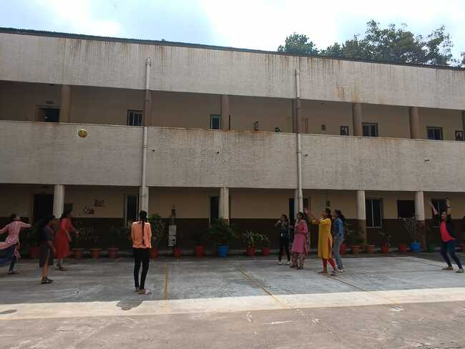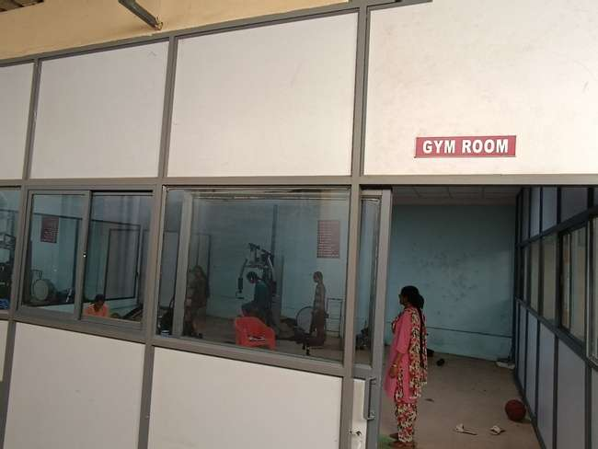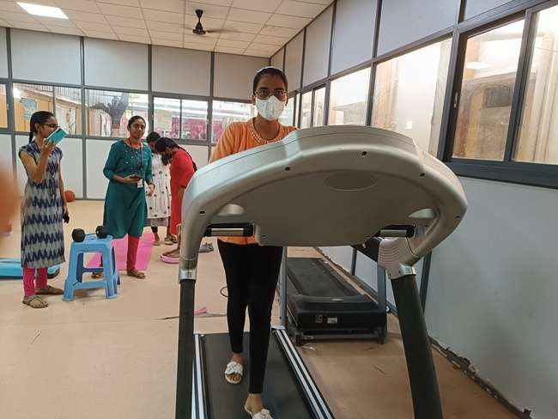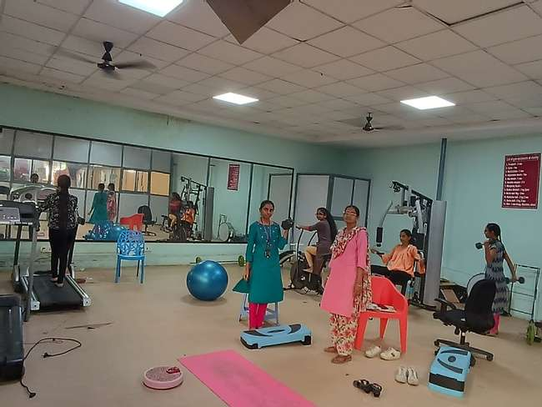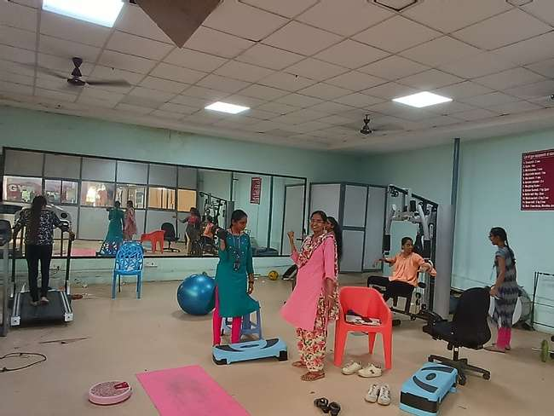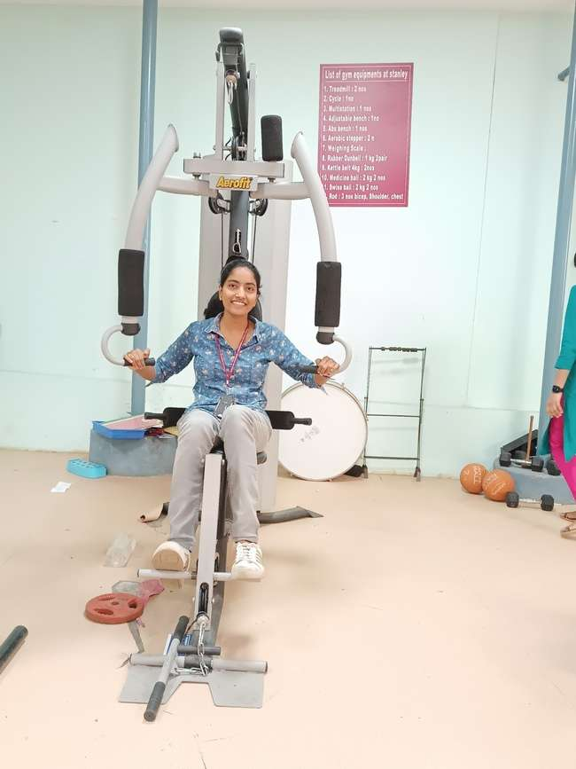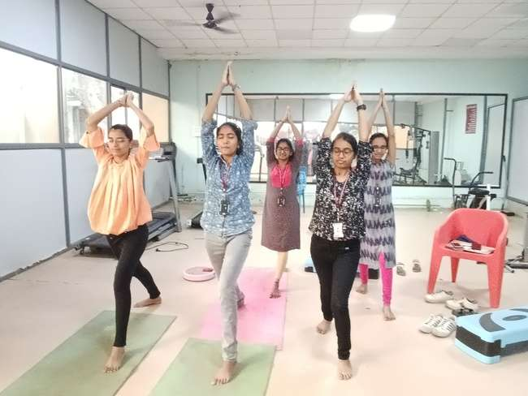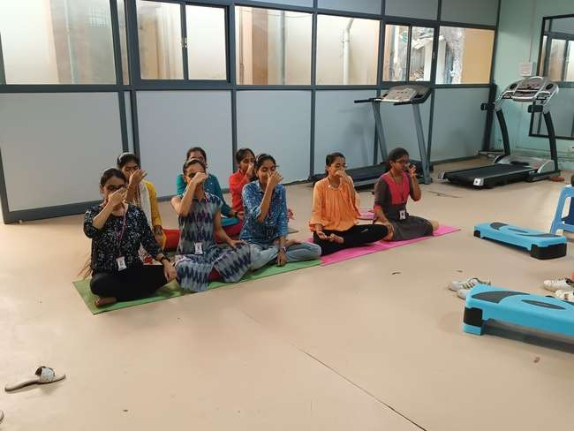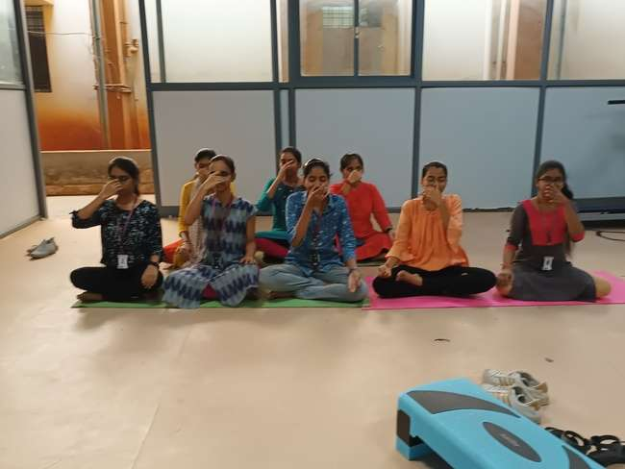

4.1.2 The Institution has adequate facilities for cultural activities, Sports, Games(Indoor, Outdoor),
Gymanasium, Yogacentre etc.

Date of event/activity (DD-MM-YY) | Name of the event/ cultural activity | Branch & Year | Name of the student participated
14-05-2022 | Annual Day –Guitar Performance | CME IInd Year | Lasya
14-05-2022 | Annual Day - Singing | CME III rd Year | Shreya
14-05-2022 | Annual Day - Dancing | CME III rd Year &IInd year | Ritika, Divya, Suvarsha, Tejaswi, Pranavi,P.Sameeksha  K.Shivani  M.Nikhitha  Darahasha  Anisha  Greeshma  VaahiniReddy.k
14-05-2022 | Annual Day- Fashion Show | CME II nd Year | Adhithi , maheshwari

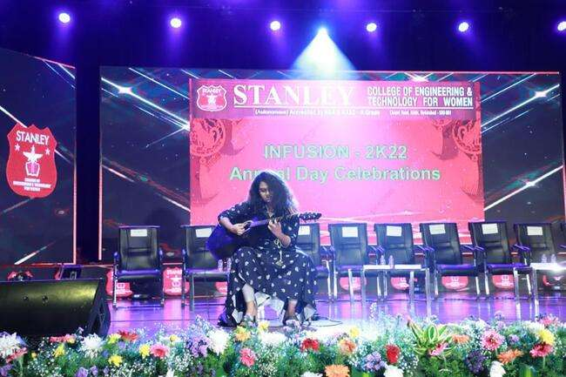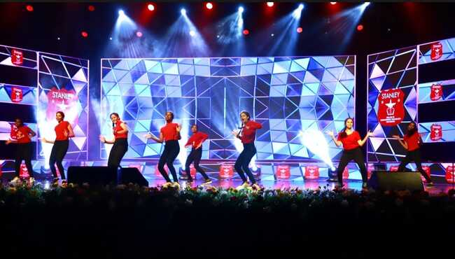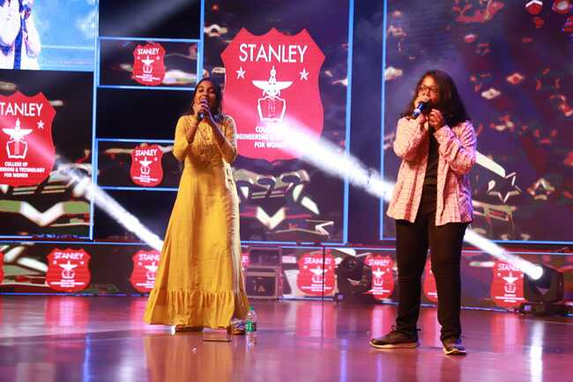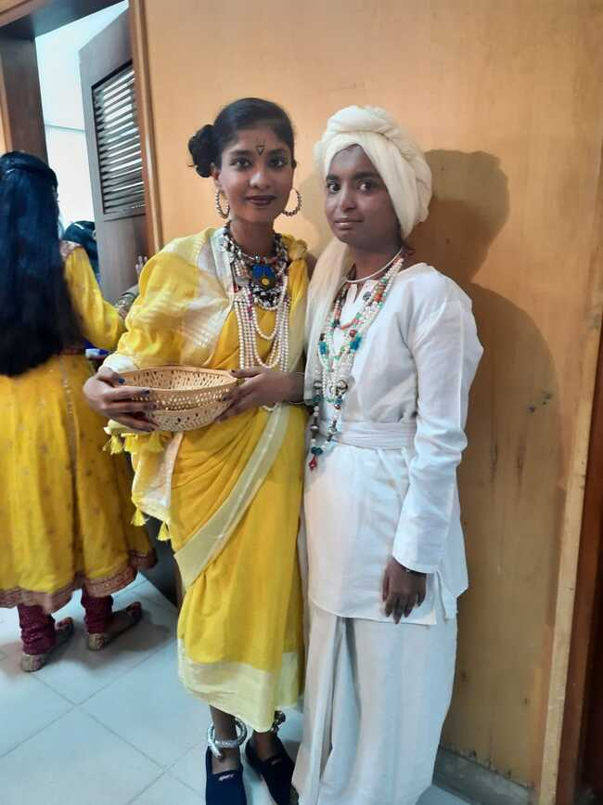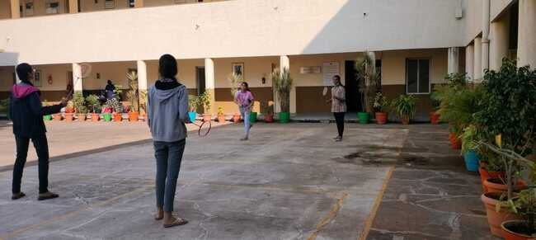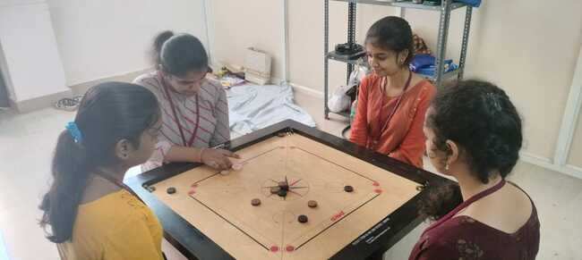
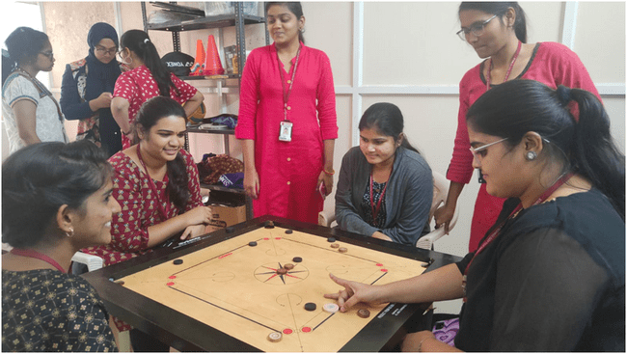

4.1.2 The Institution has adequate facilities for cultural activities, Sports, Games(Indoor, Outdoor),
Gymanasium, Yogacentre etc.

Date of event/activity (DD-MM-YY) | Name of the event/ cultural activity | Branch & Year | Name of the student participated
14/5/2022 | Annual Day –Guitar Performance | AI&DS II nd Year | Vagdevi
14/5/2022 | Annual Day - Singing | AI & DS II nd Year | Vagdevi
14/5/2022 | Annual Day - Dancing | AI & DS II nd Year | Sanjana
14/5/2022 | Annual Day- Fashion Show | AI & DS II nd Year | Afshaan

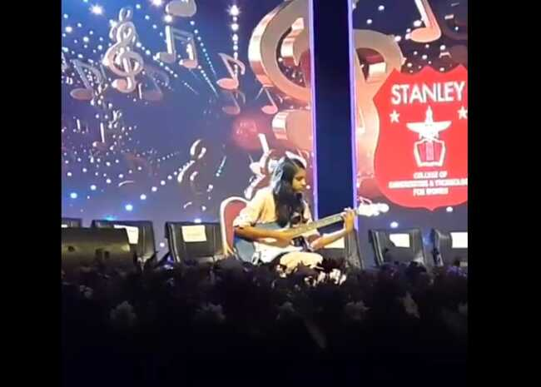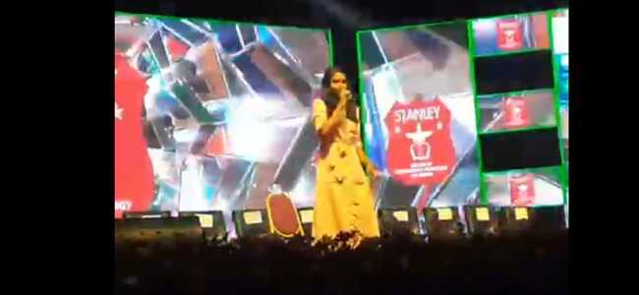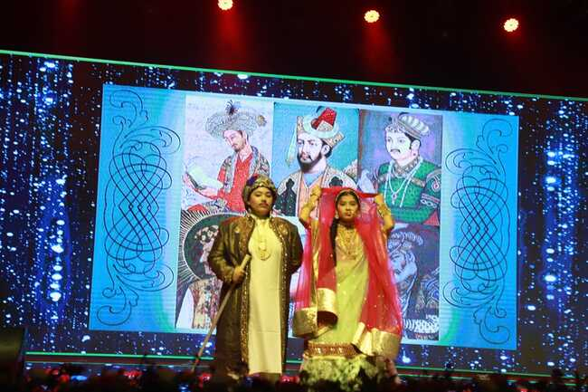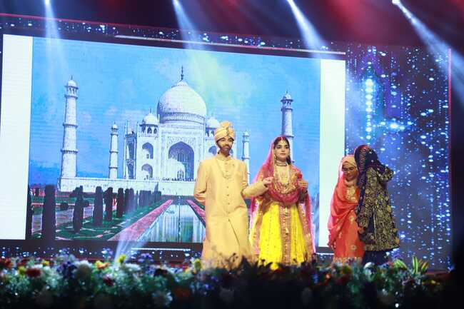

Criteria 4.1.2 - The Institution has adequate facilities for cultural activities,
sports, games (indoor, outdoor), gymnasium, yoga center etc.

Freshers’ Day Celebration
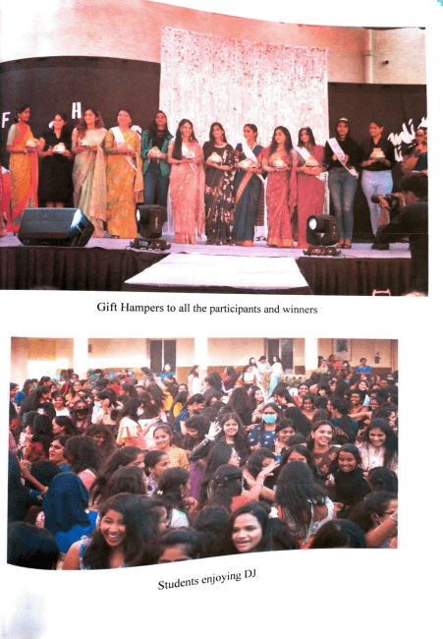
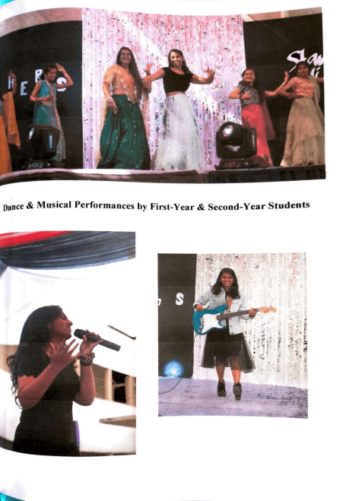
Christmas Celebrations
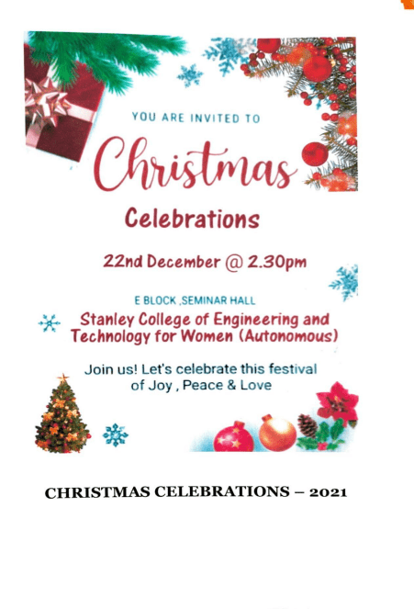
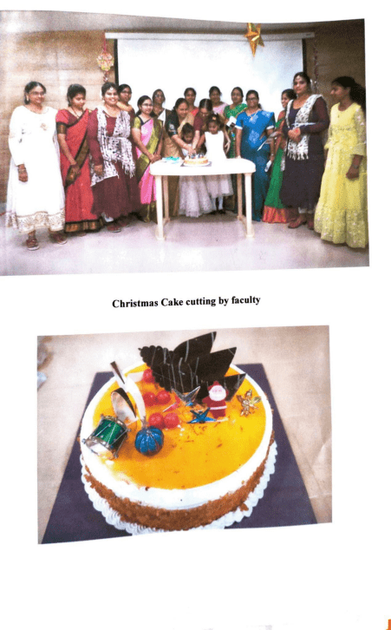
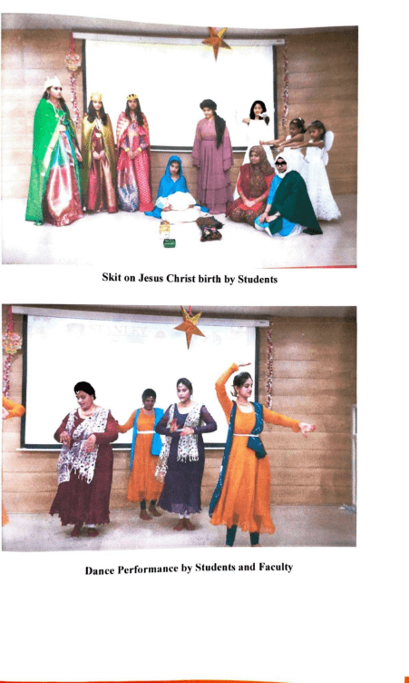
Traditional Day
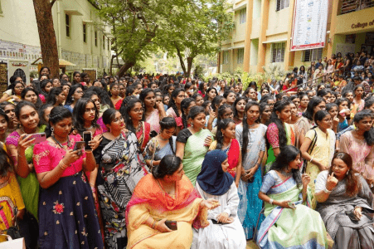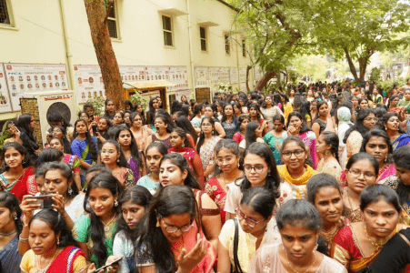
Sports
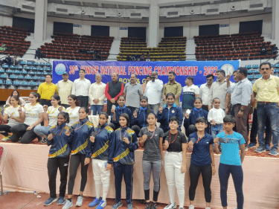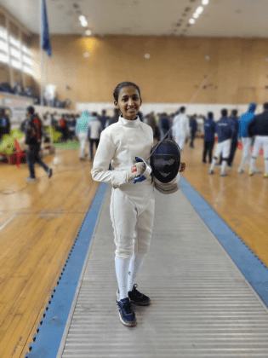

Annual Day Celebrations
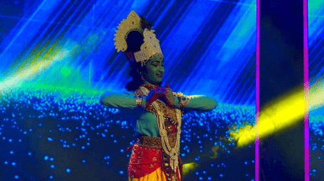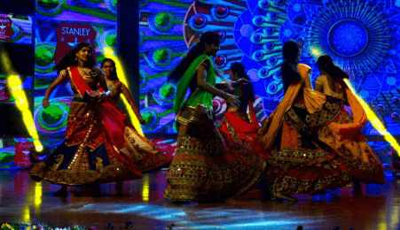
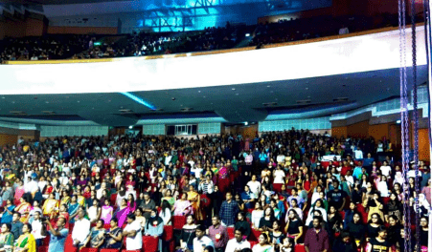
Gym, Sports and Yoga
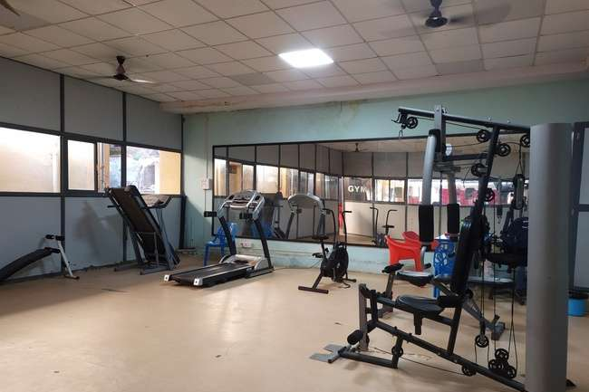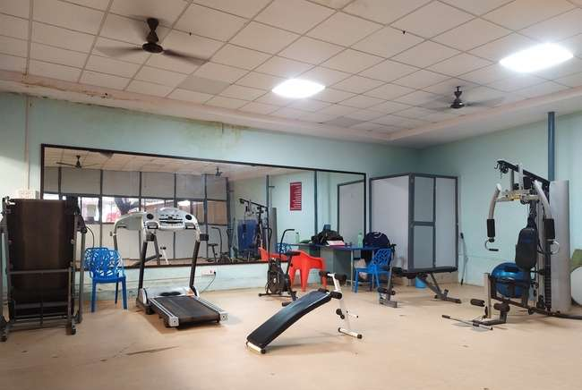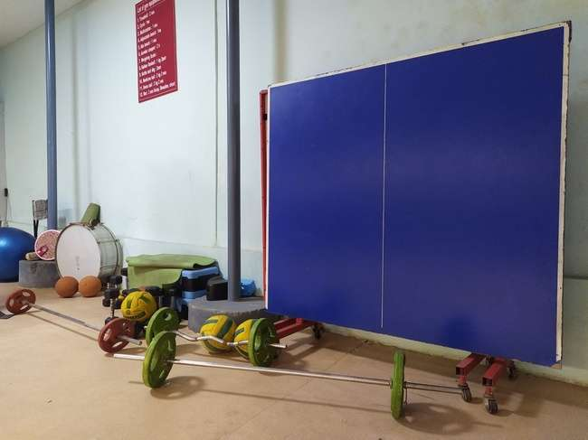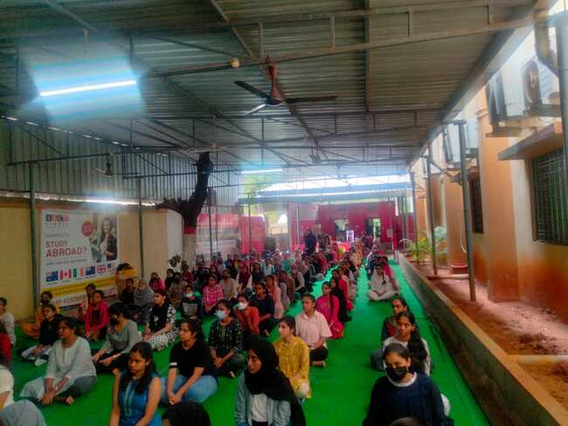

4.1.2 The Institution has adequate facilities for cultural activities, Sports, Games(Indoor, Outdoor),
Gymanasium, Yoga centre etc.

Date of event/activity (DD-MM-YY) | Name of the event/ cultural activity | Branch & Year | Name of the student participated
14/5/2022 | Annual Day – Skit | MBA IInd Year | Sowjanya and group
14/5/2022 | Annual Day- Fashion Show | MBA Ist Year | Divya, Krupali, Khushboo, Sadiya

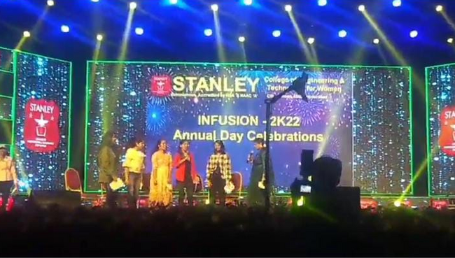

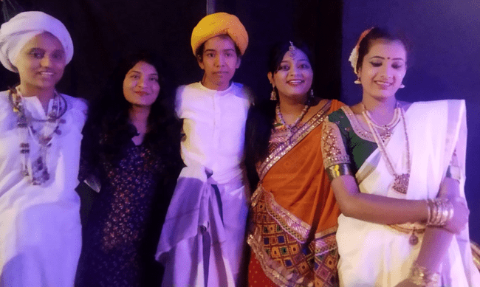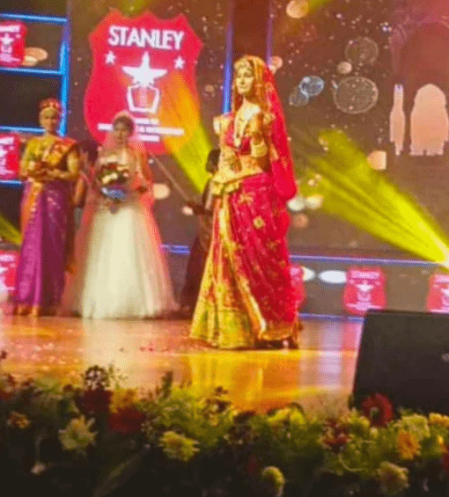

GYM

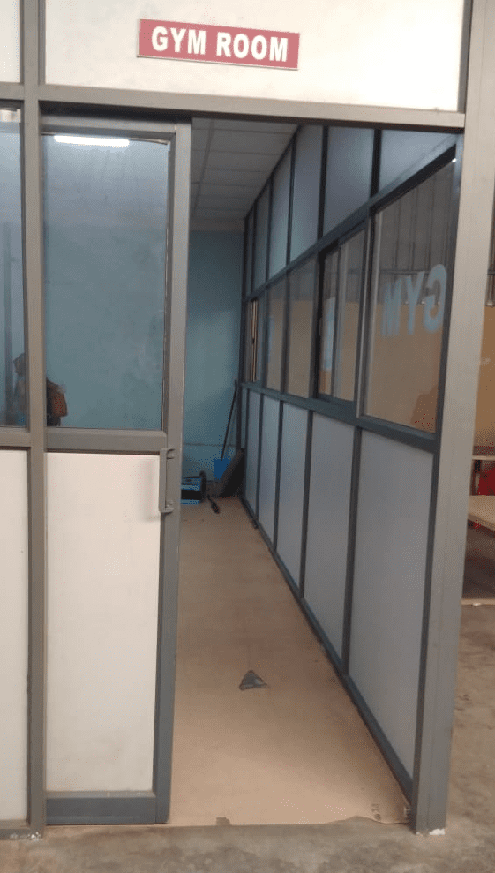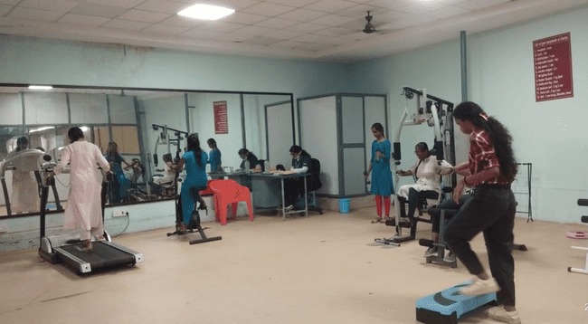

Sports
