Stanley College of Engineering & technology for women (Autonomous)
Department of Computer Science & Engineering
Timetable AY:2021-22 SEM3
ROOM A002 AI&DS w.e.f:3/12/21
DAY | 9:00-10.00 | 10:00-11.00 | 11:00-12.00 | 12:00-1.00 | L  U  N  C  H | 1:30-2.30 | 2:30-3:30 | 3:30-4:30
MON | BE Lab |  | DM | DM |  | M-3 | BE | DSA
TUE | M3 | JAVA | DSA Lab  Lab 1&2 |  |  | JAVA | DSA | DSA
WED | JAVA Lab  Lab 3 &4 |  | DM | DM |  | BE | JAVA | DSA
THUR | M-3 | M-3 | JAVA | BE |  | DSA | JAVA | BE
FRI | DE(Online) |  |  |  |  | TALENTIO(2pm to 5pm)
SAT | DE(Online)

S.No | SubjectCode | Subject Name | Name of the Faculty | Department
1 | PC301AD | Data Structures &Algorithms | Ms.Shugufta Fathima | CSE
2 | PC303AD | Discrete Mathematics | Mr.Ravi Kumar | CSE
3 | BS205MT | Mathematic-III | Mrs.GSireesha | H&S
4 | ES216EC | Basic Electronics | Mrs. Swetha | ECE
5 | ES216EC | Digital Electronics | Mrs.PriyaNandini | CSE
6 | PC302AD | OOPS Using Java | Mrs.R.Sireesha | CSE
7 | PC351AD | Data Structure & Algorithms using C Lab | Ms.Shugufta Fathima/ Mrs.G.Prasuna | CSE
8 | PC352AD | OOPS Using Java Lab | Mrs.R.Sireesha/Mrs.Shivani Yadao | CSE
9 | ES351EC | Basic Electronics Lab | Mrs.Swetha | ECE
10 |  | CLASS INCHAGE | Mrs.Amtul Sana | CSE
HOD

Stanley College of Engineering & technology for women (Autonomous)
Department of Computer Science & Engineering
Timetable AY:2021-22 Sem 3
ROOM A003 CME w.e.f: 3/12/21
WEEKDAY | 9:00-10.00 | 10:00-11.00 | 11:00-12.00 | 12:00-1.00 | L  U  N  C  H | 1:30-2.30 | 2:30-3:30 | 3:30-4:30
MON | PL | DSA | DSA LAB (Lab 3&4) |  |  | BE | PL | OR
TUE | BE LAB |  | DM | DM |  | OR | OR | BE
WED | ACS LAB - Lab 1&2 |  | BE | DSA |  | DSA | OR | BE
THUR | DM | DM | PL LAB – Lab 6 & 7 |  |  | PL | PL | DSA
FRI | DE(Online) |  |  |  |  | TALENTIO(2pm to 5pm)
SAT | DE(Online

S.No | SubjectCode | Subject Name | Name of the Faculty | Department
1 | PC301CM | Data Structures and Algorithms | Ms.Shugufta Fathima | CSE
2 | PC302CM | Discrete Mathematics | Mr.Ravi Kumar | CSE
3 | HS103ME | Operation Research | Dr. KLVasundhara | H&S
4 | ES304EC | Basic Electronics | MrsSwetha | ECE
5 | ES305EC | Digital Electronics | Mrs.PriyaNandini | CSE
6 | PC303CM | Programming Languages | Dr.GVS Raju | CSE
7 | PC353CM | Advanced Computer Skills Lab | Mrs.ASethuMadhavi | CSE
8 | HS351EC | Basic Electronics Lab | MrsSwetha | ECE
9 | PC352CM | Data Structures and Algorithms Lab | Ms.Shugufta Fathima/Dr.D.Shravani | CSE
10 | PC354CM | Programming Languages Lab | Dr.GVS Raju | CSE
11 |  | CLASS INCHAGE | Ms.NadiaAnjum | CSE

HOD

Stanley College of Engineering & Technology for women (Autonomous)
Department of Computer Science & Engineering
Timetable AY:2021-22 Sem 3
ROOM E001 CSE A w.e.f: 3/12/21
WEEKDAY | 9:00-10.00 | 10:00-11.00 | 11:00-12.00 | 12:00-1.00 | LUNCH BREAK | 1:30-2.30 | 2:30-3:30 | 3:30-4:30
MON | OR | DSA | BE | BE |  | JAVA LAB(Lab 3&4) |  | JAVA
TUE | DSA Lab  (Lab 1&2) |  | DSA | OR |  | ACS LAB(Lab 6&7) |  | BE
WED | BE Lab |  | DM | DM |  | OR | JAVA | DSA
THUR | DM | DM | DSA | OR |  | BE | JAVA | JAVA
FRI | DE (Online) |  |  |  |  | TALENTIO(2pm to 5pm)
SAT | DE (Online)
S.No | SubjectCode | Subject Name | Name of the Faculty | Department
1 | PC301CS | Data Structures and Algorithms | Mrs.Asma Begum | CSE
2 | PC302CS | Discreet Mathematics | Mr.LTirupathiReddy | CSE
3 | HS103ME | Operations Research | Ms.Chandrika | H&S
4 | ES306EC | Basic Electronics | Ms.Sujana Grace | ECE
5 | ES303EC | Digital Electronics | Mrs.KSrilatha | CSE
6 | PC303CS | Oops Using JAVA | Mrs.TMonikaSingh | CSE
7 | PC352CS | Advanced Computer Skills Lab | Mrs.ASethuMadhavi | CSE
8 | PC351CS | Data Structures and Algorithms Lab | Mrs.Asma Begum.Mr.L.Tirupathi Reddy | CSE
9 | ES351EC | Basic Electronics Lab | Ms.Sujana Grace | ECE
10 | PC353CS | Oops Using JAVA Lab | Mrs.TMonikaSingh/Mrs.Shivani Yadao | CSE
11 |  | CLASS INCHAGE | Mrs.Asma Begum | CSE

HOD

Stanley College of Engineering & technology for women (Autonomous)
Department of Computer Science & Engineering
Timetable AY:2021-22 Sem 3
ROOME201 CSE B w.e.f: 3/12/21
WEEKDAY | 9:00-10.00 | 10:00-11.00 | 11:00-12.00 | 12:00-1.00 | LUNCH BREAK | 1:30-2.30 | 2:30-3:30 | 3:30-4:30
MON | BE | JAVA | ACS Lab  Lab 6&7 |  |  | DSA | DM | OR
TUE | OR | BE | DM | DM |  | JAVA | JAVA LAB( Lab 3&4)
WED | JAVA | OR | DSA LAB( Lab 1&2) |  |  | DSA | DM | -
THUR | BE Lab |  | JAVA | DSA |  | OR | DSA | -
FRI | DE(Online) |  | BE(ONLINE) |  |  | TALENTIO(2pm to 5pm)
SAT | DE(Online)
S.No | SubjectCode | Subject Name | Name of the Faculty | Department
1 | PC301CS | Data Structures and Algorithms | Mrs.Asma Begum | CSE
2 | PC302CS | Discrete Mathematics | Mr.LTirupathiReddy | CSE
3 | HS103ME | Operations Research | Ms.Chandrika | H&S
4 | ES306EC | Basic Electronics | Ms.Sujana Grace | ECE
5 | ES303EC | Digital Electronics | Mrs.KSriLatha | CSE
6 | PC303CS | Oops Using JAVA | Mrs.DArchana | CSE
7 | PC352CS | Advanced Computer Skills Lab | Mrs.ASethuMadhavi | CSE
8 | PC351CS | Data Structures and Algorithms Lab | Mrs.Asma Begum,Dr.R.Manivannan | CSE
9 | ES351EC | Basic Electronics Lab | Ms.Sujana Grace | ECE
10 | PC353CS | Oops Using JAVA Lab | Mrs.DArchana,Mrs.M.Sowmya | CSE
11 |  | CLASS INCHAGE | Mrs.DArchana | CSE

HOD

Stanley College of Engineering & technology for women (Autonomous)
Department of Computer Science & Engineering
Timetable AY:2021-22 Sem 3
ROOM E206 CSE C w.e.f: 3/12/21
WEEKDAY | 9:00-10.00 | 10:00-11.00 | 11:00-12.00 | 12:00-1.00 |  | 1:30-2.30 | 2:30-3:30 | 3:30-4:30
MON | DM | BE | JAVA | OR | LUNCH BREAK | DSA LAB (Lab 1&2) |  | BE
TUE | DSA | DSA | JAVA Lab  Lab 3&4 |  |  | BE | OR | DM
WED | DM | JAVA | OR | DSA |  | BELab |  | JAVA
THURS | OR | BE | DSA | JAVA |  | DM | ACS LAB(Lab 3&4)
FRI | DE(Online) |  |  |  |  | TALENTIO(2pm to 5pm)
SAT | DE(Online)
S.No | SubjectCode | Subject Name | Name of the Faculty | Department
1 | PC301CS | Data Structures and Algorithms | Mr.Rajasekhar Sastry | CSE
2 | PC302CS | Discrete Mathmatics | Mr.LTirupathiReddy | CSE
3 | HS103ME | Operations Research | Ms.Chandrika | H&S
4 | ES306EC | Basic Electronics | Mrs.R.Arthi | ECE
5 | ES303EC | Digital Electronics | Mrs.KSriLatha | CSE
6 | PC303CS | Oops Using JAVA | Mrs.DArchana | CSE
7 | PC352CS | Advanced Computer Skills Lab | Mrs.ASethuMadhavi | CSE
8 | PC351CS | Data Structures and Algorithms Lab | Mr.Rajasekhar Sastry,Mrs.Sumera | CSE
9 | ES351EC | Basic Electronics Lab | Mrs.R.Arthi | ECE
10 | PC353CS | Oops Using JAVA Lab | Mrs.DArchana,,Dr.R.Manivannan | CSE
11 |  | CLASS INCHAGE | Mrs.ShivaniYadao | CSE

HOD

Stanley College of Engineering & technology for women (Autonomous)
Department of Computer Science & Engineering
Timetable AY:2021-22 Sem 5
ROOM E105 CSE A w.e.f: 3/12/21
WEEKDAY | 9:00-10.00 | 10:00-11.00 | 11:00-12.00 | 12:00-1.00 |  | 1:30-2.30 | 2:30-3:30 | 3:30-4:30
MON | WT (Online) |  | AI(Online) |  | LUNCH BREAK | TALENTIO(2pm to 5pm)
TUE | AI(Online) |  | WT (Online)
WED | ALC | IRS | SE | SE |  | OS | OS LAB(Lab 3&4)
THUR | MP LAB( Lab1&2) |  | OS | SE |  | ALC | ALC | IRS
FRI | SE Lab  (Lab 1&2) |  | OS | ALC |  | OS | IRS | SE
SAT | OS | IRS(T) | ALC(T) | SE(T)

S.No | SubjectCode | Subject Name | Name of the Faculty | Department
1 | PC501CS | Software Eingineering | Dr DShravani | CSE
2 | PC502CS | Operating Systems | Mrs.MSwapna | CSE
3 | PC503CS | Automata Languages&Computation | Mrs.KSriLatha | CSE
4 | PC321CM | Artificial Intelligence | Dr Y V S SPragathi | CSE
5 | PE521CS | Web and Internet Technologies | Mrs.ShivaniYadao | CSE
6 | PE504CM | Information Retrieval Systems | Dr RManivannan | CSE
7 | PW533CS | Mini Project | Mrs.ShivaniYadao/Mrs.T.Mona Singh | CSE
8 | PC531CS | Software Eingineering Lab | Dr DShravni,Mrs.Sumera | CSE
9 | PC532CS | Operating Systems Lab | Mrs.MSwapna/Mrs.M.Sowmya | CSE
10 |  | CLASS INCHAGE | Mrs.KSriLatha | CSE
HOD

Stanley College of Engineering & technology for women (Autonomous)
Department of Computer Science & Engineering
Timetable AY:2021-22 Sem 5
ROOM E106 CSE B w.e.f: 3/12/21
WEEKDAY | 9:00-10.00 | 10:00-11.00 | 11:00-12.00 | 12:00-1.00 |  | 1:30-2.30 | 2:30-3:30 | 3:30-4:30
MON | WT(Online) |  | AI (Online) |  | LUNCH BREAK | TALENTIO 2 TO 5PM
TUE | AI(Online) |  | WT (Online)
WED | ALC | ALC | OS | IRS |  | SE | OS | IRS
THUR | SE | SE | MP LAB(Lab 1&2) |  |  | OS | OS LAB(Lab 6&7)
FRI | OS | IRS | SE Lab (Lab 1&2) |  |  | SE | ALC | ALC
SAT | OS(T) | ALC(T) | SE(T) | IRS |  |  | - | -

S.No | SubjectCode | Subject Name | Name of the Faculty | Department
1 | PC501CS | Software Engineering | Dr DShravani | CSE
2 | PC502CS | Operating Systems | Ms.Sumera | CSE
3 | PC503CS | Automata Languages&Computation | Mrs.MSowmya | CSE
4 | PC321CM | Artificial Intelligence | Dr. YVSSPragathi | CSE
5 | PE521CS | Web and Internet Technologies | Mrs.ShivaniYadao | CSE
6 | PE504CM | Information Retrieval Systems | Dr RManivannan | CSE
7 | PW533CS | Mini Project | Mrs.ShivaniYadao, Mrs.T.Mona Singh | CSE
8 | PC531CS | Software Engineering Lab | Dr DShravani, Mrs.Sumera | CSE
9 | PC532CS | Operating Systems Lab | Ms.Sumera,Mrs.SUmayya Afreen | CSE
10 |  | CLASS INCHAGE | Mrs.SumayyaAfreen | CSE

HOD

Stanley College of Engineering & technology for women (Autonomous)
Department of Computer Science & Engineering
Timetable AY:2021-22 Sem 5
ROOM E107 CSE C w.e.f: 3/12/21
WEEKDAY | 9:00-10.00 | 10:00-11.00 | 11:00-12.00 | 12:00-1.00 |  | 1:30-2.30 | 2:30-3:30 | 3:30-4:30
MON | WT(Online) |  | AI(Online) |  | LUNCH BREAK | TALENTIO(2 TO 5 PM)
TUE | AI(Online) |  | WT(Online)
WED | OS | ALC | SE | SE |  | IRS | MP LAB(Lab 6&7)
THUR | ALC | IRS | OS | SE |  | SE Lab -  (Lab 1&2) |  | ALC
FRI | ALC | OS | SE | IRS |  | OS | OSLab (Lab 6&7)
SAT | ALC | OS | IRS(T) | SE(T) |  |  | -- | --

S.No | SubjectCode | Subject Name | Name of the Faculty | Department
1 | PC501CS | Software Eingineering | Mrs.M.Swathi | CSE
2 | PC502CS | Operating Systems | Ms.Sumera | CSE
3 | PC503CS | Automata Languages&Computation | Mrs.B.GPrasuna | CSE
4 | PC321CM | Artificial Intelligence | Dr YVSS Pragathi | CSE
5 | PE521CS | Web and Internet Technologies | Mrs.ShivaniYadao | CSE
6 | PE504CM | Information Retrieval Systems | Dr. RManivannan | CSE
7 | PW533CS | Mini Project | Mrs.ShivaniYadao, Mrs.T.Mona Singh | CSE
8 | PC531CS | Software Eingineering Lab | Mrs.M.Swathi,Mr.L.Tirupathi Reddy | CSE
9 | PC532CS | Operating Systems Lab | Ms.Sumera,Mrs.Sumayya Afreen | CSE
10 |  | CLASS INCHAGE | Mrs.B.GPrasuna | CSE

HOD

Stanley College of Engineering & technology for women (Autonomous)
Department of Computer Science & Engineering
Timetable AY:2021-22 Sem 5
ROOM A003 CME w.e.f: 3/12/21
WEEKDAY | 9:00-10.00 | 10:00-11.00 | 11:00-12.00 | 12:00-1.00 |  | 1:30-2.30 | 2:30-3:30 | 3:30-4:30
MON (E105) | AI | AI | AT&CD | AT&CD | LUNCH BREAK | SE | SE | SS
TUE (E105) | CD LAB(Lab 3&4) |  | AT&CD | AT&CD |  | AI | SE | SS
WED (ONLINE) | WT (Online) |  | DAA(Online) |  |  | TALENTIO(2pm to 5pm)
THURS (ONLINE) | WT(Online) |  | DAA(Online)
FRI (E001) | SS | SS | AI LAB – Lab 3&4 |  |  | AI | SE | -
SAT (E001) | AI | SE | MP Lab –Lab 3&4 |  |  | SS(T) | AT&CD(T)

S.No | SubjectCode | Subject Name | Name of the Faculty | Department
1 | ES215EC | Signals & Systems | Mrs.G. Nirmala | ECE
2 | PC603CS | Design Analysis and Algorithms | Mrs.B.GPrasuna | CSE
3 | PC321CM | Artificial Intelligence | Mr.RajshekharShastry | CSE
4 | PC322CM | Automata Theory&Compiler Design | Mrs.MSowmya | CSE
5 | PC501CS | Software Engineering | Mrs.MSwathi Reddy | CSE
6 | PC521CS | Web and Internet Technology | Mrs.PriyaNandini | CSE
7 | PC353CM | Mini Project | Mrs.PriyaNandini | CSE
8 | PC351CM | Artificial Intelligence Lab | Mrs.RajshekharShastry,Ms.Shugufta Fathima | CSE
9 | PC352CM | Automata Theory & Compiler Design Lab | Mrs.MSowmyaMrs.B.GPrasuna | CSE
10 |  | CLASS INCHAGE | Mrs.PriyaNandini | CSE

HOD

Stanley College of Engineering & technology for women (Autonomous)
Department of Computer Science & Engineering
Timetable AY:2021-22 Sem 7
CSE A w.e.f: 6/12/21
WEEKDAY | 9:00-10.00 | 10:00-11.00 | 11:00-12.00 | 12:00-1.00 |  | 1:30-2.30 | 2:30-3:30 | 3:30-4:30
MON (E106) | DIS | DS | DS | LIB |  | DIS | DIS
TUE(E106) | PROJECT WORK | DS | CSE A – Data Science Lab – Lab 6&7 |  |  | DIS | CSE A - Dis. Systems Lab – Lab 1&2
WED | DIS(E001) | DIS(E001) | PROJECT WORK |  |  | DS(LAB6&7) | PROJECT WORK
FRI(Online) | IS(Online) |  | IOT(Online) |  |  | IS(Online) | IOT(Online)

S.No | SubjectCode | Subject Name | Name of the Faculty | Department
1 | PC701CS | Information Security | Mrs.Amutul Sana | CSE
2 | PC703CS | Distributed Systems | Mrs.DRadhika | CSE
3 | OE701EC | Fundamentals of IOT | Mr.Raghu | ECE
4 | PC702CS | Data Science | Dr KVaidehi | CSE
5 | PW761CS | Project Work-1 | Mrs.MSowmya,Dr.YVSS Pragathi | CSE
6 | PC751CS | Data Science Lab | Dr KVaidehi/Dr.D.Shravani | CSE
7 | PC752CS | Distributed Systems Lab | Mrs.DRadhika/Mrs.Shivani Yadao | CSE
8 |  | CLASS INCHAGE | Mrs.DRadhika(A),Dr.D.Shravani(B),  Mrs.Shugufta Fatima(C) | CSE

HOD

Stanley College of Engineering & technology for women (Autonomous)
Department of Computer Science & Engineering
Timetable AY:2021-22 Sem 7
CSE B w.e.f: 3/12/21
WEEKDAY | 9:00-10.00 | 10:00-11.00 | 11:00-12.00 | 12:00-1.00 |  | 1:30-2.30 | 2:30-3:30 | 3:30-4:30
MON(E107) | DS | DIS | CSE B - Dis. Systems Lab – Lab 1&2 |  |  | DS | CSE B – Data Science Lab – Lab 6&7
WED | DS(A002) | DS(A002) | DIS(A003) | DIS(A003) |  | DS | DS | PROJECT WORK
THUR  (Online) | PROJECT WORK(E105) | DS(E105) | DIS(E106) | DIS(E106) |  | DS(E107) | PROJECT WORK | PROJECT WORK
FRI  (Online) | IS(Online) |  | IOT(Online) |  |  | IS(Online) | IOT(Online)

S.No | SubjectCode | Subject Name | Name of the Faculty | Department
1 | PC701CS | Information Security | Mrs.Amutul Sana | CSE
2 | PC703CS | Distributed Systems | Mrs.DRadhika | CSE
3 | OE701EC | Fundamentals of IOT | Mr.Raghu | ECE
4 | PC702CS | Data Science | Dr KVaidehi | CSE
5 | PW761CS | Project Work-1 | Mrs.Asma Begum ,Dr.YVSS Pragathi | CSE
6 | PC751CS | Data Science Lab | Dr KVaidehi,Dr.D.Shravani | CSE
7 | PC752CS | Distributed Systems Lab | Mrs.DRadhika/Mrs.Shivani Yadao | CSE
8 |  | CLASS INCHAGE | Mrs.DRadhika(A),Dr.D.Shravani(B),  Mrs.Shugufta Fatima(C) | CSE

HOD

Stanley College of Engineering & technology for women (Autonomous)
Department of Computer Science & Engineering
Timetable AY:2021-22 Sem 7
CSE C w.e.f: 3/12/21
WEEKDAY | 9:00-10.00 | 10:00-11.00 | 11:00-12.00 | 12:00-1.00 | LUNCH BREAK | 1:30-2.30 | 2:30-3:30 | 3:30-4:30
MON |  |  | DS |  |  |  |  | DS
TUE | DS(A003) | DIS(A003) | PROJECT WORK |  |  | DS(E001) | PROJECT WORK
WED | PROJECT WORK | DSLAB 6&7)) | CSE C – Data Science Lab – Lab 6&7 |  |  | DIS(LAB1&2) | CSE C - Dis. Systems Lab – Lab 1&2
THUR  (Online) | DIS(E201) |  | DS(A003) |  |  | DIS
FRI  (Online) | IS (Online) |  | IOT(Online) |  |  |  | IOT(Online)

S.No | SubjectCode | Subject Name | Name of the Faculty | Department
1 | PC701CS | Information Security | Mrs.Amutul Sana | CSE
2 | PC703CS | Distributed Systems | Mrs.DRadhika | CSE
3 | OE701EC | Fundamentals of IOT | Mr.Raghu | ECE
4 | PC702CS | Data Science | Dr KVaidehi | CSE
5 | PW761CS | Project Work-1 | Mr.Rajasekhar Sastry,Dr.B.V.Ramana Murthy | CSE
6 | PC751CS | Data Science Lab | Dr KVaidehi/Mrs.M.Sowmya | CSE
7 | PC752CS | Distributed Systems Lab | Mrs.DRadhikaMrs.K.Srilatha | CSE
8 |  | CLASS INCHAGE | Mrs.DRadhika(A),Dr.D.Shravani(B),  Mrs.Shugufta Fatima(C) | CSE

HOD

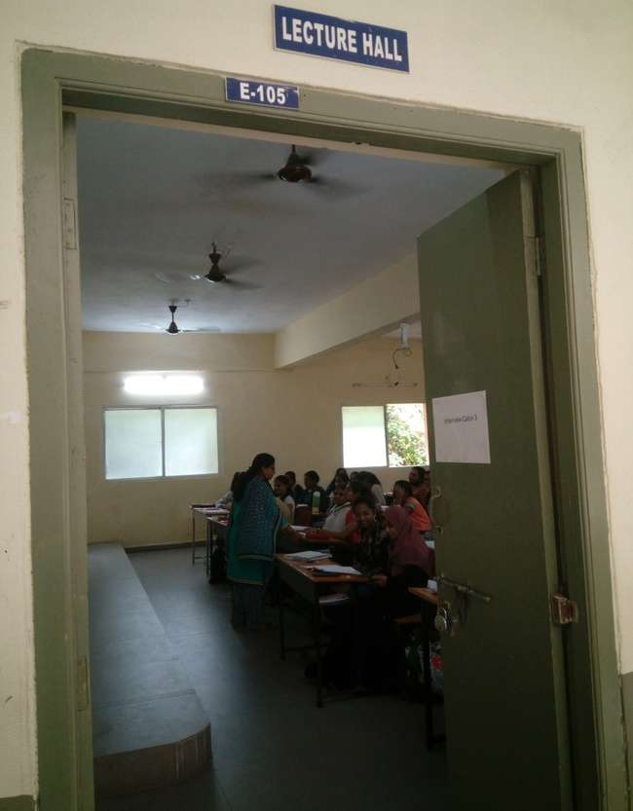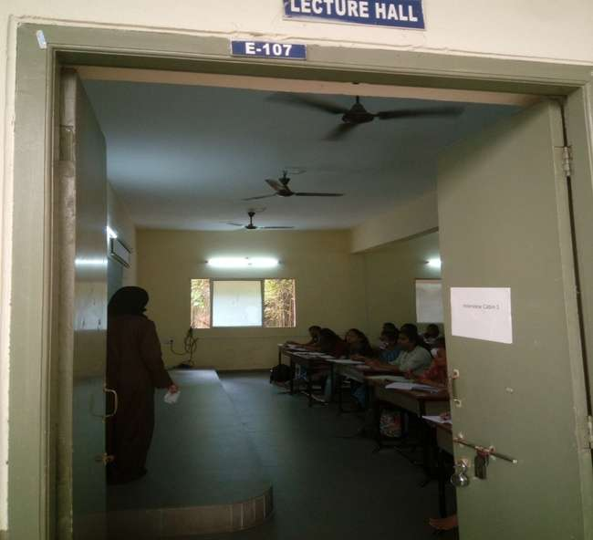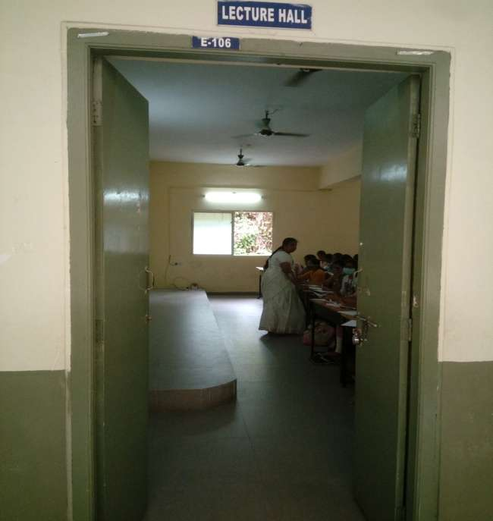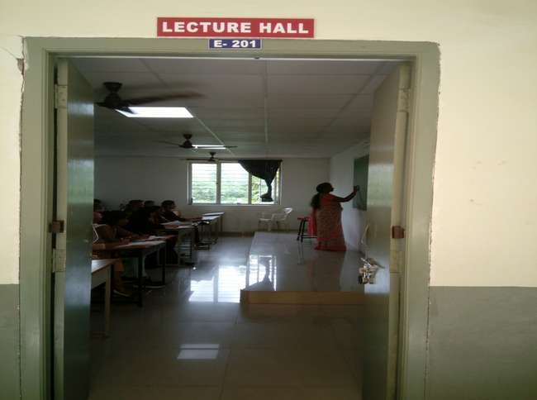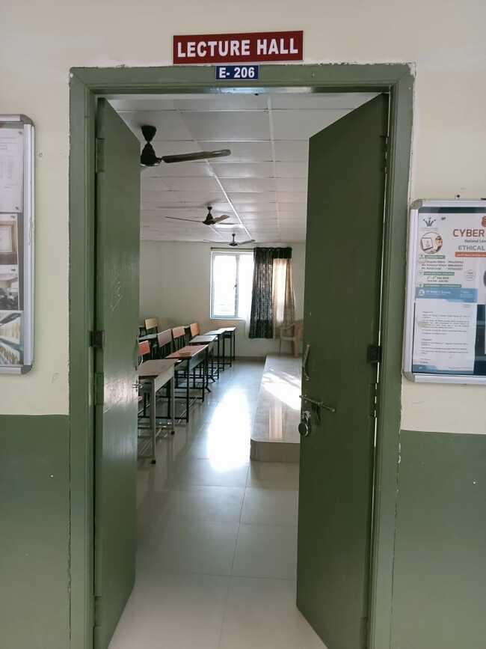

Stanley College of Engineering & Technology For Women
Department of Computer Science And Engineering
Timetable For Academic Year 2021 – 2022 Even Semester
BE IV Semester CSE -A
Room No.: A114 |  |  |  |  |  |  | w.e.f: 25/4/2022
Day | 9:00-10:00 | 10:00-11:00 | 11:00-12:00 | 12:00-1:00 | 1:00-1:30 | 1:30-2:30 | 2:30-3:30 | 3:30-4:30
MON | M-III | MEN | CO LAB (LAB 1&2) |  | LUNCH BREAK | ETC | CO | F&A
TUE | F&A | OS | M-III | DBMS |  | SS | CO | ETC
WED | OS LAB( LAB 3&4) |  | OS | SS |  | OS | F&A | M-III
THURS | ETC | DBMS | DBMS LAB(LAB 6&7) |  |  | F&A | M-III | CO
FRI | TALENTIO |  |  | SS |  | DBMS | DBMS | OS
SAT | TALENTIO |  |  | CO |  | SPORTS | OS | SS
SL. NO. | SUBJECT CODE | SUBJECT NAME |  |  | NAME OF THE FACULTY
1 | HS 104 EG | Effective Technical Communication in English |  |  | Mrs.Virgilia Richard
2 | HS 105 CM | Finance and Accounting |  |  | Ms.Anjum Fathima
3 | BS 205 MT | Mathematics – III (Probability & Statistics) |  |  | Ms.A.Anusha
4 | ES 305 EC | Signals and Systems |  |  | Mrs.Sherlin Shobitha
5 | PC 401 CS | Operating Systems |  |  | Mrs.Shivani yadao
6 | PC 402 CS | Computer Organization |  |  | Ms.Shugufta Fatima
7 | PC 403 CS | Database Management Systems |  |  | Mrs.D.Radhika
8 | PC 451 CS | Computer Organization Lab |  |  | Ms.Shugufta Fatima, Mrs.K.Srilatha, Mrs.V.Anitha
9 | PC 452 CS | Operating Systems lab |  |  | Mrs.Shivani yadao,Mrs.T.Monika Singh, Mrs.Setu madhavi
10 | PC 453 CS | Database Management Systems Lab |  |  | Mrs.D.Radhika, Mrs. Sethu Madhavi, Ms.Veena Kumari
11 |  | MENTORING |  |  | Ms.Veena Kumari,Ms.Hafsa,Ms.Shugufta Fathima
Class Incharge: Ms.Shugufta Fatima |  |  |  |  | INCHARGE

Stanley College of Engineering & Technology For Women
Department of Computer Science And Engineering
Timetable For Academic Year 2021 – 2022 Even Semester
BE IV Semester CSE - B
Room No.: E201 |  |  |  |  |  |  | w.e.f: 25/4/2022
Day | 9:00-10:00 | 10:00-11:00 | 11:00-12:00 | 12:00-1:00 | 1:00-1:30 | 1:30-2:30 | 2:30-3:30 | 3:30-4:30
MON | OS | DBMS | MENTO | F&A | LUNCH BREAK | SS | SS | SPORTS
TUE | M-III | OS | F&A | ETC |  | DBMS | DBMS LAB (LAB 6&7)
WED | CO LAB (LAB 1&2) |  | CO | DBMS |  | M-III | SS | OS
THURS | OS LAB (LAB3&4) |  | OS | SS |  | CO | ETC | F&A
FRI | TALENTIO |  |  | ETC |  | M-III | CO | F&A
SAT | TALENTIO |  |  | M-III |  | OS | CO | DBMS
SL. NO. | SUBJECT CODE | SUBJECT NAME |  |  |  | NAME OF THE FACULTY
1 | HS 104 EG | Effective Technical Communication in English |  |  |  | Mrs.Virgelia Richard
2 | HS 105 CM | Finance and Accounting |  |  |  | Ms.Anjum Fathima
3 | BS 205 MT | Mathematics – III (Probability & Statistics) |  |  |  | Mrs.A.Anusha
4 | ES 305 EC | Signals and Systems |  |  |  | Mrs.Keerthi Latha
5 | PC 401 CS | Operating Systems |  |  |  | Dr.M.Swapna
6 | PC 402 CS | Computer Organization |  |  |  | Ms.Tejaswi
7 | PC 403 CS | Database Management Systems |  |  |  | Mrs.D.Radhika
8 | PC 451 CS | Computer Organization Lab |  |  |  | Ms.Tejaswi, Ms.Shugufta Fatima
9 | PC 452 CS | Operating Systems lab |  |  |  | Dr.M.Swapna, Mrs.T.Monika Singh,Mrs.Shivani yadao
10 | PC 453 CS | Database Management Systems Lab |  |  |  | Mrs.D.Radhika, Mrs.Sethu Madhavi, Ms.Tejaswee
11 |  | MENTORING |  |  |  | Ms.Tejaswee, Mrs.Sumayya Afreen, Mrs.D.Archana
Class Incharge:Ms.Tejaswi |  |  |  | INCHARGE |  |  | HOD

Stanley College of Engineering & Technology For Women
Department of Computer Science And Engineering
Timetable For Academic Year 2021 – 2022 Even Semester
BE IV Semester CSE - C
Room No.: E206 |  |  |  |  |  |  | w.e.f: 25/4/2022
Day | 9:00-10:00 | 10:00-11:00 | 11:00-12:00 | 12:00-1:00 | 1:00-1:30 | 1:30-2:30 | 2:30-3:30 | 3:30-4:30
MON | ETC | CO | M-III | DBMS | LUNCH BREAK | OS | OS | SPORTS
TUE | SS | CO | CO LAB (LAB 1&2) |  |  | DBMS | OS | MEN
WED | M-III | F&A | CO | ETC |  | DBMS | DBMS LAB(LAB 6&7)
THURS | F&A | M-III | ETC | SS |  | OS | OS LAB( LAB 3&4)
FRI | TALENTIO |  |  | OS |  | SS | F&A | DBMS
SAT | TALENTIO |  |  | CO |  | F&A | SS | M-III
SL. NO. | SUBJECT CODE | SUBJECT NAME |  |  |  | NAME OF THE FACULTY
1 | HS 104 EG | Effective Technical Communication in English |  |  |  | Mrs.Virgelia Richard
2 | HS 105 CM | Finance and Accounting |  |  |  | Ms.Anjum Fathima
3 | BS 205 MT | Mathematics – III (Probability & Statistics) |  |  |  | Mrs.A.Anusha
4 | ES 305 EC | Signals and Systems |  |  |  | Mrs.G.Nirmala
5 | PC 401 CS | Operating Systems |  |  |  | Mrs.Shivani Yadao
6 | PC 402 CS | Computer Organization |  |  |  | Mrs.K.Srilatha
7 | PC 403 CS | Database Management Systems |  |  |  | Mrs.Sethu Madhavi
8 | PC 451 CS | Computer Organization Lab |  |  |  | Mrs.K.Srilatha,Ms.Shugufta Fahima, Mrs.Setu Madhavi
9 | PC 452 CS | Operating Systems lab |  |  |  | Mrs.Shivani Yadao, Mrs.T.monika Singh, Mrs.Sethu Madhavi
10 | PC 453 CS | Database Management Systems Lab |  |  |  | Mrs.Sethu Madhavi, Mrs.D.Radhika, Ms.Tejaswee
11 |  | MENTORING |  |  |  | Mrs.Shivani Yadao, Mrs.M.Sowmya, Mrs.Setu Madhavi
Class Incharge:Mrs.Sethu Madhavi |  |  |  | INCHARGE |  |  | HOD

Stanley College of Engineering & Technology For Women
Department of Computer Science And Engineering
Timetable For Academic Year 2021 – 2022 Even Semester
BE VI Semester CSE - A
Room No.: E001 |  |  |  |  |  |  | w.e.f: 25/4/2022
Day | 9:00-10:00 | 10:00-11:00 | 11:00-12:00 | 12:00-1:00 | 1:00-1:30 | 1:30-2:30 | 2:30-3:30 | 3:30-4:30
MON | ML | CD | CN LAB(LAB 6&7) |  | LUNCH BREAK | TALENTIO
TUE | CD LAB(LAB 3&4) |  | SS | DAA |  | TALENTIO
WED | CD | CN | DAA | ML |  | CN | SS | DM
THURS | ML | CD | DM | DM |  | CN | DAA | SPORT
FRI | SS | ML | DAA LAB(LAB 3&4) |  |  | DAA | CN | CD
SAT | ML | CN | DM | DM |  | CD | DAA | MENT
SL. NO. | SUBJECT CODE | SUBJECT NAME |  |  |  | NAME OF THE FACULTY
1 | PC 601 CS | Compiler Design |  |  |  | Mrs.M.Sowmya
2 | PC602CS | Computer Network |  |  |  | Mrs.K.Srilatha
3 | PC603CS | Design And Analysis Of Algorithms |  |  |  | Mrs.B.Gnana Prasuna
4 | PE 630 CS | Machine Learning |  |  |  | Dr.P.R.Anisha
5 | PE 651 CS | Data Mining |  |  |  | Dr.B.V.Ramana murthy
6 | OE 601 | Soft Skills & Interpersonal Skills |  |  |  | Dr.Srilatha
7 | PC 631 CS | Compiler Design Lab |  |  |  | Mrs.M.Sowmya,Ms.Ghousia
8 | PC 632 CS | Computer Network lab |  |  |  | Mrs.K.Srilatha, Ms.D.Archana
9 | PC 633 CS | Design And Analysis Of Algorithms Lab |  |  |  | Mrs.B.Gnana Prasuna, Mrs.G.Saraswathi, Ms Ghousia
10 |  | MENTORING |  |  |  | Ms.Gousia Begum, Mrs.Shivani Yadao, Mrs.M.Swathi
Class Incharge: Mrs.K.Srilatha |  |  |  | INCHARGE |  |  | HOD

Stanley College of Engineering & Technology For Women
Department of Computer Science And Engineering
Timetable For Academic Year 2021 – 2022 Even Semester
BE VI Semester CSE - B
Room No.: 107 |  |  |  |  |  |  | w.e.f: 25/4/2022
Day | 9:00-10:00 | 10:00-11:00 | 11:00-12:00 | 12:00-1:00 | 1:00-1:30 | 1:30-2:30 | 2:30-3:30 | 3:30-4:30
MON | SS | DAA | CD | ML | LUNCH BREAK | TALENTIO
TUE | ML | ML | DM | CD |  | TALENTIO
WED | DAA | DAA | CD LAB(LAB 3&4) |  |  | CN | DM | CD
THURS | CN | CN | ML | DM |  | SS | CD | ML
FRI | CN LAB(LAB 6&7) |  | DM | DAA |  | CN | DAA LAB(LAB 3&4)
SAT | DM | CD | CN | DAA |  | SPORT | SS | MEN
SL. NO. | SUBJECT CODE | SUBJECT NAME |  |  | NAME OF THE FACULTY |  |  | Department
1 | PE 630 CS | Compiler Design |  |  | Mrs.M.Sowmya |  |  | CSE
2 | PE 651 CS | Computer Network |  |  | Mr.L.Tirupati Reddy |  |  | CSE
3 | OE 601 | Design And Analysis Of Algorithms |  |  | Ms.Hafsa IUA |  |  | CSE
4 | PC 631 CS | Machine Learning |  |  | Dr.P.R.Anisha |  |  | CSE
5 | PC 632 CS | Data Mining |  |  | Dr.YVSS Pragathi |  |  | CSE
6 | PC 633 CS | Soft Skills & Interpersonal Skills |  |  | Ms.Heena Khan |  |  | ECE
7 | PC 631 CS | Compiler Design Lab |  |  | Mrs.M.Sowmya, Mrs.V.Anitha |  |  | CSE
8 | PC 632 CS | Computer Network lab |  |  | Mr.L.Tirupati Reddy, Mrs.V.Anitha |  |  | CSE
9 | PC 633 CS | Design And Analysis Of Algorithms Lab |  |  | Ms.Hafsa, Mrs.G.Saraswathi, Mrs.Veena Kumari |  |  | CSE
10 |  | MENTORING |  |  | Ms.Veena Kunari, Mrs.Sumayya Afreen, Mrs K.Srilatha
Class Incharge: Ms.Hafsa IUA |  |  |  | INCHARGE |  |  | HOD
Stanley College of Engineering & Technology For Women
Department of Computer Science And Engineering
Timetable For Academic Year 2021 – 2022 Even Semester
BE VI Semester CSE -C
Room No.: E106 |  |  | Block E |  |  |  | w.e.f: 25/4/2022
Day | 9:00-10:00 | 10:00-11:00 | 11:00-12:00 | 12:00-1:00 | 1:00-1:30 | 1:30-2:30 | 2:30-3:30 | 3:30-4:30
MON | CD LAB(LAB 3&4) |  | CD | DM | LUNCH BREAK | TALENTIO
TUE | DM | DAA | DAA LAB(LAB 3&4) |  |  | TALENTIO
WED | DAA | CN | MEN | SS |  | CN | ML | CD
THURS | CN | CD | SS | DAA |  | ML | CN LAB(LAB 6&7)
FRI | DAA | SS | DM | DM |  | CN | ML | CD
SAT | ML | ML | DAA | CD |  | DM | CN | SPORTS
SL. NO. | SUBJECT CODE | SUBJECT NAME |  |  | NAME OF THE FACULTY |  |  | Department
1 | PC 601 CS | Compiler Design |  |  | Mrs.B.Gnana Prasuna |  |  | CSE
2 | PC602CS | Computer Network |  |  | Mrs.D.Archana |  |  | CSE
3 | PC603CS | Design And Analysis Of Algorithms |  |  | Ms.Ghousia Begum |  |  | CSE
4 | PC 631 CS | Machine Learning |  |  | Ms.Hafsa |  |  | CSE
5 | PC 632 CS | Data Mining |  |  | Dr.C.Kishore Kumar Reddy |  |  | CSE
6 | PC 633 CS | Soft Skills& Interpersonal Skills |  |  | Ms.Heena Khan |  |  | ECE
7 | PC 631 CS | Compiler Design Lab |  |  | Mrs.B.Gnana Prasuna, Ms.Ghousia |  |  | CSE
8 | PC 632 CS | Computer Network lab |  |  | Mrs.D.Archana, Ms.Veena Kumari |  |  | CSE
9 | PC 633 CS | Design And Analysis Of Algorithms Lab |  |  | Ms.Ghousia Begum, Mrs.G.Saraswathi, Ms.Veena Kumari |  |  | CSE
10 |  | MENTORING |  |  | Mrs.M.Sowmya, Mrs.T.Monika Singh, Mrs.Setu Madhavi
Class Incharge: Ms.Ghousia Begum |  |  |  | INCHARGE |  |  | HOD

Stanley College of Engineering & Technology For Women
Department of Computer Science And Engineering
Timetable For Academic Year 2021 – 2022 Even Semester
BE VIIISemester CSE - A
 |  |  |  |  |  |  | w.e.f: 25/4/2022
Day | 9:00-10:00 | 10:00-11:00 | 11:00-12:00 | 12:00-1:00 | 1:00-1:30 | 1:30-2:30 | 2:30-3:30 | 3:30-4:30
MON | SWSN (E BLOCK LAB 1&2) |  | RSE(LAB 1&2) |  | LUNCH BREAK | SWSN (E001) | PROJECT | RSE (E001)
TUE | PROJECT |  |  |  |  | PROJECT
WED | RSE( E201) |  | SWSN(LAB 1&2) |  |  | RSE (E307) | PROJECT | SWSN (E307)
SL. NO. | SUBJECT CODE | SUBJECT NAME |  |  | NAME OF THE FACULTY |  |  | Department
1 | PE 828 CS | Semantic Web & Social Networking |  |  | Mrs.M.Swathi |  |  | CSE
2 | OE 881 CE | Road Safety Engineering |  |  | Mrs.D.Archana |  |  | CSE
3 | PW861 CS | Project Work |  |  | Mrs.M.Sowmya, Mrs.G.Saraswathi |  |  | CSE
4 |  | MENTORING |  |  | Mrs.K.Srilatha, Mrs.D.Radhika, Mrs.D. Archana |  |  | CSE
Class Incharge: Mrs.M.Swathi |  |  |  | INCHARGE |  |  | HOD
Stanley College of Engineering & Technology For Women
Department of Computer Science And Engineering
Timetable For Academic Year 2021 – 2022 Even Semester
BE VIII Semester CSE - B
 |  |  | Block E |  |  |  | w.e.f: 31/03/2022
Day | 9:00-10:00 | 10:00-11:00 | 11:00-12:00 | 12:00-1:00 | 1:00-1:30 | 1:30-2:30 | 2:30-3:30 | 3:30-4:30
MON | RSE (E106) |  | SWSN(LAB 3&4) |  | LUNCH BREAK | RSE(E107) | PROJECT | SWSN(E107)
TUE | PROJECT |  |  |  |  | PROJECT
WED | SWSN(A114) |  | RSE(E107) |  |  | SWSN(LAB 1&2) | PROJECT | RSE(LAB 1&2)
SL. NO. | SUBJECT CODE | SUBJECT NAME |  |  | NAME OF THE FACULTY |  |  | Department
1 | PE 828 CS | Semantic Web & Social Networking |  |  | Mrs.M.Swathi |  |  | CSE
2 | OE 881 CE | Road Safety Engineering |  |  | Mrs.Veena Kumari |  |  | CSE
3 | PW861 CS | Project Work – II |  |  | Mrs.K.Sriltha, Mrs.M.Swathi |  |  | CSE
4 |  | MENTORING |  |  | Ms.Shugufta Fatima, Dr.M.Swapna, Mrs.T.Monika Singh
Class Incharge: Mrs.D.Archana |  |  |  | INCHARGE |  |  | HOD
Stanley College of Engineering & Technology For Women
Department of Computer Science And Engineering
Timetable For Academic Year 2021 – 2022 Even Semester
BE VIII Semester CSE - C
 |  |  |  |  |  |  | w.e.f: 31/03/2022
Day | 9:00-10:00 | 10:00-11:00 | 11:00-12:00 | 12:00-1:00 | 1:00-1:30 | 1:30-2:30 | 2:30-3:30 | 3:30-4:30
MON | SWSN (LAB 6&7) |  | RSE(E001) |  | LUNCH BREAK | SWSN (E106) | PROJECT | RSE (E106)
TUE | PROJECT |  |  |  |  | PROJECT
WED | RSE(LAB 6&7) |  | SWSN(A113) |  |  | RSE (E206) | PROJECT | SWSN (E206)
SL. NO. | SUBJECT CODE | SUBJECT NAME |  |  | NAME OF THE FACULTY |  |  | Department
1 | PE 828 CS | Semantic Web & Social Networking |  |  | Mrs.V.Anitha |  |  | CSE
2 | OE 881 CE | Road Safety Engineering |  |  | Dr.R.Manivannan |  |  | CSE
3 | PW861 CS | Project Work – II |  |  | Mrs.D.Radhika, Ms.Shugufta Fatima |  |  | CSE
4 |  | MENTORING |  |  | Mrs.M.Swathi, Dr.YVSS Pragathi, Mrs.B.G.prasuna
Class Incharge: Mrs.V.Anitha |  |  |  | INCHARGE |  |  | HOD

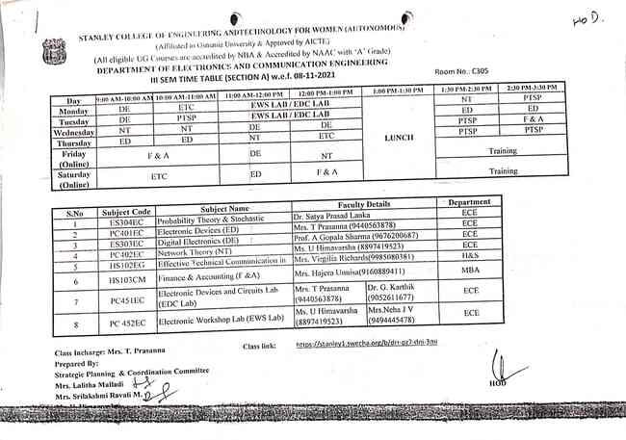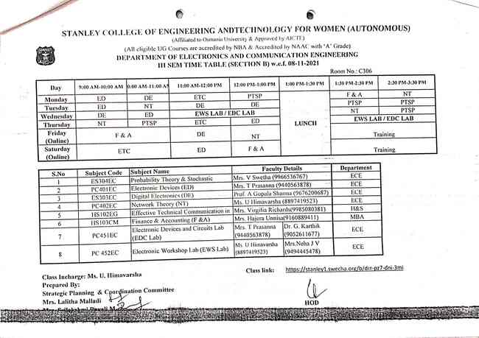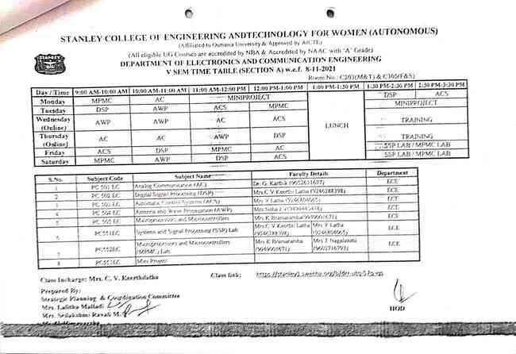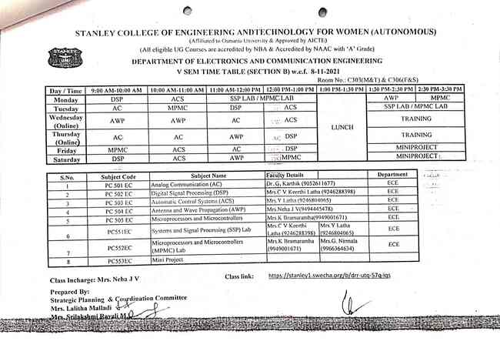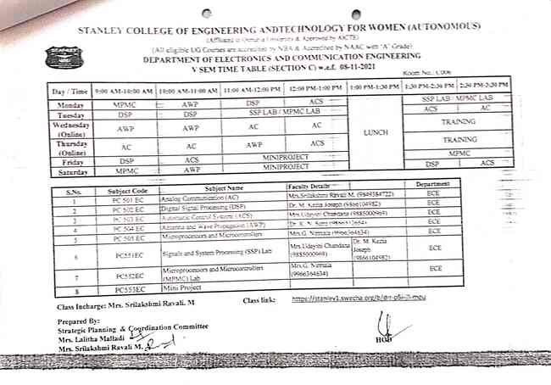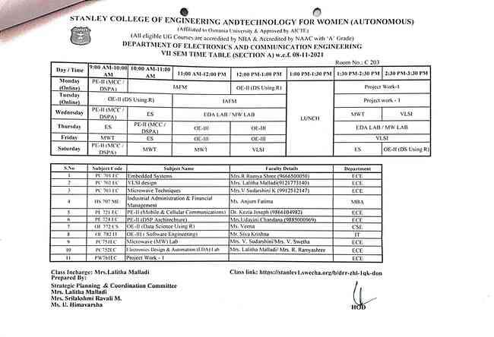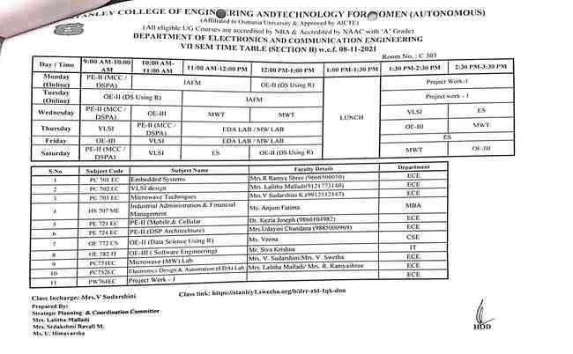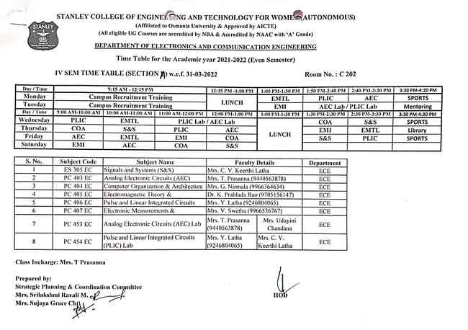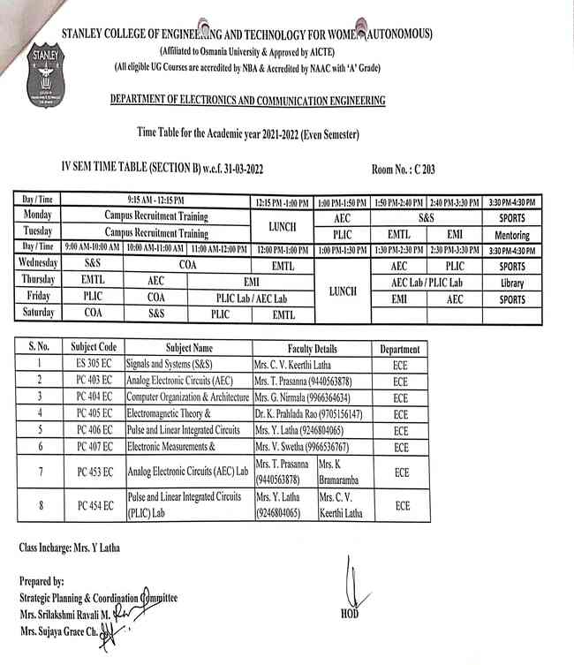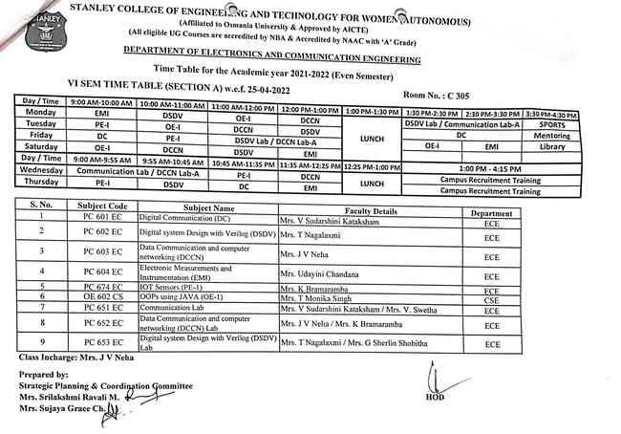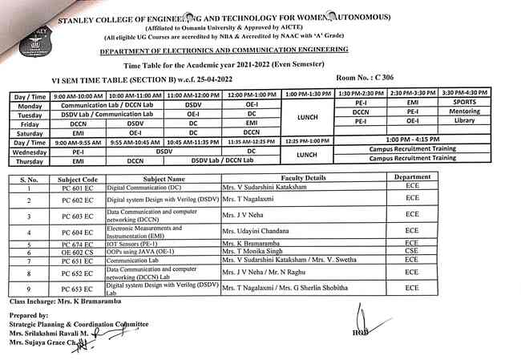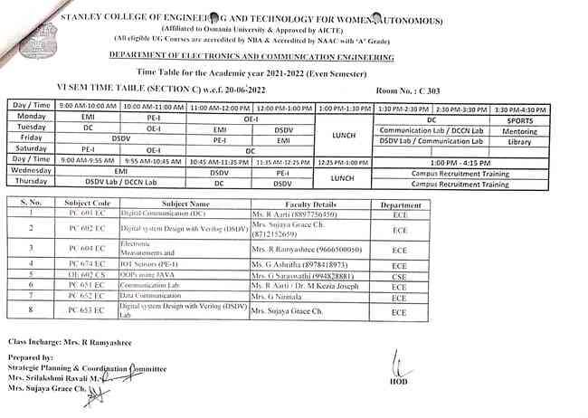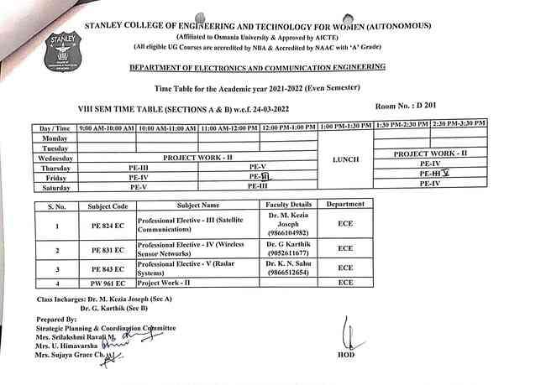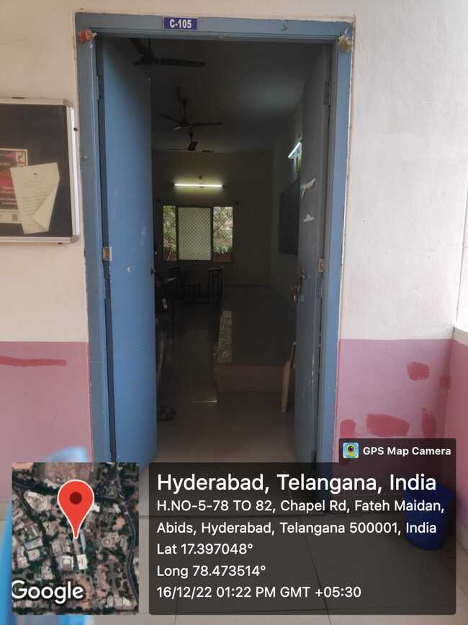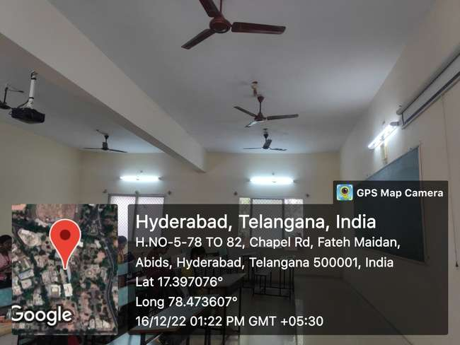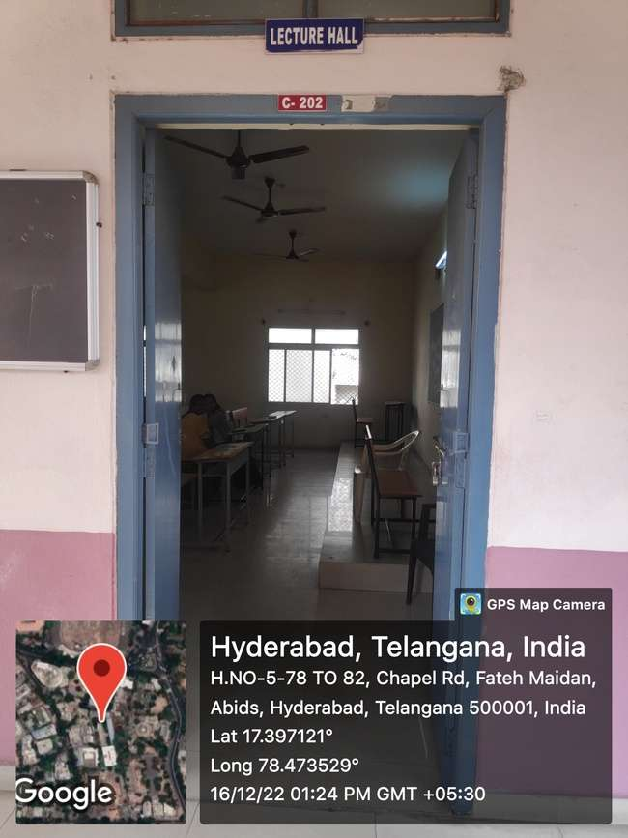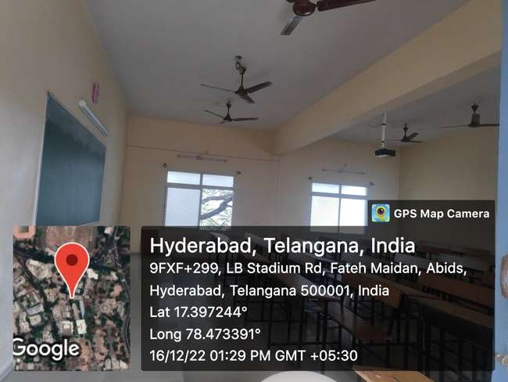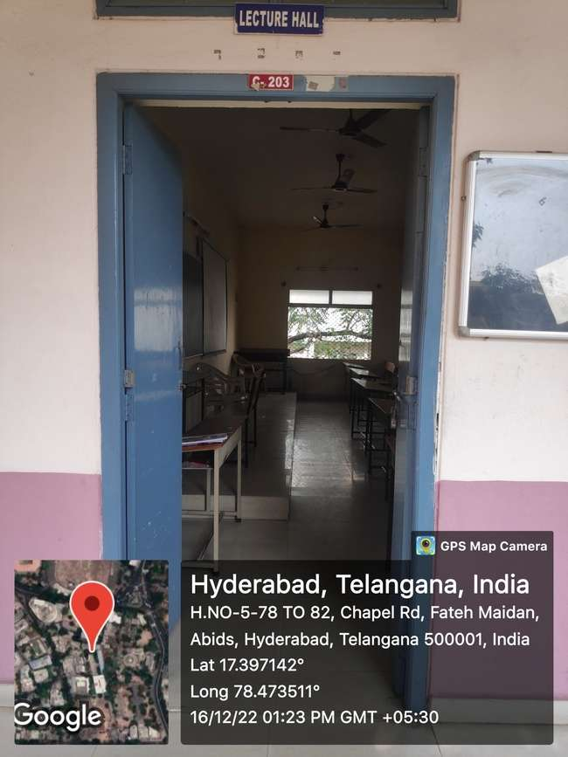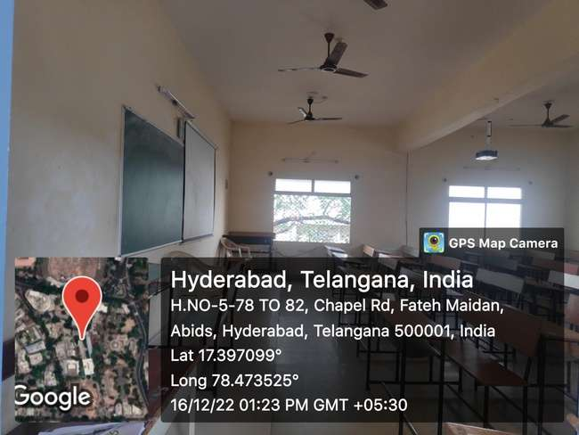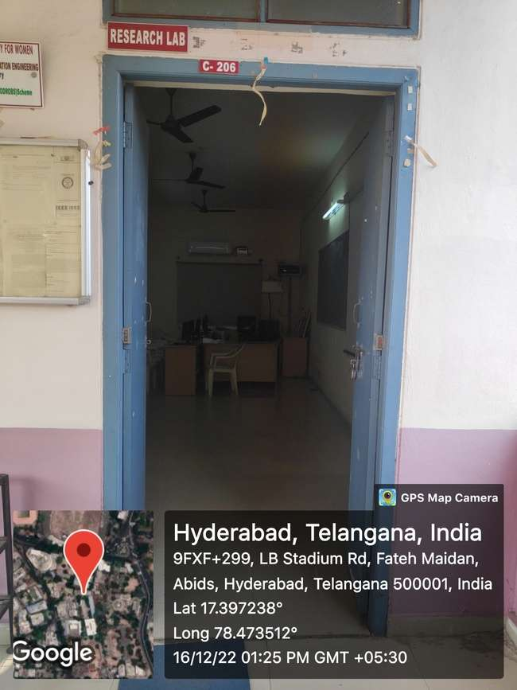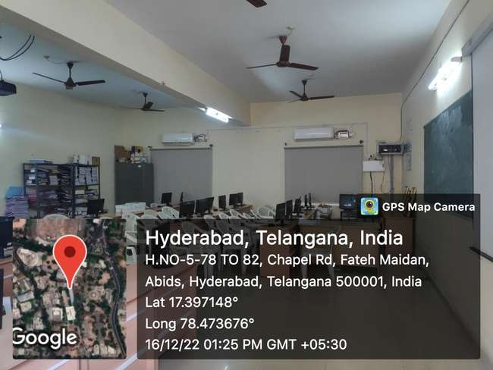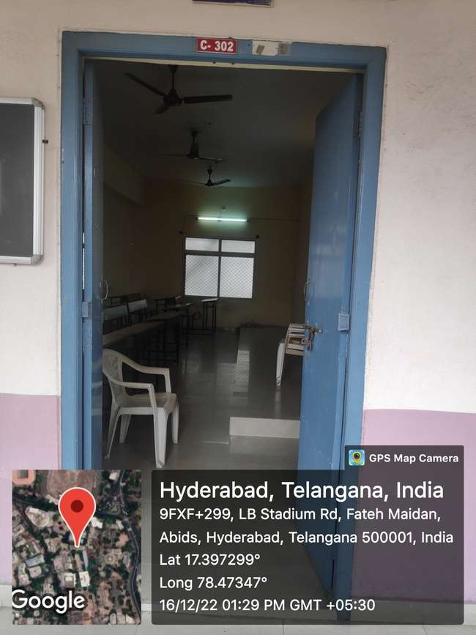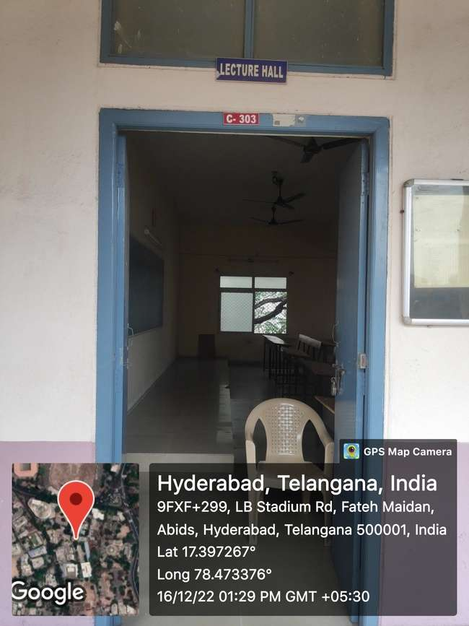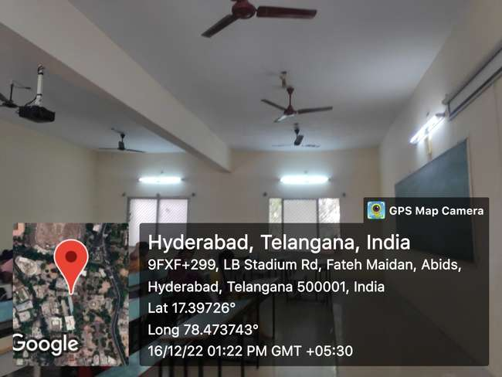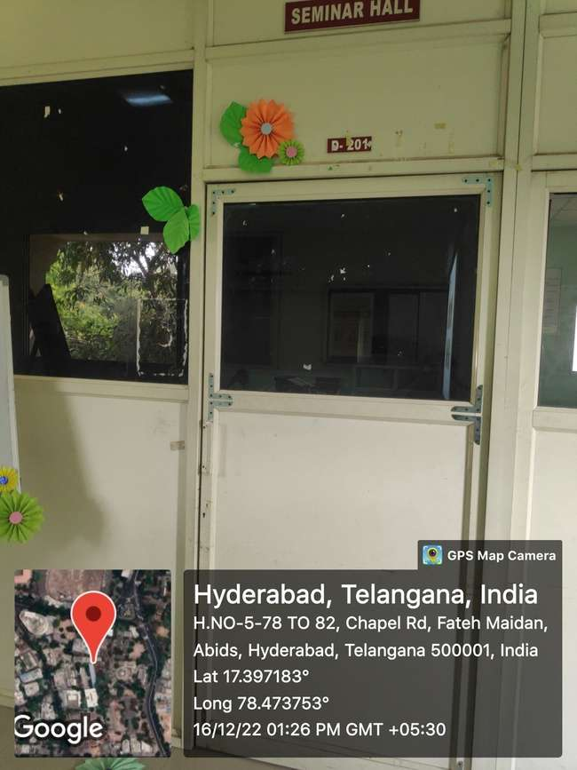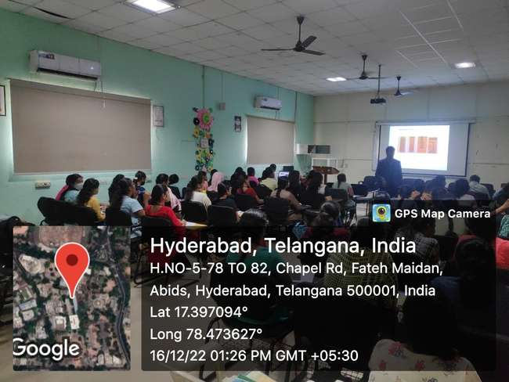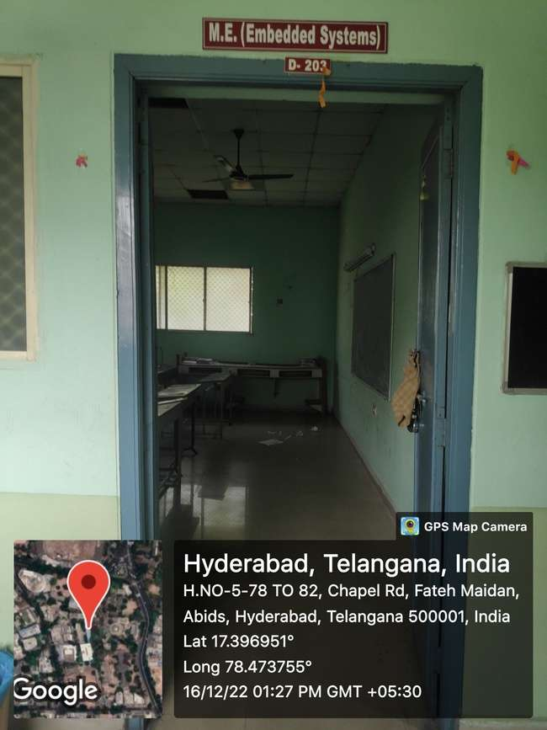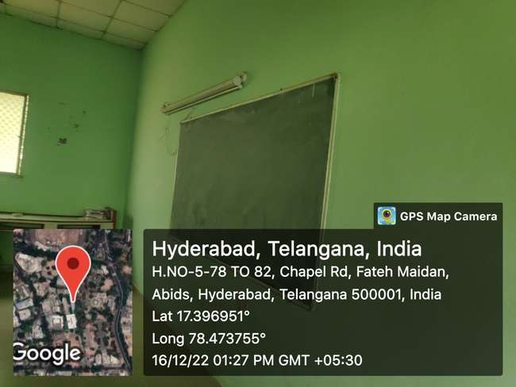

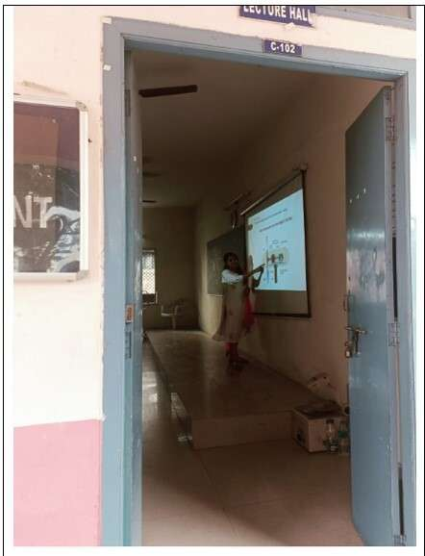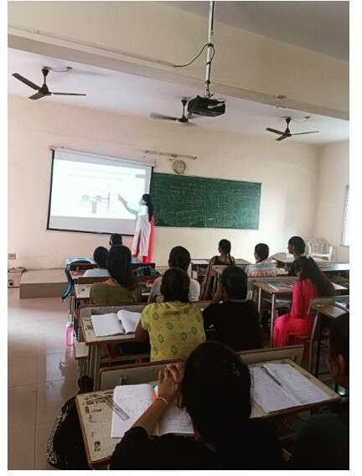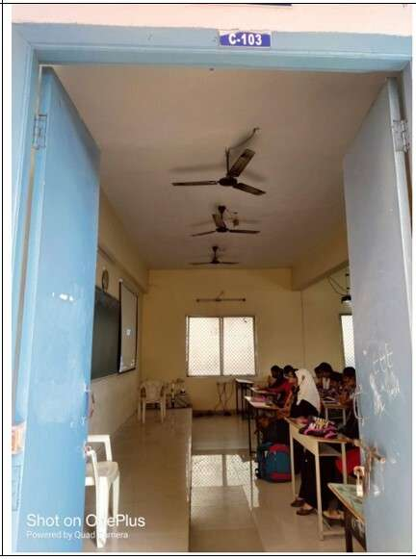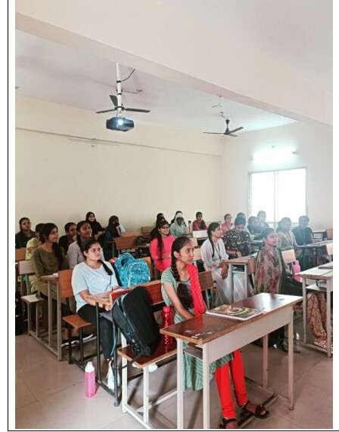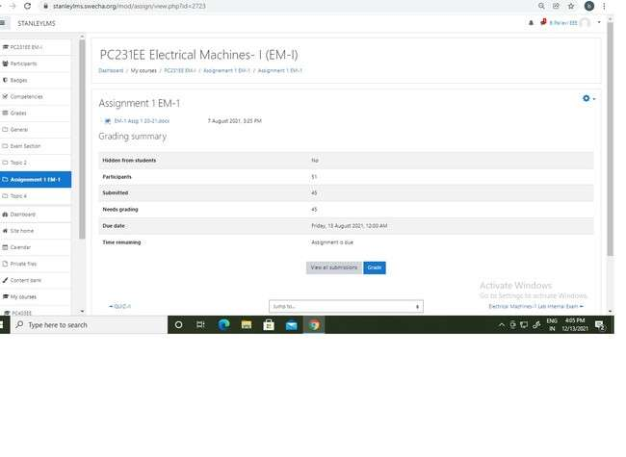

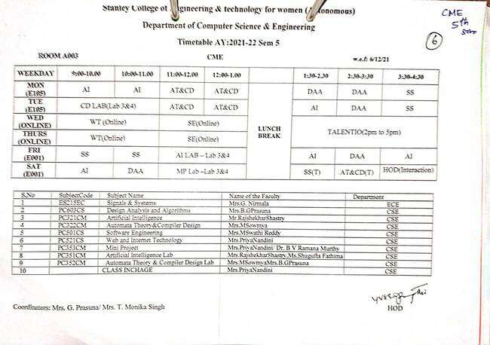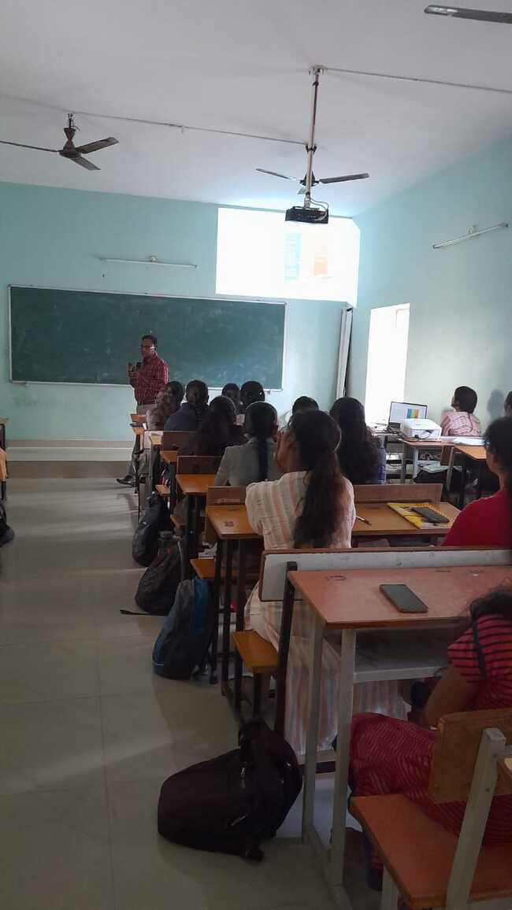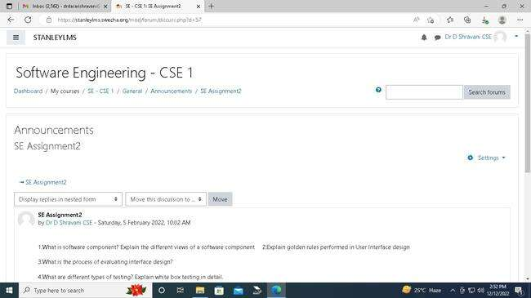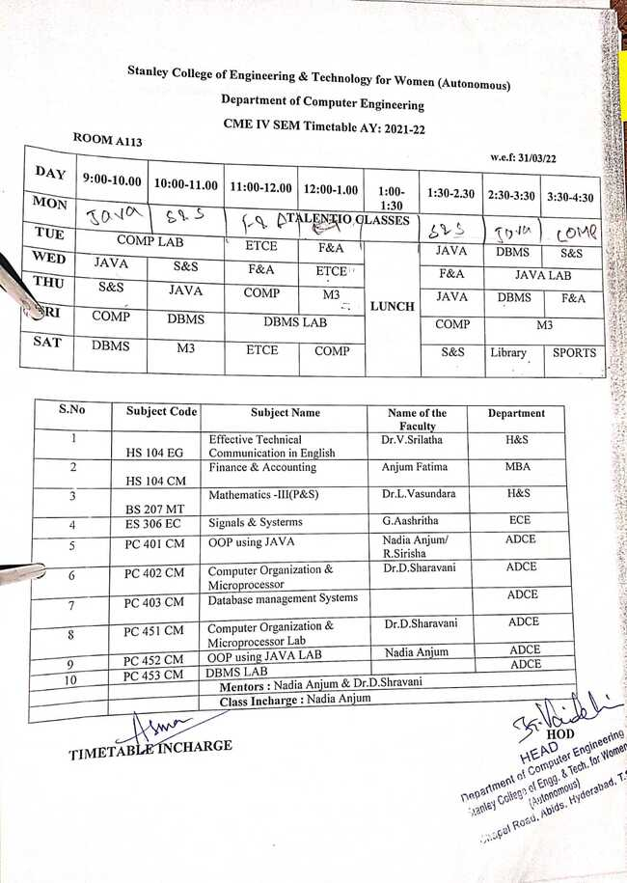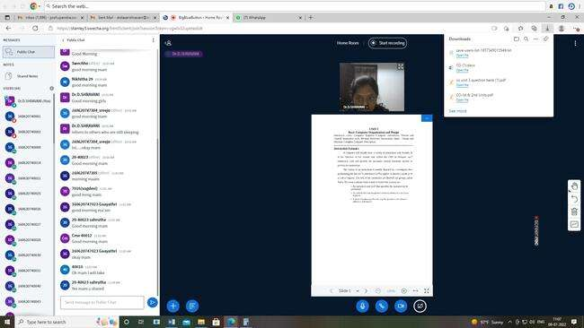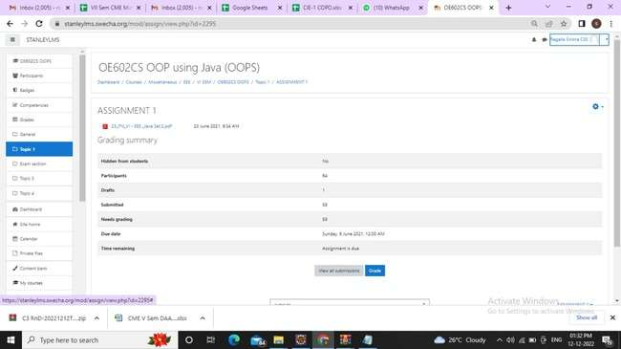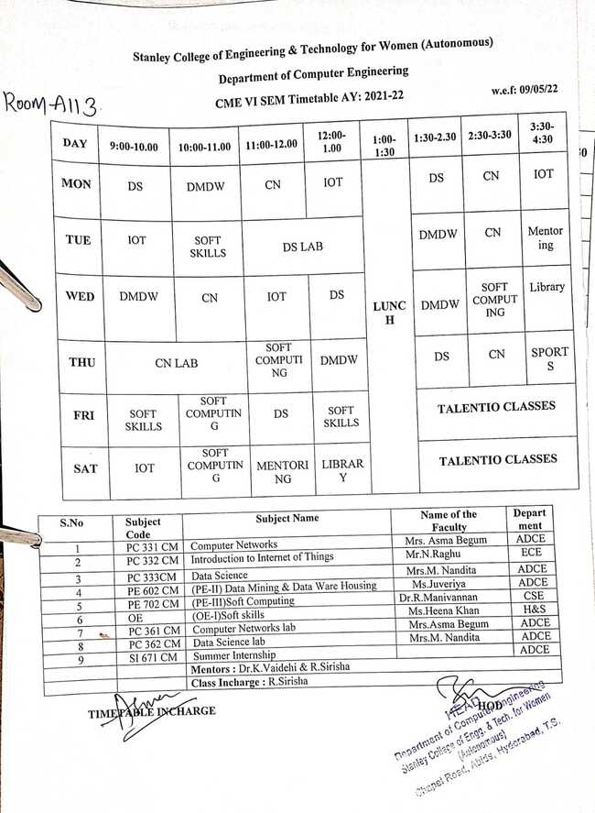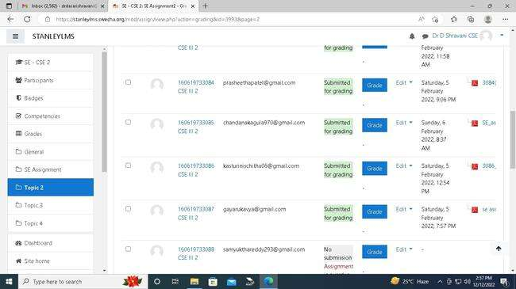

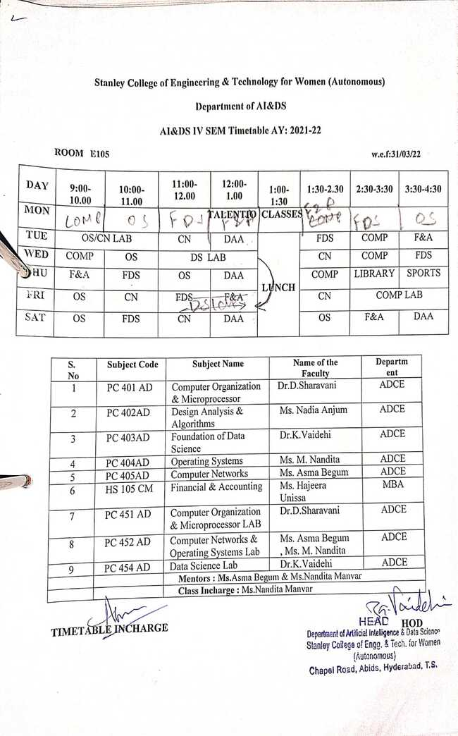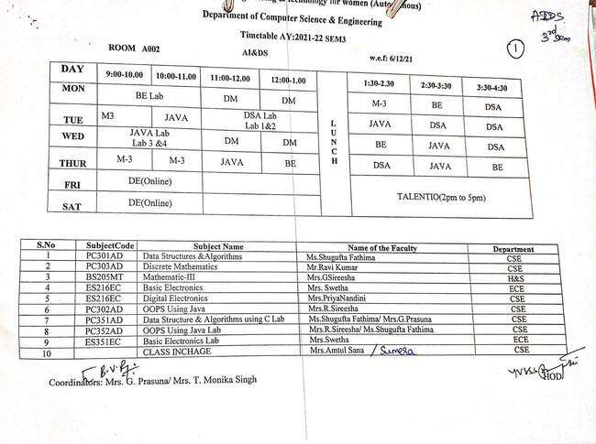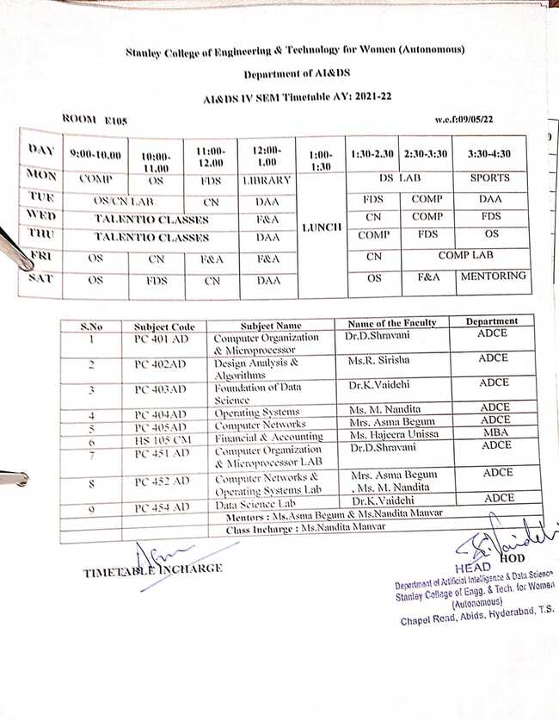
Criteria 4.1.3 - Number of classrooms and seminar halls with ICT- enabled facilities such as smart class, LMS, etc.

GraphicsLAB
Graphics lab is situated on the first floor of A Block. It has a seating capacity of 80 members. A total of 70 computers with AutoCADD software are used in the lab. The lab is networked with LAN connection. The total area of the lab is 120Sq.M.

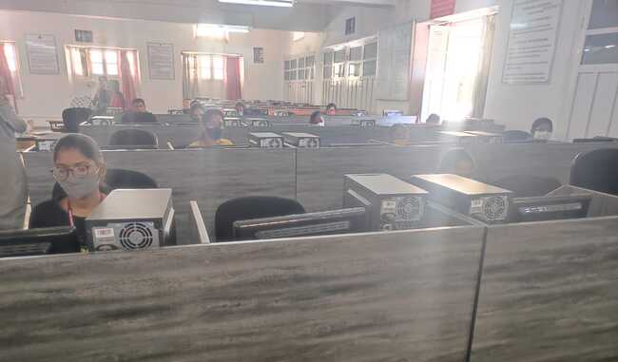
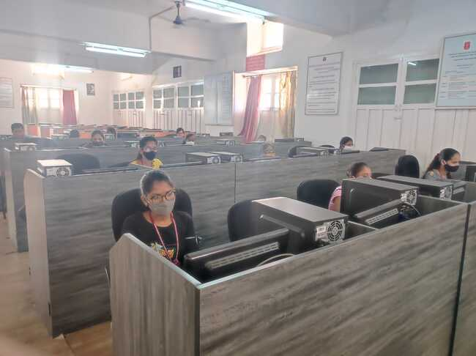

Communication Lab
Communication Lab functions in room no 202 of E Block. It is used for Communicative English and soft skill training. The total area of the lab is 74Sq.M with a capacity of 31 desktop systems, 1 projector and surround sound speaker system.

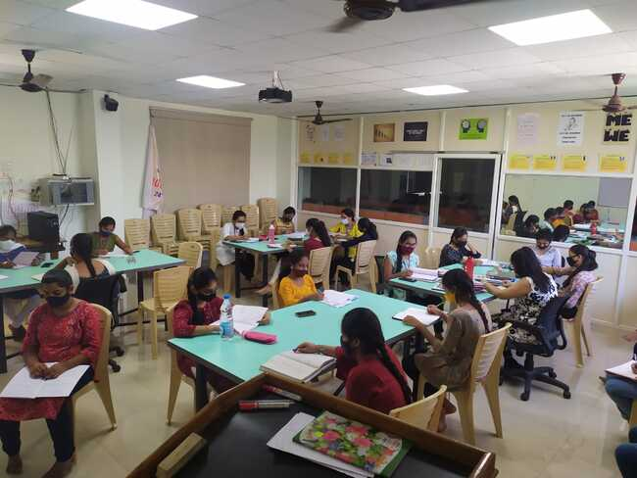

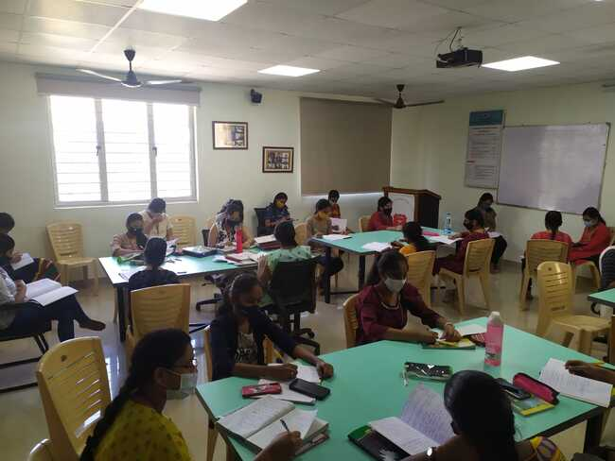

Big Blue Button
Big blue button is the online classroom platform widely adapted by Stanley College from the time of pandemic. It is a tool that allows an unlimited number of students to attend the classes. The functionality and features are more or less similar to Google meet and Microsoft teams.

