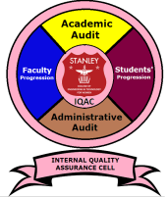
STANLEY COLLEGE OF ENGINEERING AND TECHNOLOGY FOR WOMEN
(Affiliated to Osmania University)
(Accredited by NAAC with “A” Grade, Accredited by NBA)
ABIDS, HYDERABAD- 500 001

INTERNAL QUALITY ASSURANCE CELL (IQAC)

Objective

The primary aim of the IQAC is
• To develop a mechanism to promote conscious, consistent and catalytic action plans to improve the academic and administrative performance of the institution.
• To promote institutional quality enhancement and sustenance through the internalization of quality culture and institutionalization of the best practices.

