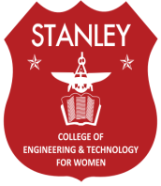
STANLEY COLLEGE OF ENGINEERING AND TECHNOLOGY FOR WOMEN (Autonomous)
ABIDS, HYDERABAD (Affiliated to Osmania University)

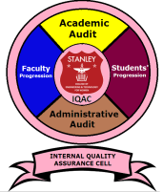

IQAC
(INTERNAL QUALITY ASSURANCE CELL)

Dr. A Kanaka Durga Dr. A. Vinaya Babu
Professor of IT Professor of CSE
Coordinator Chairman

