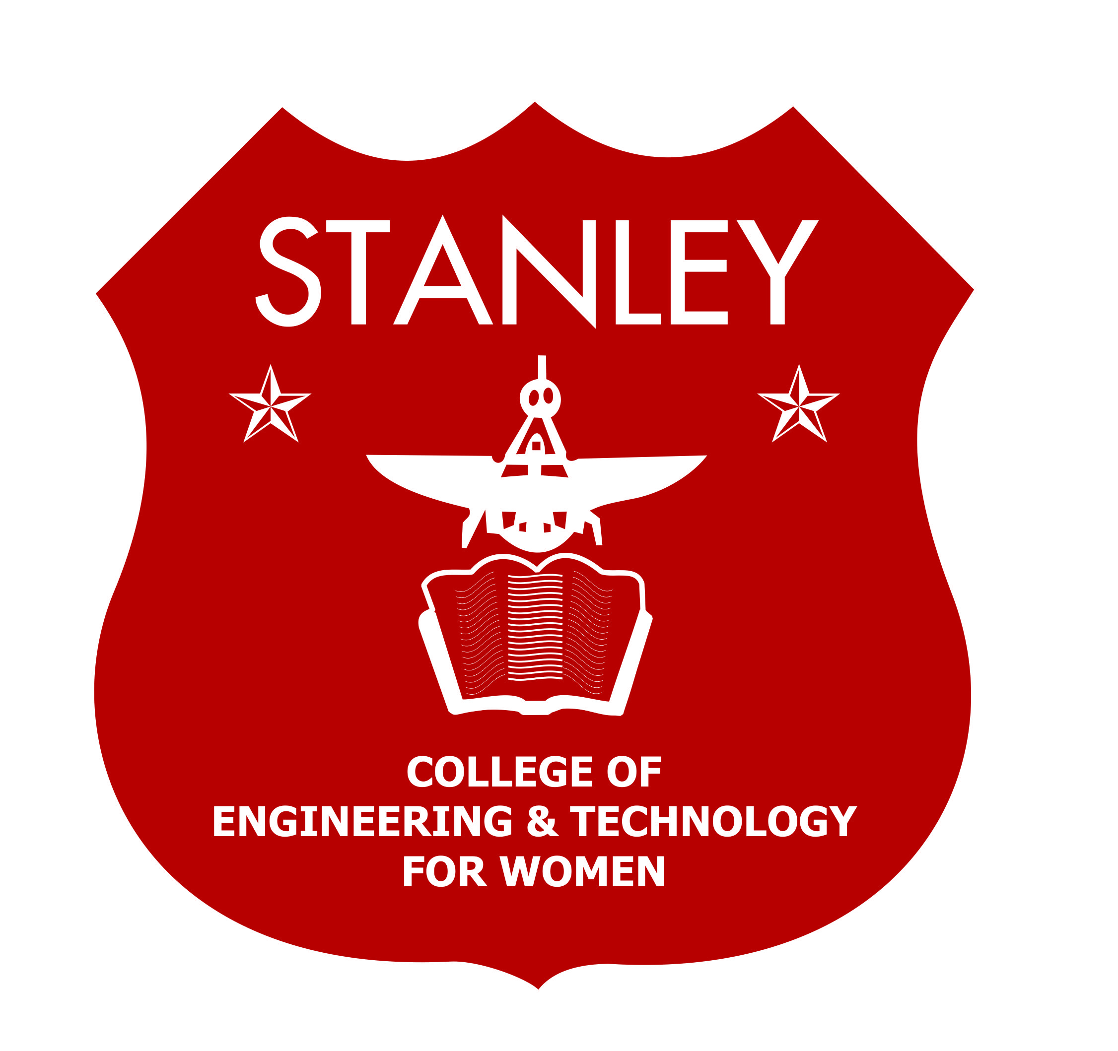
Stanley College of Engineering and Technology for Women
Chapel Road, Abids, Hyderabad – 500 001
(Autonomous)

(AUTONOMOUS)
Affiliated to Osmania University & Approved by AICTE)
(All eligible UG Courses are accredited by NBA & Accredited by NAAC with ‘A’ Grade)

(Affiliated to Osmania University & Approved by AICTE)
(All eligible UG Courses are accredited by NBA & Accredited by NAAC with ‘A’ Grade)
Department of EEE
STANFEST 2K22
2021-2022
Event Name: Technical Quiz.
Registration Fees: 50 Rupees per student.
Date of Event: 13th May’2022.
Venue of Event: C Block Room no C-103.
Timings of Event: 10:00 – 12:00PM

Guidelines for Technical Quiz:
- Team should be formed with following students of no of batches. Inter collegiate teams are permitted.
- Quiz will be conducted depending on the number of batches.
- Total number of rounds will be intimated at the event.
- Any sort of materials and electronic gadgets are not allowed at the time of quiz
- The decision of the will be final.
- First answer from the team is going to be final, no repeating of answers.
Event Coordinator’s:
- Mrs. B. Vijaya Laxmi, Assistant prof (8639034355, vijaya1105@stanley.edu.in)
- Ms. Shruthi Rao, Assistant prof (8499904444, shruthirao@stanley.edu.in)
Student Coordinator’s:
YVNS Yashaswi – VIII sem (9381063671)
M.Vaishnavi Reddy-VI sem (8121212220)
Yamini panja – IV sem (8184879277)

Faculty coordinators Convener Dr. N. Nagashekar Reddy
B. Vijayalakshmi (HOD)
M. Shruthi Rao

